
Islamic University of Technology
Leakage-Audited Multi-Horizon Handover Forecasting from LTE Drive-Test Signalling

Saadman Sakib (Student ID: 210021110)
Adhnan Kalim (Student ID: 210021308)
Evan Ashfaque (Student ID: 210021335)

A Thesis Submitted to the Academic Faculty in Consideration of Partial Fulfillment for the Requirements of the Degree of
BACHELOR OF SCIENCE IN ELECTRICAL AND ELECTRONIC ENGINEERING
Department of Electrical and Electronic Engineering
Islamic University of Technology (IUT)
Gazipur, Bangladesh
Winter Semester, 2026
DECLARATION
I do hereby declare that the work presented in this thesis, entitled Leakage-Audited Multi-Horizon Handover Forecasting from LTE Drive-Test Signalling, is the outcome of the investigation and research carried out by us under the supervision of Dr. Mohmmad Tawhid Kawser, Professor, Department of Electrical and Electronic Engineering, Islamic University of Technology (IUT), Gazipur, Bangladesh.
I further declare that neither this thesis nor any part of it has been submitted anywhere else for the award of any academic qualification, certificate, diploma or degree. All sources of information and material used in the preparation of this thesis have been duly acknowledged and cited.

………………………………………
Saadman Sakib (Student ID: 210021110)

Date: ……………………

………………………………………
Adhnan Kalim (Student ID: 210021308)

Date: ……………………

………………………………………
Evan Ashfaque (Student ID: 210021335)

Date: ……………………

APPROVAL
Leakage-Audited Multi-Horizon Handover Forecasting from LTE Drive-Test Signalling

Saadman Sakib (Student ID: 210021110)
Adhnan Kalim (Student ID: 210021308)
Evan Ashfaque (Student ID: 210021335)

The thesis titled above has been examined and approved as partial fulfillment of the requirements for the degree of Bachelor of Science in Electrical and Electronic Engineering.

………………………………………
Dr. Mohmmad Tawhid Kawser
Supervisor and Professor
Department of Electrical and Electronic Engineering
Islamic University of Technology (IUT), Boardbazar, Gazipur-1704

Date: ……………………
ACKNOWLEDGEMENTS
All praise is due to Allah, the Most Gracious and the Most Merciful, whose mercy made the completion of this work possible.
We wish to express our sincere gratitude to our supervisor, Dr. Mohmmad Tawhid Kawser, Department of Electrical and Electronic Engineering, Islamic University of Technology, for the guidance, patience and critical reading that shaped this thesis. His insistence that a measured claim is worth more than an impressive one is the single most useful lesson we carry out of this project, and it is visible in every chapter that follows — most of all in Chapter 5, where an early and flattering result did not survive its own audit.
I thank the Department of Electrical and Electronic Engineering for providing access to the drive-test instrumentation without which none of the measurement campaigns reported here could have been conducted, and the faculty members whose questions during the progress presentations sharpened the evaluation protocol considerably.
We are grateful to the authors of the publicly released LTE drive-test dataset used for the independent check in Chapter 5; publishing measured data under a citable identifier is what made that check possible at all.
Finally, I thank my family for their patience during the field campaigns and the long analysis that followed.
ABSTRACT
Long Term Evolution networks execute handovers through Event A3, a rule that fires only after a neighbour cell has already become stronger than the serving cell by a configured offset and has remained stronger for a full time-to-trigger. The rule is reactive by construction: it issues a response, not a warning. This thesis asks whether the next handover can be forecast from the measurements a handset already reports, how far ahead, with what guarantee — and, as it turned out, what has to be verified before any such number can be believed.
Four drive-test campaigns were conducted on a live commercial LTE network in Dhaka and Gazipur, yielding 4 continuous logging sessions, 10,260 samples at one hertz and 957 handover commands decoded from RRC signalling rather than inferred from vendor counters. An alignment audit of the one-hertz export is reported first, because it governs every result that follows: in 76% of handovers the export row stamped before the handover command already carries the post-handover serving cell, so a row summarises the second that follows its own timestamp. Every feature is therefore lagged by one row, which moves the one-second AUPRC of the same model from 0.600 to 0.179. The task is posed as discrete-time survival: one model estimates per-interval hazards and horizon probabilities are products of hazards, so ordering holds by construction for any learner.
Under leave-one-campaign-out evaluation — the only protocol whose units are genuinely independent here, since each campaign is one continuous session — gradient-boosted trees reach AUPRC 0.179 at one second against a 6.8% prevalence floor (2.6x lift, AUROC 0.777) and AUPRC 0.475 at five seconds (1.8x), against 0.116 for the deployed A3 rule scored as a predictor. Splitting rows at random instead inflates the same number by 48 %, and splitting by 180-second chunks of one session — the protocol this work used before the audit — still inflates it by 13 %. The hazard formulation yields zero ordering violations against 40.2% of rows for independent per-horizon classifiers, a defect that a cumulative-maximum projection also removes at no cost, so the formulation is defended on needing neither a held-out calibration split nor five separate fits rather than on coherence alone.
Two properties of the deployed network are corrected against the earlier draft of this work. Weighted by handovers rather than by configurations, 75% of A3-triggered handovers fire under a positive offset, so the operator's negative offsets belong to measurement configurations that rarely lead to mobility. Counted per trigger episode rather than per transmitted report, 30% of A3 episodes are not followed by a handover within two seconds, against 63% per report; the dominant mobility profile is declined on only 2.3% of its episodes. The contribution is a signalling-grounded, leakage-audited framework that converts measured handover events into coherent multi-horizon probabilities with a stated operating cost, together with a reproducible demonstration of how much of an apparently strong result on drive-test data can be timestamp alignment.
Keywords: LTE, handover prediction, Event A3, RRC signalling, discrete-time survival analysis, data leakage, evaluation protocol, conformal risk control, calibration, drive test.
TABLE OF CONTENTS
Acknowledgements iv
Abstract v
List of figures x
List of tables xii
List of acronyms xiii
Chapter 1 Introduction 1
1.1 Background 1
1.2 Motivation 2
1.3 Problem statement 3
1.4 Objectives 4
1.5 Scope and limitations 4
1.6 Contributions 5
1.7 Organisation of the report 5
Chapter 2 Literature review and methodology 7
2.1 LTE mobility and the Event A3 trigger 7
2.2 The measurement literature 8
2.3 The prediction literature and a protocol audit 8
2.4 Ping-pong and its definitional instability 10
2.5 Survival analysis as the appropriate formulation 11
2.6 Distribution-free uncertainty quantification 11
2.7 Point processes and the self-excitation of handover arrivals 12
2.8 Evaluation practice imported from adjacent fields 12
2.9 Research gap 13
2.10 Methodology 13
2.10.1 Approaches considered and rejected 14
Chapter 3 Measurement campaign and ground truth 16
3.1 Instrumentation 16
3.2 The four campaigns 17
3.3 Signalling decoding and the configuration timeline 18
3.3.1 The attribution chain 18
3.3.2 Why a flat parse is wrong 18
3.3.3 The timeline 19
3.4 Drive segmentation and quality control 19
3.5 The deployed configuration 20
3.6 The dataset 21
Chapter 4 Predictive formulation and system design 24
4.1 Problem formalisation 24
4.2 The multi-horizon binary formulation and its defect 25
4.3 The discrete-time survival formulation 26
4.4 The likelihood under censoring 27
4.5 Why class reweighting is inadmissible here 28
4.6 Feature construction 28
4.7 Models compared 29
4.8 Calibration 30
4.9 Evaluation protocol 30
4.10 Distribution-free risk control 31
4.11 Point-process analysis of handover arrivals 32
Chapter 5 Results and discussion 34
5.1 The alignment audit and what it costs 34
5.2 The primary prediction result 36
5.3 Splitting protocol: what each unit is worth 38
5.4 Coherence and calibration 40
5.5 Risk control and its price 43
5.6 Generalisation across corridors and speed regimes 44
5.7 An independent collection on the same network 45
5.8 What the model uses, and where it works 46
5.9 The A3 report-conversion rate, per episode 48
5.10 Ping-pong: definitional instability and its actual source 50
5.11 Negative results 54
5.12 Discussion against the objectives 55
5.13 Threats to validity 56
Chapter 6 Demonstration of outcome based education 58
6.1 Introduction 58
6.2 Course outcomes addressed 58
6.3 Aspects of program outcomes addressed 59
6.4 Knowledge profiles addressed 60
6.5 Use of complex engineering problems 61
6.6 Socio-cultural, environmental and ethical impact 61
6.7 Attributes of complex engineering problem solving addressed 62
6.8 Attributes of complex engineering activities addressed 63
6.9 Project management, resources and budget 63
Chapter 7 Conclusions 65
7.1 Summary of findings 65
7.2 Limitations 66
7.3 Recommendations for future work 67
7.4 Concluding remark 67
References 69
Appendix A Full per-horizon results 71
Appendix B Feature inventory 72
Appendix C Reproduction notes 73
Appendix D The 22 audited models 74
LIST OF FIGURES
Figure 1.1 Event A3 fires only after the neighbour has been better than the serving cell by a configured offset for a full time-to-trigger. The profile that produces most of the handovers measured here is a +1 dB offset with a 320 ms time-to-trigger and 1 dB hysteresis.
Figure 2.1 The methodology in five stages. Stage 2 supplies the ground truth; Stage 4 is the formulation that keeps the five horizons mutually consistent; Stage 5 is the evaluation protocol whose unit is a whole campaign.
Figure 3.1 The three Dhaka campaigns on an OpenStreetMap background. Events cluster at particular junctions rather than distributing uniformly along the route. The 15 September highway campaign lies outside this extent. Map data © OpenStreetMap contributors.
Figure 3.2 Measurement identifiers persist in VarMeasConfig until they are modified or removed. A flat parse resolves every report against the union of all configuration fragments; the timeline replays additions, modifications and removals in order and resolves each report against the configuration in force at its own timestamp.
Figure 3.3 Handovers attributed to each configuration profile, weighted by the handovers each actually produced rather than by the number of configurations present. Blue bars are positive-offset A3 profiles, red bars negative-offset A3 profiles, grey bars other events.
Figure 3.4 Composition of the pooled dataset. The four campaigns differ in duration and in event density; the highway campaign contributes the fewest handovers per minute and the highest mean speed.
Figure 4.1 Independent per-horizon classifiers against the hazard formulation, drawn on simulated rows with the measured violation rate. Independent fits cross; the product of hazards cannot.
Figure 4.2 The splitting ladder. Leave-one-campaign-out holds out a whole continuous session; blocked cross-validation holds out a contiguous stretch of each session with a 60-second purge on either side; the two leaky protocols draw 180-second blocks, or rows, at random.
Figure 5.1 The alignment audit. Left: share of handovers whose target cell is already the serving cell in the export rows around the row whose second contains the handover command (t). Right: the same check on an independent public drive-test dataset logged with a different tool, where the row is not contaminated.
Figure 5.2 Event-level cost of the warning at the 5 % false-positive operating point: share of handover commands detected against the 1 Hz grid ceiling, with the false-alarm episode rate per hour on the right axis.
Figure 5.3 AUPRC lift over the prevalence floor by horizon for every learner, out of fold under leave-one-campaign-out. A lift of one is the floor itself.
Figure 5.4 One-second AUPRC lift by learner, with each held-out campaign drawn separately. The spread across campaigns is wider than the spread across learners.
Figure 5.5 The splitting ladder, at one and five seconds. Every learner rises as the protocol weakens, and the learners rise by different amounts, so the ranking changes with the protocol.
Figure 5.6 Calibration error at one second, one line per held-out campaign, for independent classifiers against the hazard formulation.
Figure 5.7 Calibration error against the horizon for every coherence arm (left) and the share of rows violating horizon ordering (right).
Figure 5.8 Where the model earns its advantage: rows with no handover in the previous ten seconds against rows inside a burst.
Figure 5.9 Conformal risk control in both regimes. Left: realised mean per-unit miss rate against the target, with the guarantee boundary as the diagonal. Right: the alarm rate that compliance costs.
Figure 5.10 Leave-one-campaign-out on four metrics. Each bar holds one campaign out entirely and trains on the other three; the dashed line is the pooled out-of-fold value. The highway campaign is in red.
Figure 5.11 Transfer to an independently collected dataset on the same network, with both domains built from L3 signalling alone. Bars are 95 % bootstrap intervals over runs.
Figure 5.12 Single-feature discriminative power at one second on the lagged export. No single feature approaches the full model.
Figure 5.13 Probability of a handover command within one and five seconds against the time since the previous command, computed from signalling timestamps.
Figure 5.14 A3 report conversion under two units. Counting transmitted reports counts periodic re-reports of one trigger; counting trigger episodes does not.
Figure 5.15 The ping-pong rate over the full definitional grid: three return windows against three conventions for cell identity and return, computed on one unchanging set of handover commands.
Figure 5.16 Where ping-pong concentrates. The dominant axis is the carrier relationship, not the mobility regime.
Figure 5.17 Hawkes branching ratio estimated on each campaign separately and on the pooled stream, with bootstrap intervals.
Figure 5.18 Self-excitation in the handover arrival stream. The clustering is real; the Ogata residual test rejects the exponential kernel, so its temporal shape is not exponential.
Figure 5.19 Feature-block, alignment and censoring ablations at one and five seconds, out of fold under leave-one-campaign-out, with the spread over three seeds.
LIST OF TABLES
Table 2.1 Protocol audit of the 22 most comparable prediction models, contrasted with the protocol adopted here. Appendix D lists the models.
Table 3.1 Deployed Event A3 configuration recovered from RRC signalling, weighted by the handovers each profile produced.
Table 3.2 The four measurement campaigns after quality control.
Table 4.1 Positive-class prevalence by horizon on the common row set, and the accuracy obtained by a constant negative prediction.
Table 4.2 Measured discrete-time hazard by bin, and the cumulative incidence it implies, against the prevalence of Table 4.1. The two agree exactly by construction.
Table 4.3 Feature blocks, their source and their alignment.
Table 5.1 The alignment audit: share of handovers whose target cell already serves in export rows around the command.
Table 5.2 What the one-row lag costs, with everything else held fixed.
Table 5.3 Out-of-fold performance of LightGBM under the hazard formulation, leave-one-campaign-out. Intervals are block-bootstrapped over 180 s blocks and are conditional on these four sessions.
Table 5.4 Every learner under identical folds, features, formulation and tuning budget.
Table 5.5 One-second AUPRC under four splitting protocols, with all else held fixed.
Table 5.6 Horizon coherence and calibration for the hazard formulation and its four controls.
Table 5.7 Conformal risk control at the one-second horizon, in the exchangeable regime and across campaigns.
Table 5.8 Leave-one-campaign-out performance at the one-second horizon.
Table 5.9 Transfer between our campaigns and an independently collected public dataset on the same network, both built from L3 signalling alone.
Table 5.10 Single-feature AUROC at the one-second horizon on the lagged export.
Table 5.11 Performance inside and outside handover bursts.
Table 5.12 Event A3 report conversion, counted per transmitted report and per trigger episode.
Table 5.13 The ping-pong rate on one fixed set of handover commands under four definitions.
Table 5.14 Ping-pong rate by carrier relationship and mobility regime.
Table 5.15 Approaches implemented and measured that produced no improvement.
Table 5.5 Conformal risk-control frontier. The certified target is the bound on the expected per-drive miss rate; the alarm rate and realised miss rate are measured on held-out drives. 43
Table 5.6 Leave-one-campaign-out performance at the one-second horizon. Each row is trained on the other three campaigns and tested on the campaign named. 44
Table 5.7 External validation at the one-second horizon on an independently collected public drive-test dataset. 45
Table 5.8 Single-feature AUROC at the one-second horizon. Each feature is evaluated on its own. 46
Table 5.9 Event A3 report-conversion rate by campaign. The figure reported is the fraction of A3 reports not followed by a handover command within two seconds. 48
Table 5.10 The ping-pong rate on one fixed set of handovers under four definitions. 50
Table 5.11 Ping-pong rate by carrier relationship, configuration profile and mobility regime. 51
Table 5.12 Approaches implemented and measured that produced no improvement. 54
Table 6.1 Course outcomes addressed in this project. 58
Table 6.2 Aspects of program outcomes addressed, with the evidencing section. 59
Table 6.3 Knowledge profiles addressed, with justification. 60
Table 6.4 Attributes of complex engineering problem solving addressed. 62
Table 6.5 Attributes of complex engineering activities addressed. 63
Table 6.6 Resource and cost summary for the project. 64
Table A.1 Complete per-horizon results for all seven learners under the grouped-drive rotation. AUPRC is reported with its prevalence floor; lift is AUPRC divided by prevalence. 71
Table A.2 Event-level operating characteristics of the primary model at the certified operating point of Section 5.5. 71
LIST OF ACRONYMS
3GPP | Third Generation Partnership Project
A3 | Event A3 (neighbour becomes offset better than serving)
AUPRC | Area Under the Precision–Recall Curve
AUROC | Area Under the Receiver Operating Characteristic Curve
CHO | Conditional Handover
CO | Course Outcome
CORAL | Correlation Alignment
CRC | Conformal Risk Control
E-UTRAN | Evolved Universal Terrestrial Radio Access Network
EARFCN | E-UTRA Absolute Radio Frequency Channel Number
ECE | Expected Calibration Error
GRU | Gated Recurrent Unit
GPS | Global Positioning System
HOM | Handover Margin
KPI | Key Performance Indicator
LTE | Long Term Evolution
MLP | Multi-Layer Perceptron
PCI | Physical Cell Identity
PO | Program Outcome
QoE | Quality of Experience
RLF | Radio Link Failure
RRC | Radio Resource Control
RSRP | Reference Signal Received Power
RSRQ | Reference Signal Received Quality
SINR | Signal-to-Interference-plus-Noise Ratio
TCN | Temporal Convolutional Network
TTT | Time-to-Trigger
UE | User Equipment

CHAPTER 1

INTRODUCTION

Mobility is the property that distinguishes a cellular network from every other access technology, and the handover is the mechanism that delivers it. Each time a user equipment moves beyond the useful coverage of its serving cell, the network must transfer the connection to a neighbour without interrupting the service carried on it. On a dense urban network this happens constantly: across the campaigns reported here a handover command was issued on average once every 11 seconds of driving. Every one of those events is a brief window in which throughput drops and latency rises.
This chapter states the problem the thesis addresses, the reason it is worth addressing, and the objectives against which the work should be judged. Section 1.1 describes how handover is triggered in Long Term Evolution (LTE) and why the triggering rule is structurally incapable of providing advance warning. Section 1.2 quantifies the cost of that limitation on measured data. Section 1.3 states the problem formally, Section 1.4 lists the objectives, Section 1.5 bounds the scope, Section 1.6 summarises the contributions, and Section 1.7 describes the organisation of the remainder of the report.

1.1 Background
In an LTE network the user equipment (UE) continuously measures the Reference Signal Received Power (RSRP) and Reference Signal Received Quality (RSRQ) of its serving cell and of the neighbour cells it can detect, and reports those measurements to the network when a condition configured by the network is satisfied [1]. The dominant condition governing intra-frequency mobility is Event A3, which is defined in 3GPP TS 36.331 as the condition that a neighbour cell becomes better than the serving cell by a configured offset, and that this relation persists for a configured time-to-trigger (TTT) before the report is sent [1].
Two properties of that definition matter for this thesis. First, the condition is written on a comparison that must already hold: the neighbour must have become better before anything happens. Second, the TTT imposes an additional delay whose purpose is to suppress spurious triggering caused by fast fading. Together they guarantee that by the time a measurement report leaves the handset, the radio environment has already changed. The network then evaluates the report and, if it decides to proceed, issues an RRCConnectionReconfiguration message carrying mobilityControlInfo, which is the handover command itself.
Figure 1.1 draws that sequence against a measured pair of serving and neighbour traces. Event A3 is therefore a reaction rule and not a prediction rule, and this is not a deficiency of the standard. The rule was designed to decide reliably, not early, and it performs that function well. What the standard does not provide, and what an increasingly latency-sensitive service mix increasingly wants, is advance notice: an indication, one or two seconds before the fact, that a handover is imminent, so that the target cell can be prepared, the transmission schedule adjusted, or an unnecessary transfer suppressed.
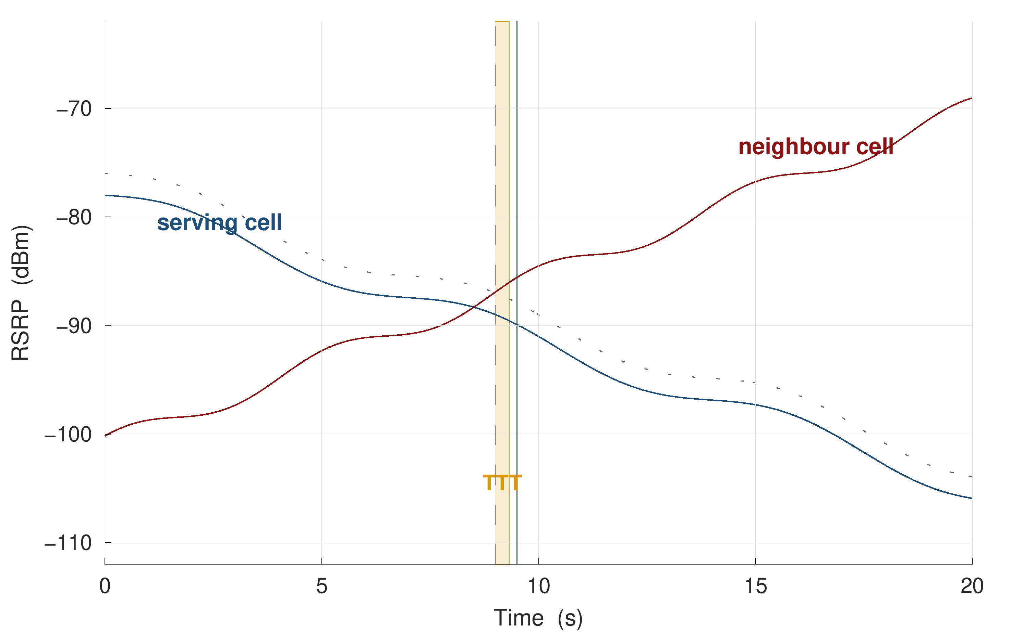
Figure 1.1 Event A3 fires only after the neighbour has been better than the serving cell by a configured offset for a full time-to-trigger. The profile that produces most of the handovers measured here is a +1 dB offset with a 320 ms time-to-trigger and 1 dB hysteresis.

1.2 Motivation
The cost of reacting rather than anticipating is measurable, and it was measured on the data collected for this thesis rather than assumed from the literature. Across four campaigns totalling 2.9 hours of logging, 957 signalling-confirmed handover commands were observed, a mean interval of 11 seconds with a median gap of 3.7 seconds between consecutive commands. Of those handovers, 26.3% returned to the cell just vacated within fifteen seconds; each such pair is two signalling exchanges and two service interruptions that produce no net change of serving cell. The signalling log also records 341 RRC connection re-establishment procedures, of which 321 carry the cause reconfigurationFailure and only 3 carry handoverFailure; Section 3.6 treats them accordingly, and they are not described here as radio link failures. Measurement reporting is likewise abundant: 8,136 Event A3 reports were transmitted, which resolve into 2,361 distinct trigger episodes, and 30% of those episodes are not followed by a handover command within two seconds.
These are not pathological numbers for a dense urban deployment; they are what the deployed configuration produces. They do, however, establish that even a short prediction horizon has something to act on. A warning one second ahead of a handover command is sufficient time for the network to complete target-cell preparation, and a warning that a handover is likely to be reversed within fifteen seconds is sufficient information to consider not performing it.
The natural question is whether such a predictor already exists. A screening of 108 publications, of which 22 were audited in detail in Chapter 2 and listed in Appendix D, indicates that it does not exist in a form an operator could act upon. Of those 22 models, none holds out the mobility unit — a whole drive or a whole device session — when evaluating a per-timestep classification task on measured radio data; none reports a calibration curve, an expected calibration error or a Brier score; and none reports how early its warnings arrive or how many false alarms they generate per unit time. Seven report headline accuracy on tasks whose positive-class prevalence lies between 0.86 % and 11 %, where a constant negative prediction already scores between 89 % and 99 %. None of them states how the timestamp of a measurement row relates to the interval it summarises, which Chapter 5 shows to be worth more than any modelling choice made in this thesis.

1.3 Problem statement
The problem addressed in this thesis is the following. Given the measurements available to a handset at time t — serving and neighbour signal levels and qualities, their short-term statistics, mobility state and the recent signalling history — estimate the probability that the network will issue a handover command within h seconds, for several values of h simultaneously, such that:
- the estimates are mutually consistent, in the sense that the probability for a longer horizon is never smaller than that for a shorter one;
- the estimates are calibrated, in the sense that an asserted probability of p corresponds to an empirical event frequency near p;
- the evaluation protocol cannot transfer information from a test drive into training; and
- the warning derived from the estimates carries a stated bound on the fraction of handovers it will miss on future units; and
- the information available to the model at time t is demonstrably available at time t — that is, the alignment between the measurement grid and the event clock is verified rather than assumed.
None of these five requirements is satisfied jointly anywhere in the audited literature, and the fourth and fifth are not satisfied anywhere at all in the handover-prediction setting.

1.4 Objectives
The specific objectives of this thesis are as follows.
O1. To predict the next handover at five look-ahead times — 0.5, 1, 2, 3 and 5 seconds — using only quantities observable at the handset at the instant of prediction.
O2. To establish an evaluation protocol that cannot leak information between training and test, by grouping every split at the level of the whole drive, and to measure how much that protocol is worth relative to the random-row splitting that is standard in the comparator literature.
O3. To make the resulting probabilities usable by an operator: mutually coherent across horizons, calibrated in value, and accompanied by a distribution-free bound on the per-drive miss rate.
O4. To test whether the result generalises beyond the campaign on which it was developed, both to a corridor and speed regime held out entirely and to an independently collected public dataset.
O5. To explain the mechanism underlying the prediction, rather than reporting accuracy alone, and in doing so to characterise the behaviour of the deployed mobility configuration on this network.

1.5 Scope and limitations
The scope of this work is deliberately bounded, and the bounds are stated here rather than deferred to the conclusion.
The study covers one commercial LTE operator, four measurement days, two mobility regimes and 57 drives. It does not claim that the numerical results transfer to another operator or another radio access technology, although Chapter 5 reports an external validation that bears on that question. The measurement export is sampled at one hertz, which caps the fraction of handover events that can in principle be resolved at 90.5 %; this is a property of the instrument and not of the models.
The system developed here is an offline predictor evaluated on recorded data. It is not integrated into a network, and no claim is made that deploying it would improve any network key performance indicator. In particular, no causal claim is made about the benefit of acting on the warning, for the reason given in Chapter 5: the logging policy is deterministic, so the propensities required for off-policy evaluation are zero or one and the causal estimand is not identified on observational data of this kind. Only a counting upper bound is reported.
Finally, the thesis makes no claim relating to human health. No human subjects were involved, no exposure measurements were taken, and the impact analysis in Chapter 6 is confined to what the measurements support.

1.6 Contributions
The contributions of this thesis are the following five, each supported by a specific result in Chapter 5. They are stated as they stand after the alignment audit of Section 5.1, which revised two of them downwards from an earlier draft of this work.
1. A timestamp-alignment audit for drive-test prediction studies, and a measurement of what it is worth. In 76% of handovers the one-hertz export row stamped before the handover command already carries the post-handover serving cell; removing that information by lagging every export feature one row moves the one-second AUPRC from 0.600 to 0.179 and single-feature dwell AUROC from 0.873 to 0.664. The audit is three lines of code and is reproducible on any export that carries a serving-cell column.
2. A measurement of what the unit of splitting is worth on drive-test radio data, on a ladder of four protocols rather than the usual two. Against leave-one-campaign-out, splitting by random 180-second chunks of the same continuous session inflates the one-second AUPRC by 13 % and splitting rows at random by 48 %; the inflation is architecture-dependent, so the protocol determines the ranking of models and not only their level.
3. A discrete-time hazard formulation of handover prediction that renders five look-ahead horizons mutually consistent from a single model fit, for any learner, without a held-out calibration split and without post-hoc correction. Independent per-horizon classifiers violate ordering on 40.2% of rows; the hazard model cannot. The comparison is reported against the repairs a reviewer would ask for — a cumulative-maximum projection, and isotonic calibration composed with it — which also reach zero violations, so the argument for the formulation rests on reaching coherence and competitive calibration from one fit and with no held-out calibration split.
4. A distribution-free risk guarantee whose exchangeable unit is stated and tested in both the regime where it holds and the regime where it does not: calibration and test units drawn from the same pool of chunks, and calibration on one campaign with the guarantee claimed for another. The campaign-design floor that follows — the number of calibration units bounds the tightest expressible miss rate — is a direct corollary of the conformal risk control bound [21] rather than a new result, and is reported as such.
5. Two corrected characterisations of the deployed network that the prediction literature has not modelled: the A3 report-conversion rate measured per trigger episode (30% declined within two seconds, against 63% when periodic re-reports are counted individually), and the deployed offset distribution weighted by handovers rather than by configurations (75% of A3-triggered handovers fire under a positive offset).

1.7 Organisation of the report
The remainder of this report is organised as follows. Chapter 2 reviews the four literatures that bear on this problem — cellular measurement studies, handover prediction, survival analysis and distribution-free uncertainty quantification — presents a protocol audit of the 22 most comparable prediction models, and sets out the methodology adopted, including the approaches that were considered and rejected. Chapter 3 describes the measurement campaign, the signalling-decoding procedure and the construction of the dataset. Chapter 4 develops the predictive formulation, the feature construction, the models compared, the evaluation protocol and the risk-control procedure. Chapter 5 reports and discusses the results against the objectives of Section 1.4. Chapter 6 demonstrates how the work addresses the course outcomes, program outcomes, knowledge profiles and complex engineering problem and activity attributes required of a capstone project. Chapter 7 concludes and identifies the work that follows from the limits of the present study.
CHAPTER 2

LITERATURE REVIEW AND METHODOLOGY

Four bodies of work bear on the problem stated in Chapter 1, and they nearly meet without quite touching. The cellular measurement literature establishes what handovers look like in deployed networks but does not build predictors. The handover-prediction literature builds predictors, but predominantly on simulated data and predominantly without an evaluation protocol that would survive scrutiny. The survival-analysis and point-process literatures supply exactly the right mathematical objects — a discrete-time hazard and a self-exciting process validated by time rescaling — but have not been directed at mobility data. The distribution-free uncertainty literature supplies guarantees, but for signal-processing tasks whose exchangeability structure differs from that of an event stream recorded along a drive.
This chapter reviews each in turn, then presents a quantitative audit of the 22 most comparable prediction models, states the research gap that the audit establishes, and describes the methodology adopted in response, including the alternatives that were considered and rejected.

2.1 LTE mobility and the Event A3 trigger
The mobility procedure in E-UTRAN is specified in 3GPP TS 36.331 [1] and described at system level in TS 36.300 [2]. The network configures the UE with measurement objects, report configurations and measurement identities that bind the two; the UE evaluates the configured entry condition against its filtered measurements and transmits a MeasurementReport when the condition has held for the configured time-to-trigger.
For intra-frequency mobility the governing condition is Event A3. Writing M_{n} for the measured neighbour quantity, M_{s} for the serving quantity, Off for the configured offset, Ocn and Ocs for cell-individual offsets and Hys for hysteresis, the entry condition of TS 36.331 is
M_n + Ocn − Hys > M_s + Ocs + Off (2.1)
and the condition must remain satisfied throughout the time-to-trigger interval before the report is sent. The decision to hand over is then taken by the network, not the UE, and is communicated by an RRCConnectionReconfiguration message carrying mobilityControlInfo.
Three consequences follow, and all three are used later in this thesis. First, the report is evidence that the network may hand over, not that it will; the conversion rate from report to command is an empirical quantity and is measured in Chapter 5. Second, the parameters Off, Hys and the TTT are operator-configured and are not observable without decoding the signalling; the prediction literature that assumes textbook values is therefore assuming something it has not checked. Third, because the condition is defined on a state that must already obtain and must then persist, the earliest instant at which Event A3 can produce any output is strictly after the radio environment has changed.

2.2 The measurement literature
A mature line of work in the networking-measurement community recovers operator mobility configurations from control-plane traces on live networks. Deng et al. [3] present the LTE precedent, a measurement study of operational 4G mobility configurations and their consequences. Ghoshal et al. [4] perform the equivalent analysis at large scale on contemporary networks, extracting hysteresis, threshold, offset, time-to-trigger and trigger quantity for events A1–A6, B1 and B2 per operator and band, over more than 15,000 km of driving. Hassan et al. [5] establish the use of commercial diagnostic tooling for RRC extraction as accepted methodology, and their Prognos component is the closest prior system to the one built here: it predicts handovers from XCAL-decoded RRC state on a live network and reports a lead-time gain of roughly 900 ms. Section 2.3 therefore positions this thesis against Prognos explicitly rather than against the simulated literature alone. M2HO [6] reads mobilityControlInfo for mobility analysis without recovering the numerical parameters.
This literature is relevant in two ways. Methodologically, it legitimises the decoding pipeline used in Chapter 3 rather than competing with it: the extraction of deployed A3 parameters from measConfig is established practice and is not claimed as a contribution here. Substantively, it supplies the comparison points against which the configuration measured here is interpreted; Ghoshal et al. report positive A3 offsets of +6 to +10 dB and shortest time-to-trigger values of 256 to 640 ms on the operators they study, whereas the network measured here runs configurations from −15 dB to +5 dB with a shortest time-to-trigger of 160 ms — but, as Section 5.9 shows, 75% of the handovers it actually produces fire under the +1 dB profile, so the two findings are less far apart than a table of configurations suggests.
What this literature does not do is predict. Ghoshal et al. state explicitly that they perform no machine-learned prediction, no off-policy evaluation and no counterfactual analysis; the work is descriptive by design. The ping-pong rates these studies report are likewise descriptive, and, as Section 2.4 discusses, are reported under definitions that differ enough to change the number by a factor of two.

2.3 The prediction literature and a protocol audit
A large body of work predicts handover, radio-link failure or next-cell occupancy using learned models. Recent systematic reviews characterise it unfavourably from the outside. Ankome and Hanada [7] screened 429 records under a PRISMA protocol, retained 336 after deduplication and included 49 studies spanning 2010–2025; they were unable to perform a meta-analysis because simulators and outcome definitions were too heterogeneous, they observe that most studies report percentage improvements over baselines of their own choosing rather than absolute performance, and they report that data splitting, class imbalance and calibration receive minimal explicit discussion anywhere in the included set. Saoud et al. [8] find that the field lacks quantitative cross-comparison between strategies, and Chabira et al. [9] enumerate the metric vocabulary actually in use — handover failure rate, latency, quality of service, energy — in which neither calibration nor any prevalence-aware ranking metric appears.
To convert that general complaint into something specific enough to act on, 108 publications were screened for this thesis and the 22 that present a learned or analytical model predicting handover, radio-link failure or next-cell occupancy were audited on protocol quality rather than on headline performance. Table 2.1 reports the audit in summary; Appendix D lists every audited model with its venue, data type and split protocol, so each row of Table 2.1 can be checked.
Table 2.1 Protocol audit of the 22 most comparable prediction models, contrasted with the protocol adopted here. Appendix D lists the models.
Protocol property | Papers satisfying it | This work
Splits by drive, session or route | 0 / 22 | Yes; leave-one-campaign-out is primary
Uses any split coarser than a random row | 5 / 22 | Yes, four protocols compared
States a split protocol at all | 12 / 22 | Yes, with the code released
States the alignment between measurement timestamps and event clock | 0 / 22 | Yes, audited in Section 5.1
Reports a prevalence-aware ranking metric | 2 / 22 | AUPRC with floor and lift
Reports calibration (curve, ECE or Brier) | 0 / 22 | ECE and Brier at every horizon
Reports lead time or false alarms per hour | 0 / 22 | Both, and per kilometre
Reports headline accuracy on an imbalanced task | 7 / 22 | Never
Releases code | 2 / 22 | Planned
Releases data | 1 / 22 | Planned

Two observations from the audit are load-bearing for the remainder of this thesis.
The first concerns metrics. Seven of the 22 report accuracy on tasks whose positive prevalence lies between 0.86 % and 11 %, at which a constant negative prediction scores between 89 % and 99 %; three of the headline figures so reported are 98.03 %, 99.84 % and 94.83 %. A related failure appears in a railway radio-link-failure study that reports area under the ROC curve above 0.95 for all six architectures it compares, on a task with approximately one positive per five hundred samples, and consequently separates none of them.
The second concerns splitting, and the exceptions are named rather than rounded away. Five of the 22 do split on something coarser than a random row: by spatial zone, by device, by time under a rolling-origin protocol on operator data, by travel day [10], and by deployment event [11]. None of the five, however, holds out the mobility unit for a per-timestep classification task on measured radio; the two most recent additions are regression tasks in which prevalence does not arise, and the strongest protocol in the set addresses next-day cell-level radio-link failure rather than a per-sample mobility forecast.
A structural feature of this literature explains the pattern. Protocol quality and measurement quality are anti-correlated within it. The studies with the cleanest splits operate on ray-traced or SUMO-simulated trajectories [10], on aggregated operator key performance indicators, or at cell-and-day granularity [11]; the studies carrying real per-sample drive-test radio, whose data most resembles that used here, are precisely those whose split protocol is unstated. Recent graph-based models illustrate both halves: TH-GCN [12] builds a dynamic UE–cell graph for dense vehicular scenarios but is simulated, states no split protocol and reports relative deltas against baselines of its own choosing, while GRIMCELL [11] applies graph learning to radio-planning, configuration-management and performance-management data from a commercial LTE-A Pro network across 55 real deployment events, but predicts post-deployment key performance indicators per cell per day and is therefore a planning tool rather than a per-second warning system. Graser et al. [13] organise the trajectory-learning literature by data density and observe that the dense individual-trace regime, in which one-hertz drive data sits, is where the literature is thinnest for event prediction as opposed to location prediction.
The narrow claim the audit supports, and the one made in this thesis, is therefore the following: of twenty-two audited models, ten state no split protocol at all, five split on a unit coarser than a row, and none holds out the mobility unit for a per-timestep classification task on measured radio data; none reports calibration; none reports how early its warnings arrive; and none states the alignment between its measurement timestamps and its event clock. Prognos, inside reference [5], is the strongest system in the neighbourhood of this work and is not part of the audited set because it is a system component rather than a published prediction model with its own protocol; it reports F1 on a per-event task and, like the audited set, neither calibration nor an alignment statement.

2.4 Ping-pong and its definitional instability
Handover ping-pong — a return to a recently vacated cell — is widely reported and inconsistently defined. There is no standardised definition in 3GPP; what exists is a cell return within an author-chosen window, and the window alone moves the reported rate substantially. Zidic et al. [14] report ping-pong measurements on real 4G networks, and Ghoshal et al. [4] report per-operator rates of 15 % to 25 % under a fifteen-second window with a per-handover denominator.
Three choices determine the number, and papers rarely state all three: whether a cell is identified by physical cell identity alone or by physical cell identity together with carrier; whether any return within the window counts or only a return to the immediately preceding cell; and whether the denominator is the set of raw handover events or of quality-controlled ones. The consequences are severe enough to invalidate cross-paper comparison: Amirova et al. [15] report a ping-pong rate of 0.13 % because they divide by measurement records rather than by handovers. Chapter 5 reports the full ladder of these choices on a single fixed set of 938 handovers, where the rate moves from 24.5 % to 41.3 % without any change in the underlying data.

2.5 Survival analysis as the appropriate formulation
The task posed in Section 1.3 — the probability that an event occurs within h seconds, for several values of h — is a time-to-event problem, and the appropriate formulation is therefore a survival model rather than a set of independent classifiers. Wiegrebe et al. [16] review 61 deep time-to-event methods and place the discrete-time route, in which the time axis is binned and binary indicators per interval are trained as classification, firmly in the mainstream. Thorsen-Meyer et al. [17] construct structurally the same object for intensive-care outcome prediction, with a censoring-aware log-likelihood over discretised windows.
This literature is used here without any claim of novelty attaching to the formulation itself, and stating that plainly removes an obvious reviewer objection. Conformal prediction has also already been combined with survival analysis by Candès, Lei and Ren [18], who give distribution-free lower bounds on survival times under covariate shift; that work is the correct reference point for anything calling itself conformalised survival analysis, and this thesis does not claim that combination. What is new here is narrower: the application of the discrete-time hazard formulation to mobility events, and a risk bound on an operational miss rate whose exchangeable unit is a driving unit rather than a sample.
One departure from the survival literature is deliberate. That literature evaluates predominantly with the concordance index and the integrated Brier score, both of which aggregate over the horizon axis. An operator, however, acts at a single horizon. A model that ranks well on average while asserting that a handover is more likely within one second than within three on 40.2% of samples is not deployable whatever its concordance index. Chapter 4 therefore evaluates horizon-wise, reporting AUPRC at each horizon together with a coherence-violation rate.

2.6 Distribution-free uncertainty quantification
Conformal prediction supplies finite-sample, distribution-free guarantees under an exchangeability assumption, and it has already been applied inside wireless communications by a strong group. Cohen, Park, Simeone and Shamai [18] apply split and cross-validation conformal prediction to demodulation, modulation classification and channel prediction; Simeone, Park and Zecchin [19] generalise the approach into a deployment lifecycle covering pre-deployment calibration and hyperparameter selection, monitoring under distribution shift, and post-deployment counterfactual analysis. Conformal risk control, which extends the guarantee from coverage of a prediction set to the expectation of a bounded monotone risk, is due to Angelopoulos et al. [20].
The claim made in this thesis is consequently narrow. The guarantees in [19] and [20] are over prediction sets for tasks that are independent and identically distributed within a frame; conformalised survival analysis [18] gives calibrated lower bounds on event times under covariate shift. What Chapter 4 develops is a risk — an operator key performance indicator, the per-unit miss rate — on a stream that is exchangeable at best at the level of a driving unit. Section 5.5 reports the bound in the regime where that exchangeability is plausible and in the regime where it is not, and the difference between the two is the honest content of the claim.

2.7 Point processes and the self-excitation of handover arrivals
Handover events do not arrive independently. The self-exciting point process introduced by Hawkes [21] is the standard model for arrival streams in which each event raises the intensity of subsequent events, and Laub et al. [22] provide the contemporary reference treatment, including the branching-ratio interpretation used in Chapter 5. Fitting such a process is not, by itself, evidence that the process is self-exciting; the fit must be checked. The residual analysis of Ogata [23], in which the time axis is rescaled by the fitted compensator and the transformed arrivals tested against a unit-rate Poisson process, is the standard check, and Price-Williams and Heard [24] establish the precedent for its use in a networking context, validating a self-exciting fit to campus and laboratory network traffic by time rescaling with Kolmogorov–Smirnov tests on held-out data. Chapter 5 follows that precedent and reports the test outcome, including where it rejects the fitted kernel.

2.8 Evaluation practice imported from adjacent fields
Two further results from adjacent literatures inform the evaluation design and are cited here because they make the negative results of Chapter 5 interpretable rather than embarrassing. Ismail Fawaz et al. [25] benchmark nine unsupervised domain-adaptation algorithms across twelve time-series datasets and find that several published methods perform worse than source-only training with no adaptation at all, and that the adaptation technique rather than the backbone drives the outcome; the null result reported for Deep CORAL [26] in Chapter 5 is therefore consistent with a published benchmark rather than evidence of faulty implementation. Shi et al. [27] supply the shift taxonomy that names the shift encountered here as a device-and-day shift rather than a sensor-modality shift. Wagner et al. [28] show formally that the commonly used point-adjusted metrics for time-series event detection each satisfy only a subset of the desirable properties and that none satisfies all of them, which is the justification for reporting event-level detection rate, lead time and false alarms per hour alongside row-level AUPRC rather than in place of it.
Finally, the standards track bears on the choice of horizon. Deb et al. [29] model conditional handover as a discrete-time Markov chain over preparation and execution offsets and timers, and their analysis makes explicit that conditional handover consumes a lead time rather than a label: a model that identifies the correct target cell two hundred milliseconds before the event buys nothing, because the preparation message must be sent, acknowledged and stored. This is the analytical justification for reporting a lead-time distribution rather than a detection rate alone, and for retaining horizons of two, three and five seconds even though the deployed trigger fires within a few hundred milliseconds.

2.9 Research gap
Collecting the preceding sections, the gap this thesis occupies can be stated precisely. Measurement-grade ground truth exists, but is not joined to prediction. Prediction models exist, but not under an evaluation protocol that holds out the mobility unit, and not with calibrated outputs or event-level costs. The correct formulation exists in the survival literature, but has not been applied to mobility events. Distribution-free guarantees exist in wireless, but for a different exchangeability structure and not for any mobility-management task.
This work sits in that gap: measurement-grade ground truth obtained from decoded signalling, a borrowed formulation made coherent across horizons, a conformal risk bound whose exchangeability unit is stated and defended, and an evaluation protocol designed to be acceptable to a reviewer from the machine-learning community rather than only to one from the wireless community.

2.10 Methodology
The methodology adopted follows directly from the gap. It consists of five stages, illustrated in Figure 2.1, and each stage is developed in detail in Chapters 3 and 4.
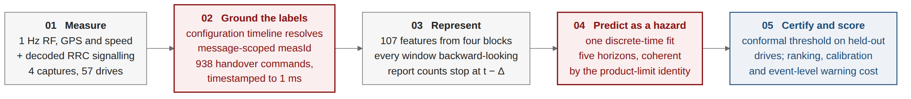
Figure 2.1 The methodology in five stages. Stage 2 supplies the ground truth; Stage 4 is the formulation that keeps the five horizons mutually consistent; Stage 5 is the evaluation protocol whose unit is a whole campaign.
Stage 1 — Collection. Four drive-test campaigns are conducted on a live commercial LTE network using an instrumented handset, recording a one-hertz radio measurement export and, in parallel, a decoded RRC signalling log.
Stage 2 — Ground truth and configuration recovery. Handover instants are taken from decoded RRCConnectionReconfiguration messages carrying mobilityControlInfo. Because measurement identifiers are scoped to the message that carries them, a configuration timeline is replayed so that every measurement report resolves against the configuration in force at its own timestamp.
Stage 3 — Feature construction. One hundred and fifty-two candidate features are constructed from radio, mobility, history and signalling sources; all are strictly causal, closing at the prediction instant, and none crosses a drive boundary.
Stage 4 — Formulation and modelling. The task is posed as discrete-time survival. A single model estimates the per-interval hazard and horizon probabilities are recovered by the product-limit identity, which guarantees ordering. Seven learners are compared under identical conditions.
Stage 5 — Evaluation and risk control. Splits are grouped by whole drive under a four-fold rotation repeated over five seeds; confidence intervals are bootstrapped over drives; and a warning threshold is certified by conformal risk control whose exchangeable unit is the drive.

2.10.1 Approaches considered and rejected
Four alternatives were considered seriously and rejected, and the reasons are recorded here because they constitute part of the methodological argument.
Independent per-horizon classifiers. The obvious approach — one binary classifier per look-ahead time — was implemented and retained as a control arm rather than as the primary method. It is rejected as the primary method because it produces mutually contradictory outputs on a large fraction of samples, as Chapter 5 quantifies, and because repairing that defect after the fact costs both a held-out split and predictive performance.
Random-row cross-validation. The splitting protocol used by the majority of the comparator literature was implemented solely to measure what it is worth. It is rejected because adjacent one-second samples within a drive are near-duplicates, so a random split places nearly identical rows on both sides of it; Chapter 5 shows that the resulting inflation is architecture-dependent and therefore alters the ranking of models.
Class reweighting for imbalance. The standard reflex on a rare-event task is to reweight the positive class. It is rejected in the hazard arm for a reason specific to the formulation: reweighting transforms the fitted probability monotonically, which leaves ranking metrics unchanged but destroys the probability scale, and the product-limit identity multiplies K such probabilities together, so a per-interval multiplicative error compounds with the horizon. Both arms are therefore fitted unweighted, which also keeps the comparison between them fair.
Reinforcement learning of the handover decision. A decision-theoretic formulation, in which an agent learns when to hand over, was considered and is the formulation adopted by the nearest comparator study available on this network. It is rejected here because it answers a different question: it optimises a decision the network is entitled to make at its own pace, whereas this thesis forecasts an event. Chapter 5 reports a reimplementation of that comparator scored as a predictor, for completeness.
CHAPTER 3

MEASUREMENT CAMPAIGN AND GROUND TRUTH

Every claim made in this thesis rests on the quality of the measurement underneath it, and this chapter describes how that measurement was obtained. Section 3.1 describes the instrumentation. Section 3.2 describes the four campaigns and the routes they cover. Section 3.3 describes the signalling-decoding procedure and the configuration-timeline correction that it required. Section 3.4 describes how continuous driving is segmented into drives and quality controlled. Section 3.5 reports the deployed mobility configuration recovered from the signalling, and Section 3.6 summarises the resulting dataset.

3.1 Instrumentation
Measurements were collected with a commercial drive-test handset running Accuver XCAL, which exposes the chipset diagnostic interface and produces two synchronised outputs: a tabular radio-measurement export sampled at one hertz, and a decoded control-plane log containing the RRC messages exchanged between the handset and the network. The use of this class of instrumentation for RRC extraction on live networks follows established practice in the measurement literature [5], [4].
The radio export carries, per sample, the serving-cell physical cell identity (PCI), E-UTRA absolute radio frequency channel number (EARFCN), RSRP, RSRQ and signal-to-interference-plus-noise ratio (SINR), together with the corresponding quantities for each detected neighbour cell, and a Global Positioning System (GPS) fix with speed and heading. The signalling log carries the complete RRCConnectionReconfiguration, MeasurementReport and RRCConnectionReestablishment message sequence with millisecond timestamps.
Using the signalling log rather than a vendor handover counter is a deliberate design choice and is the foundation of the ground truth used throughout. A counter reports that the vendor's internal logic considered a handover to have occurred; a decoded RRCConnectionReconfiguration carrying mobilityControlInfo is the handover command, timestamped at the instant it was transmitted. The difference matters for a prediction task, because the label instant defines what "one second ahead" means.

3.2 The four campaigns
Four campaigns were conducted on a single commercial LTE operator in September 2026, covering two distinct mobility regimes. Three cover urban corridors in Dhaka: an urban arterial road, an urban loop, and a dense urban area. The fourth covers the Uttara–Gazipur highway, at a mean speed of 50.9 km/h, roughly twice the mean urban speed. Each campaign is one continuous logging session, a fact that Section 3.4 and the evaluation protocol of Section 4.9 both depend on. Figure 3.1 shows the routes and the geographical distribution of the handover events for the three Dhaka campaigns; the highway corridor runs north-east beyond the mapped extent and is summarised in Table 3.2 rather than mapped.
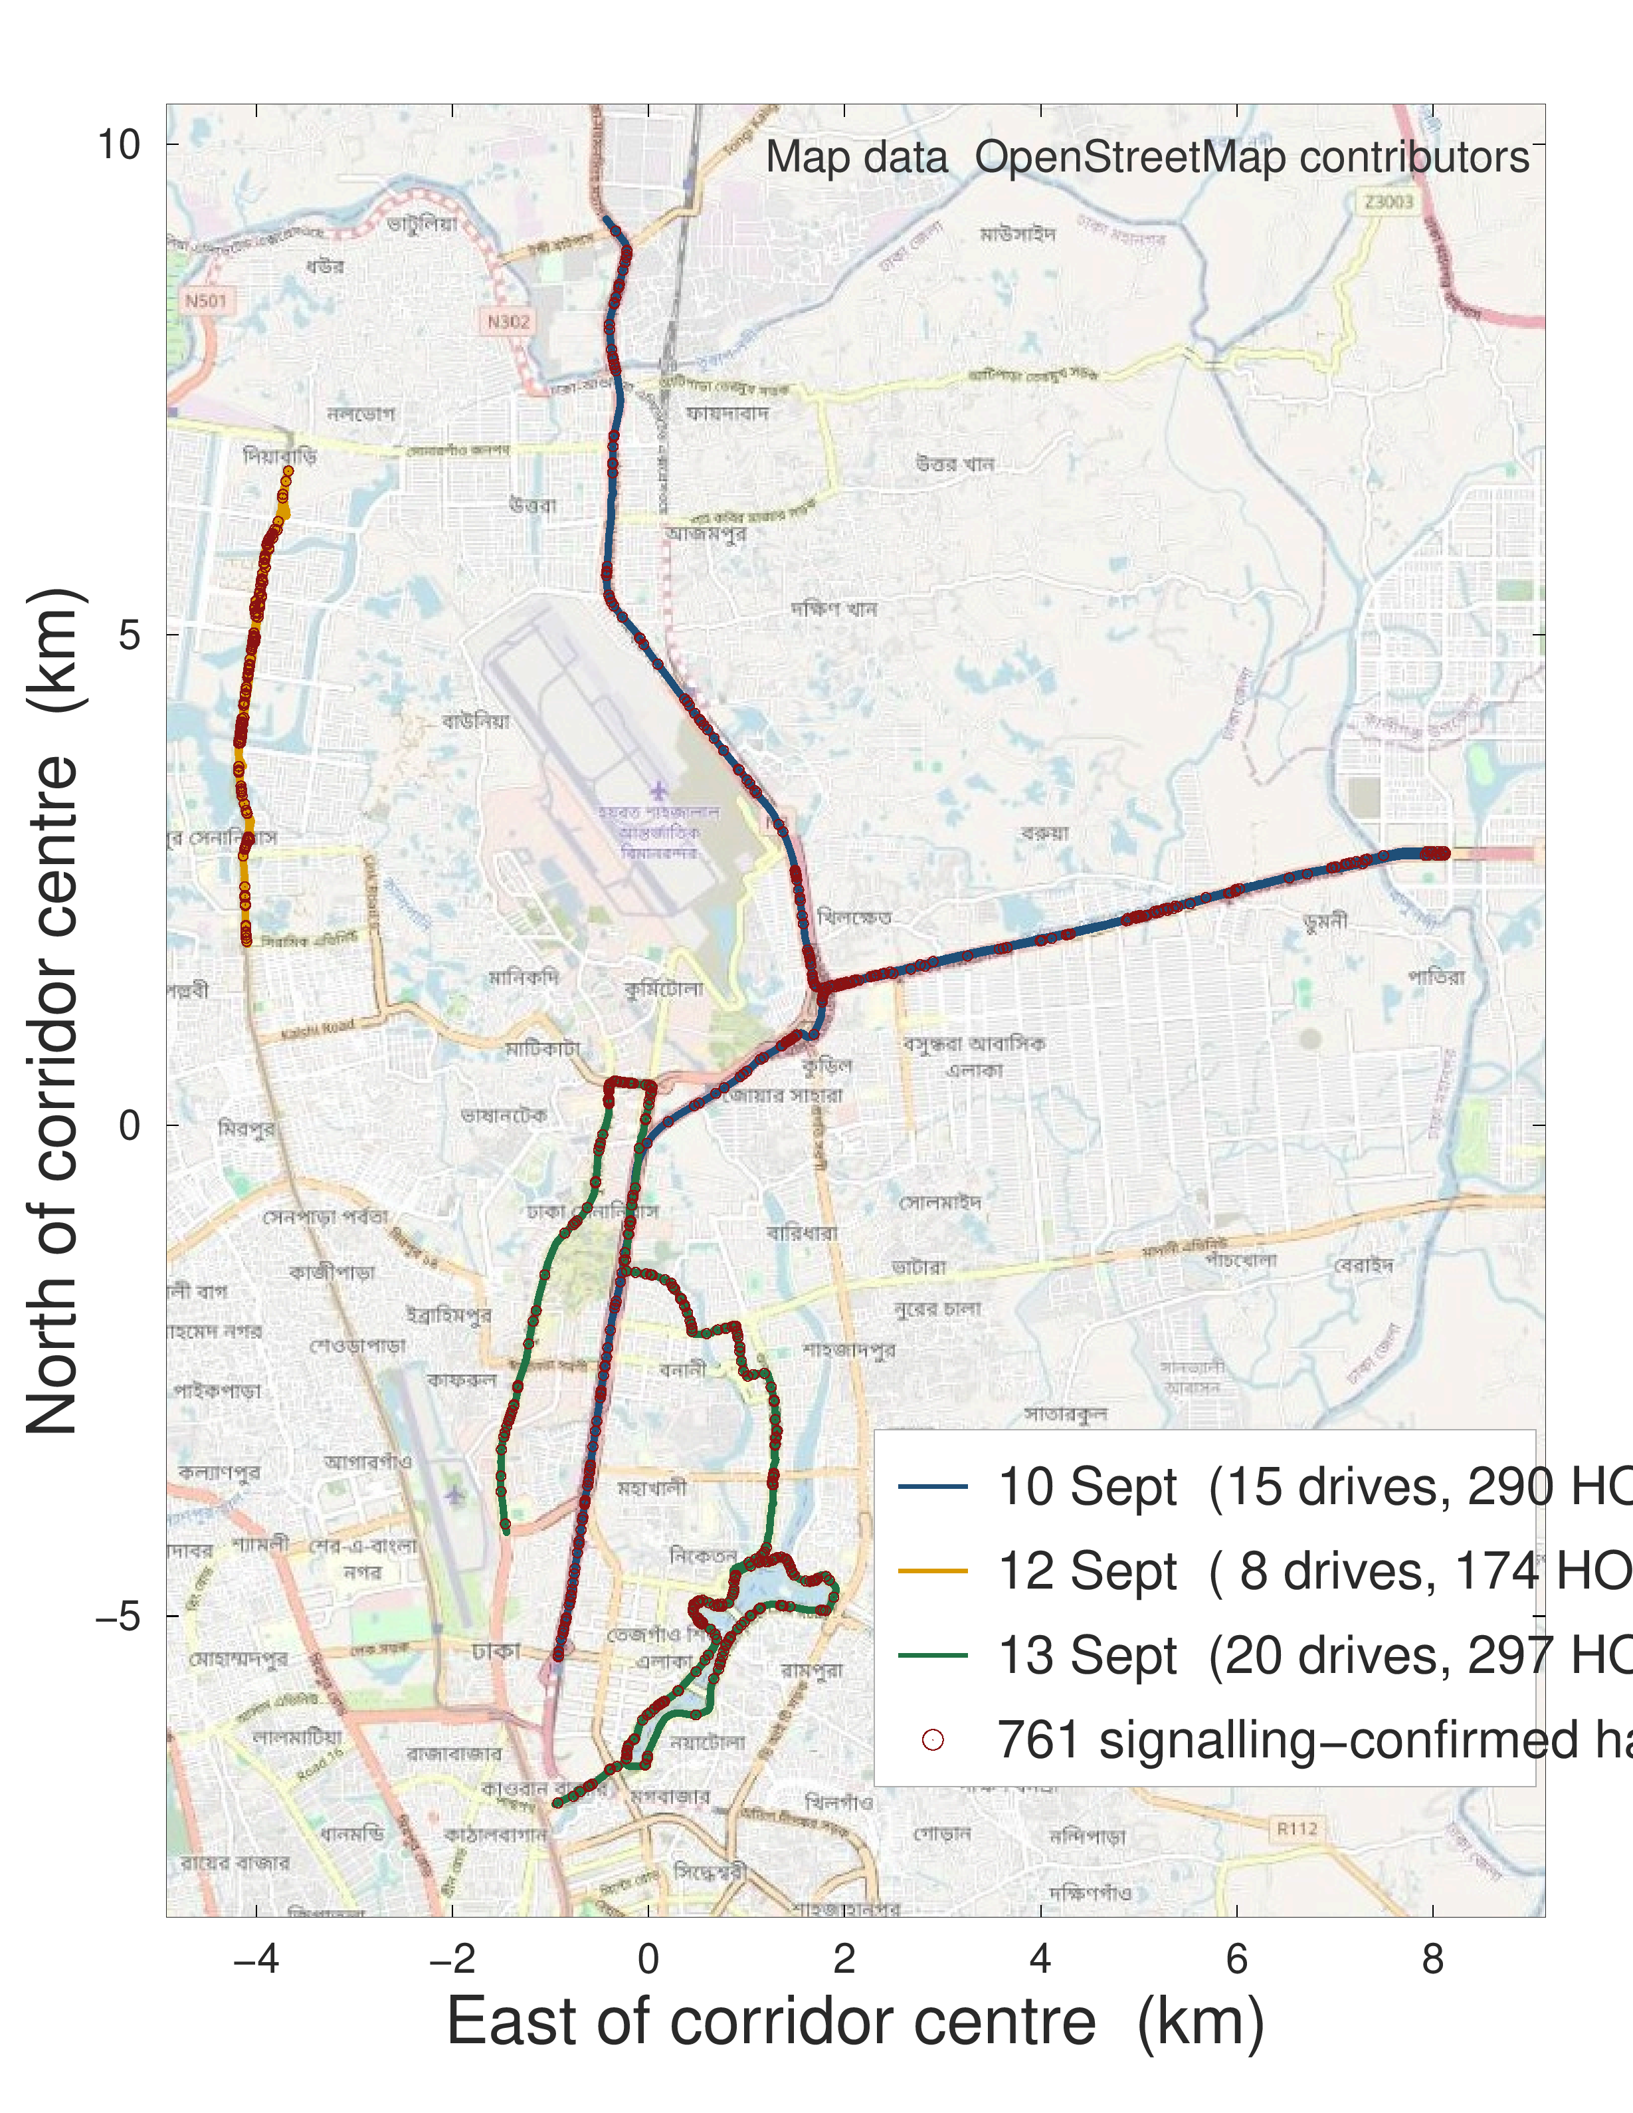
Figure 3.1 The three Dhaka campaigns on an OpenStreetMap background. Events cluster at particular junctions rather than distributing uniformly along the route. The 15 September highway campaign lies outside this extent. Map data © OpenStreetMap contributors.
The clustering visible in Figure 3.1 is the first indication that the prediction signal is partly geometric, and it is also the first argument against random-row splitting: if handovers concentrate at identifiable locations, a random split allows a model to learn those locations from the training rows and recognise them in the test rows of the same drive.
The fourth campaign occupies a particular position in the experimental design. It was driven after the modelling decisions of the first three campaigns had been recorded — the feature set, the formulation, the model family and the evaluation protocol — and it is the only campaign that differs in both corridor and speed regime, so it is reported as a held-out campaign throughout. Two qualifications are stated here rather than left for a reader to find. The freeze was recorded in the project's own version history between 13 and 15 September 2026, not registered with a third party, so it is auditable but not independently timestamped. And the alignment audit of Section 5.1, which is the single largest change in this work, was performed after all four campaigns, so no campaign is out of sample with respect to it.

3.3 Signalling decoding and the configuration timeline

3.3.1 The attribution chain
Resolving a measurement report to the event that triggered it requires a chain of three objects defined in TS 36.331 [1]. A MeasurementReport carries a measId. The measId binds, through measIdToAddModList, a measurement object — which specifies the carrier frequency being measured — to a report configuration, which specifies the triggering event and its parameters. To determine that a given report is an A3 report, and the offset and time-to-trigger under which it fired, that chain must be followed.

3.3.2 Why a flat parse is wrong
The difficulty is that the configuration does not arrive as a single object. It is delivered incrementally across many RRCConnectionReconfiguration messages, with entries added, modified and removed over the lifetime of a connection. The bindings are held in the UE's VarMeasConfig and persist until modified or removed; they are not scoped to the message that carries them, as an earlier draft of this work stated. What is scoped to a message is the fragment, and a parser that resolves reports against the union of all fragments inherits every binding a message ever carried.
Applied to this dataset, such a flat parse classified 99.4 % of all measurement reports as Event A3, including reports transmitted when no neighbour cell was present in the measurement export at all. Since Event A3 is defined on a neighbour quantity, a report attributed to A3 in the absence of any neighbour cannot be correct, and it was this impossible consequence that exposed the error. Correcting it is a bug fix rather than a contribution, and it is reported here as part of the method.

3.3.3 The timeline
The correction is to replay VarMeasConfig as a timeline: every fragment is timestamped and applied in order, so that for any instant t the exact set of bindings in force at t is available, and each MeasurementReport is resolved against the state at its own timestamp. Three elements of TS 36.331 that a first implementation of this replay omitted are applied here: the removal lists (measIdToRemoveList, reportConfigToRemoveList and measObjectToRemoveList, which account for 15,100 measId removals across the four logs, and where removing a report configuration or a measurement object removes every measId that links to it); the measId swap that clause 5.5.6.1 requires on an inter-frequency handover, which applies 187 times here; and the release of the whole configuration when the UE leaves RRC_CONNECTED, which occurs 56 times. Applying them changes the event type assigned to 18% of reports relative to the earlier replay, and every signalling quantity in Chapter 5 is computed after the correction.
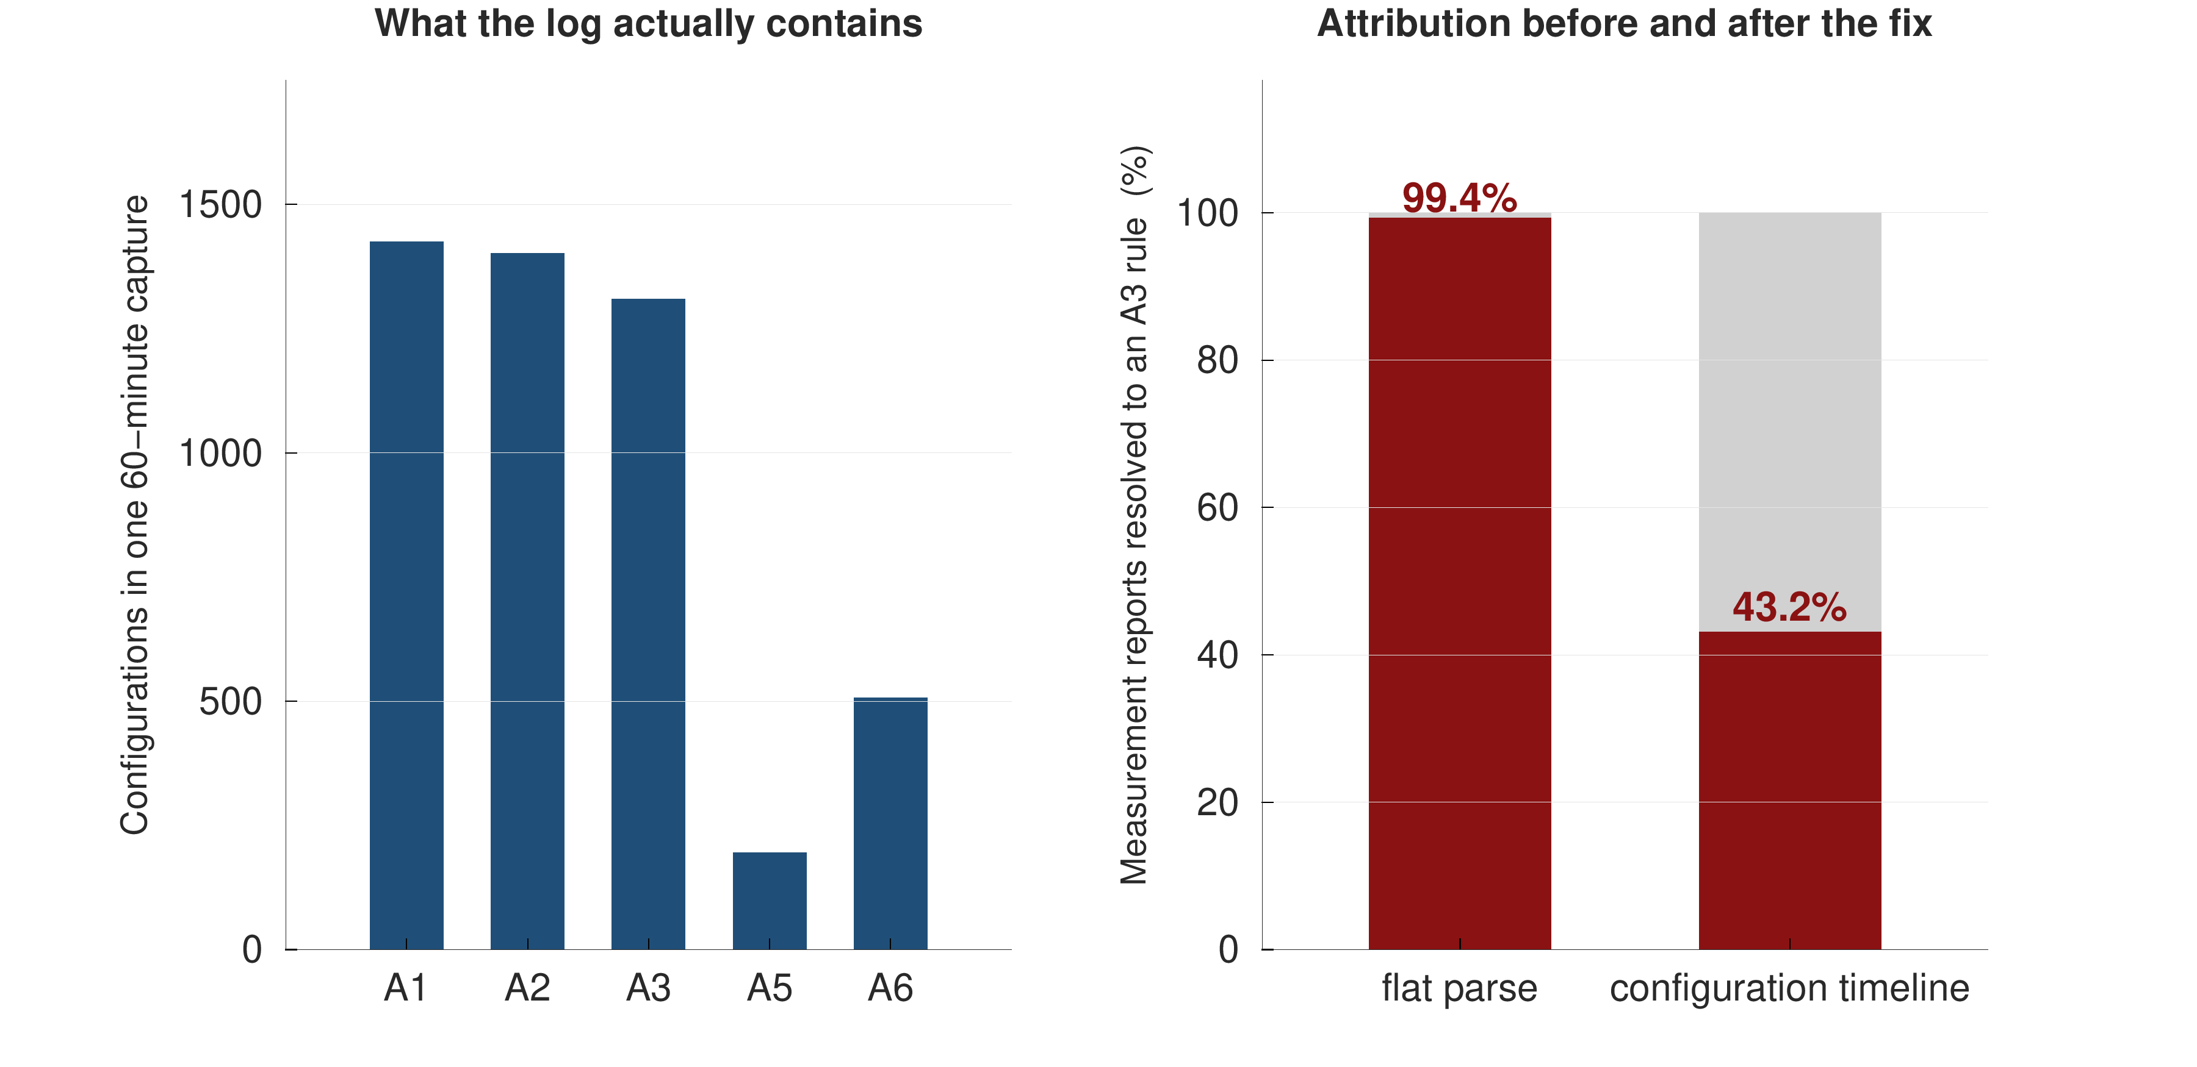
Figure 3.2 Measurement identifiers persist in VarMeasConfig until they are modified or removed. A flat parse resolves every report against the union of all configuration fragments; the timeline replays additions, modifications and removals in order and resolves each report against the configuration in force at its own timestamp.
After the correction, between 39% and 45% of measurement reports resolve to Event A3, depending on the campaign, with the remainder distributed across A1, A2, A4, A5, A6 and periodic reporting. Every quantity reported in this thesis that depends on report classification — most importantly the report-conversion rate of Section 5.9 — is computed after the correction, and no pre-correction figure is quoted anywhere.

3.4 Drive segmentation and quality control
Continuous logging produces one long record per campaign. For analysis that record is cut into fixed 180-second blocks, and a block is retained if it carries a valid serving-cell attachment for at least sixty seconds of unbroken sample grid. This is a bookkeeping device and not a mobility unit: adjacent blocks of one campaign are contiguous in time and share cells, traffic and trajectory, so they are not independent of one another. Section 4.9 draws the evaluation consequence, and Section 5.3 measures what treating them as independent is worth. The four campaigns are 4 sessions, which is the number of genuinely independent units in this dataset; the 57 blocks are used for interval estimation within a campaign, never as if they were separate drives.
Segmentation and quality control reduce the raw handover count from 957 commands to 938 that fall inside a retained block. Both counts are reported wherever a handover count appears: the event-level analyses of Sections 5.9 and 5.10 use all 957 commands, since the event stream does not depend on whether a sample row survived quality control, and the modelling of Sections 5.2 to 5.8 uses the 8,586 sample rows that carry a full five-second follow-up window and lie outside the two-second post-handover blank.
Both counts are reported here because both are correct under their own definitions, and the distinction is stated explicitly wherever a handover count appears in this thesis. Every model reported in Chapter 5 is trained and scored against the 938 events that fall inside quality-controlled drives. The 957 figure is used only where the raw event stream is the appropriate object, which in this thesis occurs in exactly one place: the ungrouped variant of the ping-pong definition ladder in Section 5.9.

3.5 The deployed configuration
Replaying the configuration timeline across all four campaigns recovers the operator's deployed mobility parameters. Table 3.1 reports them in two ways: as the set of configurations present in the signalling, and weighted by the handovers each actually produced.
Table 3.1 Deployed Event A3 configuration recovered from RRC signalling, weighted by the handovers each profile produced.
Event A3 profile (offset, hysteresis, time-to-trigger) | Handovers attributed | Share of all handovers
+1 dB, Hys 1 dB, TTT 320 ms | 472 | 49.3 %
-10 dB, Hys 2 dB, TTT 640 ms | 108 | 11.3 %
-15 dB, Hys 1 dB, TTT 160 ms | 45 | 4.7 %
+2 dB, Hys 1 dB, TTT 320 ms | 12 | 1.3 %
-6.5 dB, Hys 2 dB, TTT 640 ms | 6 | 0.6 %
-15 dB, Hys 1 dB, TTT 320 ms | 5 | 0.5 %
triggered by A5 instead of A3 | 79 | 8.3 %
triggered by A4 instead of A3 | 66 | 6.9 %
triggered by A1 instead of A3 | 51 | 5.3 %
triggered by A6 instead of A3 | 33 | 3.4 %
triggered by none in 2 s instead of A3 | 30 | 3.1 %
A3-triggered handovers under a positive offset | 651 A3 total | 74.8 % of A3

Two features of Table 3.1 are worth comment, and the second corrects an earlier reading of the same data. First, the configuration set is stable across all four campaigns, which is what makes the leave-one-campaign-out experiment of Section 5.6 a test of corridor and speed rather than of configuration. Second, although negative offsets are present and are unusual against the +6 to +10 dB reported by Ghoshal et al. [4], they are not the offsets under which this network hands over: weighting by handovers, 75% of A3-triggered commands follow a report sent under the +1 dB profile with a 320 ms time-to-trigger and 1 dB hysteresis. The negative-offset configurations are re-reporting configurations — long report intervals, mostly unconverted episodes — and are better read as neighbour-monitoring than as a mobility trigger.
The practical consequence for the prediction literature is therefore narrower than an earlier draft of this work claimed, and it is stated in its corrected form: a study that assumes a textbook +3 dB offset assumes the right sign on this network but the wrong magnitude, and a study that reads the configuration table without weighting by handovers can conclude the opposite of what the network does.
Figure 3.3 makes the same point graphically: the profile that produces almost half of all handovers is not the profile whose entry condition is satisfied most often, so whether the gap condition holds is a weak indicator of whether a handover is imminent.
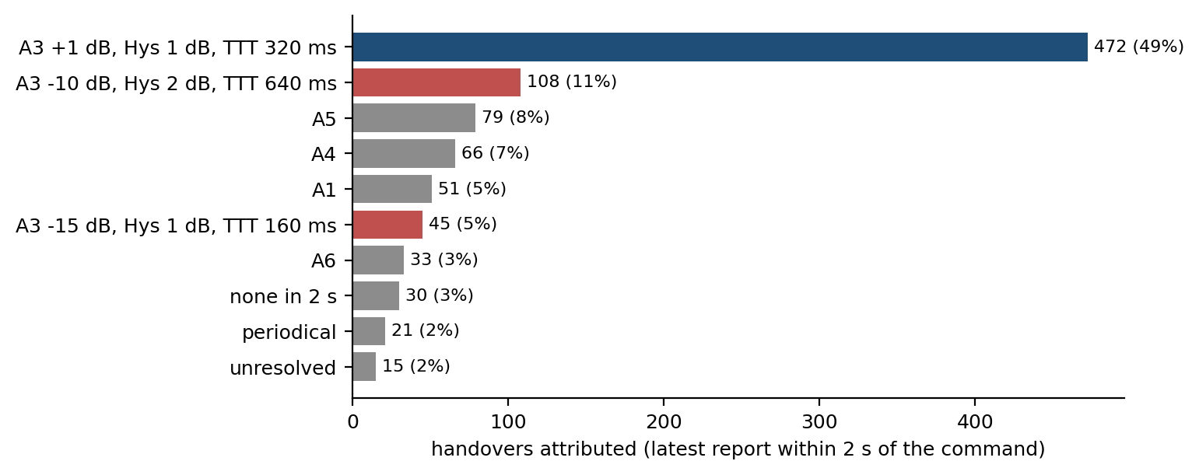
Figure 3.3 Handovers attributed to each configuration profile, weighted by the handovers each actually produced rather than by the number of configurations present. Blue bars are positive-offset A3 profiles, red bars negative-offset A3 profiles, grey bars other events.

3.6 The dataset
Table 3.2 summarises the resulting dataset.
Table 3.2 The four measurement campaigns after quality control.
Campaign (2026) | Sessions | 180 s blocks | Samples | Usable rows | Handover commands | Re-establishments | Duration | Mean speed
10 Sept (urban arterial) | 1 | 15 | 2,700 | 2,178 | 307 | 113 | 45 min | 39.1 km/h
12 Sept (urban loop) | 1 | 8 | 1,440 | 1,131 | 176 | 64 | 24 min | 25.0 km/h
13 Sept (dense urban) | 1 | 20 | 3,600 | 3,072 | 297 | 159 | 60 min | 21.4 km/h
15 Sept (highway) | 1 | 14 | 2,520 | 2,205 | 177 | 5 | 42 min | 50.9 km/h
Pooled | 4 | 57 | 10,260 | 8,586 | 957 | 341 | 2.9 h | —

The pooled dataset covers approximately 78 km of driving. A handover command is issued on average once every 11 seconds, with a median inter-command gap of 3.7 seconds. Alongside the 957 commands, the signalling log records 341 RRC connection re-establishment procedures. Their causes matter and were decoded: 321 carry reconfigurationFailure, 17 otherFailure and 3 handoverFailure, and the median re-establishment occurs 8 seconds after the previous handover command. These are predominantly failures to apply a reconfiguration rather than radio link failures during mobility, and they are treated as a competing event in Section 5.8 rather than as a motivating statistic. Figure 3.4 shows the distribution of samples and events across the campaigns.
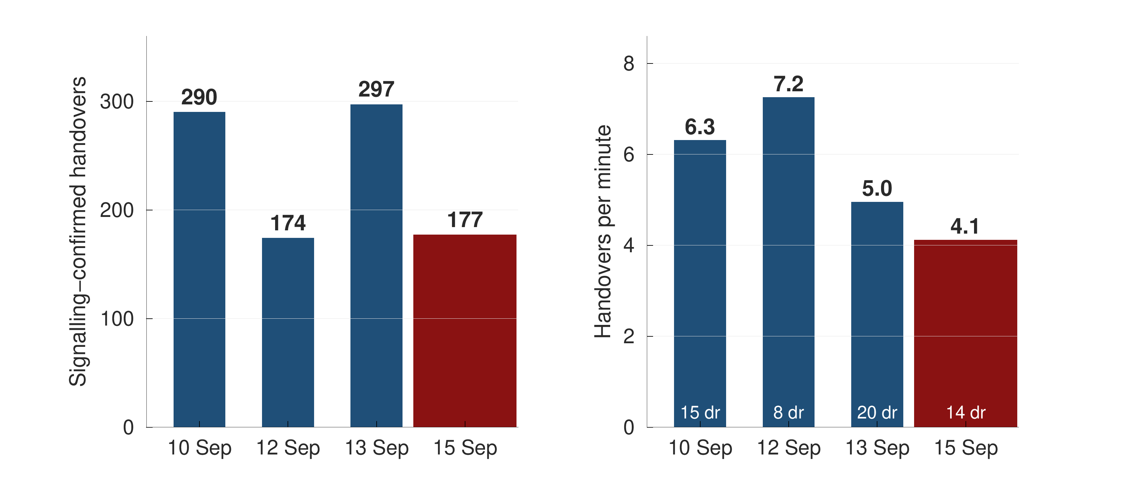
Figure 3.4 Composition of the pooled dataset. The four campaigns differ in duration and in event density; the highway campaign contributes the fewest handovers per minute and the highest mean speed.
Three properties of this dataset bound what can be claimed from it, and they are stated here rather than in the conclusion.
The dataset is small by machine-learning standards and ordinary by drive-test standards. Four campaigns give four independent units; the 57 blocks into which they are cut are not independent, and Section 5.3 measures the difference. Four units is enough to hold one out at a time and to see whether a result survives, and too few for any paired test over units to reach a small p-value: with four paired observations the smallest attainable two-sided sign-test p-value is 0.125, and this thesis reports effect sizes and per-campaign spreads rather than significance claims.
The sampling rate caps event resolution and, more importantly, fixes the information cut-off. At one sample per second the earliest usable evidence for a handover at time tau is the row closing at or before the prediction instant; Section 5.1 shows what happens when that is not enforced. The fraction of events that have at least one usable row inside the one-second window before them is 64.6%, and event-level detection figures are reported against that ceiling rather than against 100 %.
The dataset covers one operator and four days. The configuration in Table 3.1 is one operator's configuration, and the independent collection used in Section 5.7 is on the same operator, same city and same instrument, so it tests collection and route rather than network.
CHAPTER 4

PREDICTIVE FORMULATION AND SYSTEM DESIGN

This chapter develops the predictive system. Section 4.1 formalises the task and fixes notation. Section 4.2 presents the obvious formulation, the independent multi-horizon classifier, and shows why it is structurally defective. Section 4.3 presents the discrete-time survival formulation adopted in its place, and Section 4.4 gives its likelihood under censoring. Section 4.5 explains why class reweighting, the standard reflex on a rare-event task, is inadmissible under this formulation. Sections 4.6 and 4.7 describe the features and the models. Section 4.8 describes calibration, Section 4.9 the evaluation protocol, Section 4.10 the risk-control procedure, and Section 4.11 the point-process analysis used to characterise handover clustering.
Each modelling subsection is presented in the same order: the problem that motivates the component, the design of the component, and the technical advantage it confers over the alternative it replaces.

4.1 Problem formalisation
Let a drive d consist of samples indexed by t on a uniform one-second grid. At each sample the handset observes a feature vector x_{t} constructed from measurements available at or before t. Let T_{t} denote the time remaining from t until the next handover command on the same drive.
The task is to estimate, for a set of horizons h₁ &lt; h₂ &lt; … &lt; h_{K}, the cumulative incidence
F_k(x_t) = P( T_t ≤ h_k │ x_t ), k = 1 … K (4.1)
with K = 5 and horizons of 0.5, 1, 2, 3 and 5 seconds. Samples for which the drive ends before the next handover occurs are right-censored: the event is known not to have occurred within the observed window, but its eventual time is unknown. Right censoring is not a nuisance to be discarded here; the last samples of every drive are censored, and discarding them would both waste data and bias the observed event-time distribution towards short intervals.
Table 4.1 reports the resulting positive-class prevalence at each horizon, computed on the row set used for every experiment in this thesis: rows with a full five-second follow-up window inside their own campaign and outside the two-second post-handover blank. Using one row set for all five horizons is what makes the prevalence table of Table 4.1 and the hazard table of Table 4.2 two views of the same numbers.
Table 4.1 Positive-class prevalence by horizon on the common row set, and the accuracy obtained by a constant negative prediction.
Horizon | Prevalence | Accuracy of a constant “no handover”
0.5 s | 3.7 % | 96.3 %
1 s | 6.8 % | 93.2 %
2 s | 12.6 % | 87.4 %
3 s | 17.6 % | 82.4 %
5 s | 26.1 % | 73.9 %

Table 4.1 is the reason accuracy is not reported anywhere in this thesis. At the one-second horizon a model that never predicts a handover already scores 93.2%, which exceeds several of the headline accuracies reported in the audited literature of Section 2.3.

4.2 The multi-horizon binary formulation and its defect
Motivation. The most direct approach to Equation (4.1) is to define, for each horizon, a binary label y_{t,k} = 1{ T_{t} ≤ h_{k} } and fit K independent classifiers. This is the formulation implied by every model in the audit of Section 2.3 that predicts at more than one horizon, and it requires no special machinery.
The defect. The K classifiers are fitted independently and are therefore free to produce estimates that violate the ordering implied by their own definitions. Because the event { T_t ≤ h1 } is contained in { T_t ≤ h2 } whenever h1 < h2, the probabilities must satisfy F1 ≤ F2 ≤ … ≤ FK at every sample. Independent fits do not enforce this, and Section 5.4 measures how often they violate it: on 40.2% of rows.
A violation is not a small numerical irregularity. It is an assertion that a handover is more likely within one second than within three, which is impossible, and it destroys the interpretation of the output as a probability. An operator presented with such a pair of numbers cannot act on either.
Why post-hoc repair is not free, and where it is. The defect can be repaired after the fact by projecting the K outputs onto the monotone cone — a per-row cumulative maximum, or the pool-adjacent-violators projection — or by calibrating each horizon separately with isotonic regression. All three are implemented and reported in Section 5.4 as controls, and the first two need no held-out split and reach zero violations by construction, exactly as the hazard formulation does. The case for the hazard formulation is therefore not that it alone achieves coherence; it is that it achieves coherence from one fit rather than five, inherits the censoring treatment of Section 4.4, and — as Section 5.4 measures — calibrates better than the projected controls at the horizons where the output is usable as a probability.

4.3 The discrete-time survival formulation
Motivation. The ordering constraint is a consequence of the definition of cumulative incidence, so the natural remedy is to estimate a quantity from which ordering follows automatically, rather than to estimate the ordered quantities directly and repair them.
Design. Partition the time axis into K bins whose upper edges are exactly the horizons of interest:
B_1 = (0, h_1], B_2 = (h_1, h_2], …, B_K = (h_{K−1}, h_K]
and define the discrete-time hazard as the probability that the event falls in bin k given that it has not occurred by the start of that bin:
λ_k(x) = P( T ∈ B_k │ T > h_{k−1}, x ) (4.2)
The survival function is the product of per-bin survivals,
S_k(x) = Π_{j=1..k} ( 1 − λ_j(x) ) = P( T > h_k │ x ) (4.3)
and the cumulative incidence required by Equation (4.1) is its complement, which is the product-limit identity:
F_k(x) = P( T ≤ h_k │ x ) = 1 − Π_{j=1..k} ( 1 − λ_j(x) ) (4.4)
Technical advantage. Monotonicity is now a theorem rather than a hope. Since λ_{j} ∈ [0,1], every factor (1 − λ_{j}) lies in [0,1], so
S_{k+1} = S_k · ( 1 − λ_{k+1} ) ≤ S_k ⟹ F_{k+1} ≥ F_k (4.5)
The argument uses no property of the learner beyond the range of its output. Any model that emits a value in [0,1] per bin produces a coherent set of horizon probabilities under Equation (4.4). This is why the coherence result reported in Section 5.4 is learner-independent while the calibration result is not, and it is the single most important structural property of the system developed here.
Figure 4.1 illustrates the two formulations side by side.
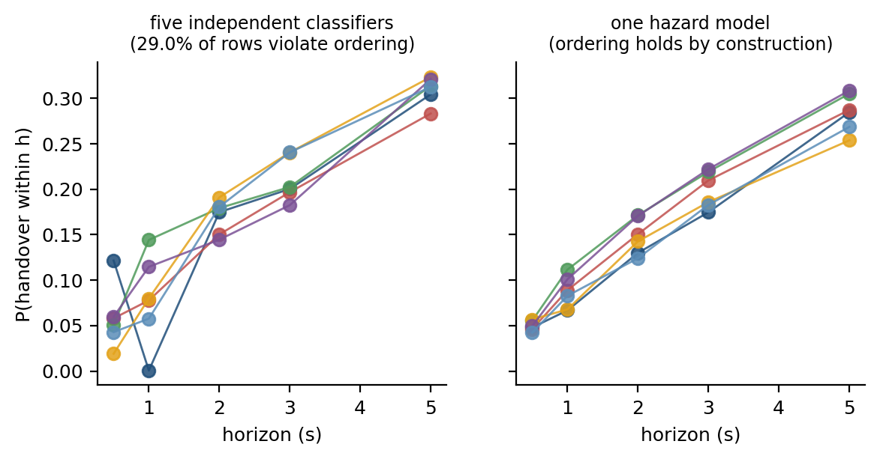
Figure 4.1 illustrates the two formulations side by side.

4.4 The likelihood under censoring
Let k_{t} be the bin in which the event occurs for sample t, and let c_{t} be the last bin fully survived before censoring. Define the at-risk set R_{t} = {1 … min(k_{t}, c_{t})} — the bins the sample actually entered — and the per-bin indicator z_{t,k} = 1{ k = k_{t} }. The discrete-time survival log-likelihood then collapses into a single expression covering both the censored and uncensored cases:
ℓ = Σ_t Σ_{k ∈ R_t} [ z_{t,k} log λ_k(x_t) + (1 − z_{t,k}) log(1 − λ_k(x_t)) ] (4.6)
Equation (4.6) is exactly a binary cross-entropy over the expanded set of (sample × at-risk bin) pairs. The practical consequence is that fitting a discrete-time survival model requires no specialised software: the data are expanded from wide to long format, the bin index k is appended as a feature so that the model can learn the shape of the baseline hazard, and a single binary classifier is fitted. A censored sample contributes a (1 − λ_{k}) term for every bin it survived rather than being discarded.
On this dataset the expansion takes the 8,586 usable rows to 39,435 (sample, bin) pairs. Because every retained row carries a full five-second follow-up window inside its own campaign, no row is censored inside the horizon grid, and the measured per-bin hazards chain exactly to the prevalences of Table 4.1 by Equation (4.4). Table 4.2 reports both, side by side, as an arithmetic check on the implementation.
Table 4.2 Measured discrete-time hazard by bin, and the cumulative incidence it implies, against the prevalence of Table 4.1. The two agree exactly by construction.
Bin | Interval | At risk | Events | Hazard | F(h) from hazards | Prevalence (Table 4.1)
1 | (0, 0.5] s | 8,586 | 319 | 0.0372 | 0.0372 | 0.0372
2 | (0.5, 1] s | 8,267 | 264 | 0.0319 | 0.0679 | 0.0679
3 | (1, 2] s | 8,003 | 497 | 0.0621 | 0.1258 | 0.1258
4 | (2, 3] s | 7,506 | 433 | 0.0577 | 0.1762 | 0.1762
5 | (3, 5] s | 7,073 | 730 | 0.1032 | 0.2612 | 0.2612

4.5 Why class reweighting is inadmissible here
The standard response to a rare-event task is to reweight the positive class, for example through the scale_pos_weight parameter of a gradient-boosting implementation. That response must not be used in the hazard arm, for a reason specific to Equation (4.4).
Reweighting the positive class by a factor w transforms the fitted probability monotonically,
λ̃ = w λ / ( w λ + (1 − λ) ) (4.7)
Ranking metrics are invariant under this transformation, since AUPRC and AUROC depend only on the order of scores. The probability scale, however, is not. Writing the reweighted hazards as λ̃_k ≈ w λ_k for small λ_k, the survival function is transformed as
S̃_k = Π_j (1 − w λ_j) ≈ (S_k)^w, so F̃_k ≈ 1 − (1 − F_k)^w (4.8)
Equation (4.8) replaces a compounding claim made in an earlier draft of this work, which stated that a per-bin multiplicative error ε grows as (1+ε)^k with the horizon. That is not what the product-limit identity does: for small hazards the relative distortion of F_k is bounded by w and is largest at the shortest horizon, while the absolute distortion grows with F_k and is therefore largest at the longest. Either way the calibrated interpretation is destroyed while the ranking is untouched, which is the reason both the hazard arm and the independent-classifier control arm are fitted unweighted, and the fairness of the comparison between them is a secondary benefit.

4.6 Feature construction
Motivation. The system must predict from quantities a handset actually possesses at the instant of prediction. Two constraints follow: no feature may use information from the future, and no feature may use information from a different drive.
Design. The feature vector at the prediction instant t has three blocks and 112 columns in total. The radio and mobility blocks are built from the one-hertz export; the history block is built from the decoded signalling. Two rules govern their construction, and the first is the single most consequential decision in this thesis.
Alignment. An export row stamped t summarises an interval that ends after t, not before it: Section 5.1 shows that in 76% of handovers the row stamped inside the second before the handover command already carries the post-handover serving cell, against a background rate of 12% three rows earlier. Every export-derived feature is therefore lagged by one row, so that a prediction made at t uses only the row closing at or before t. Nothing else in this thesis changes as much as this does.
History from the event clock, not from the export. Time since the previous handover command, the number of commands in the previous 30 and 60 seconds, and whether the previous command was a return are computed from the decoded signalling, whose timestamps are exact to the millisecond, and over the whole continuous session rather than within a 180-second block. Computing them per block left a third of every block with a truncated history, and computing dwell time from the export's serving-cell column imports the alignment error described above: that single substitution moves the dwell feature's own AUROC from 0.873 to 0.664.
Block | Count | Source | Content
Radio | 83 | 1 Hz export, lagged one row | Serving and neighbour RSRP, RSRQ, SINR, RSSI, CQI; rolling mean, standard deviation, range, slope and first difference over 3, 5 and 10 s; serving-to-neighbour gaps
Mobility | 17 | 1 Hz export, lagged one row | GPS speed, heading change, acceleration and their rolling statistics
History | 6 | decoded signalling, session-level | Time since the previous and second-previous handover command, command counts in the previous 30 and 60 s, whether the previous command was a return
Main feature set | 112 |  | used by every learner in Sections 5.2 to 5.8
Signalling (ablation only) | 10 | decoded signalling | A3 and all-event report counts in (t−w, t], time since the last A3 report, A3 hold time, and the offset, hysteresis and time-to-trigger in force

Every rolling window is strictly backward-looking and closes at the lagged row, and window computation is performed per campaign so that no window spans a session boundary. Scalers, imputation values, thresholds and calibrators are fitted inside the training partition of each fold only.
The signalling block is reported as an ablation rather than used in the main arm. It counts measurement reports by event type in the windows (t − w, t] for w in {1, 2, 5} seconds, the time since the most recent A3 report, how long the A3 entry condition has held, and the offset, hysteresis and time-to-trigger in force. These are quantities the network itself holds at t, so using them is legitimate; they are separated out because a handset-side predictor may not have them, and because their contribution is worth reporting on its own (Section 5.8).

4.7 Models compared
Seven learners are compared under identical folds, identical seeds, the identical hazard formulation and the identical feature matrix. The last of those is a change from an earlier draft, in which the sequence models consumed raw per-second measurements while the tabular models received the engineered features and the history block; under that arrangement the comparison varied the inputs as well as the learner. Here the sequence models consume windows of the ten most recent feature vectors — the same vectors, lagged the same way — so the only thing that varies between arms is the learner.
The Event A3 rule. The deployed rule is scored as if it were a predictor, using the recovered configuration of Table 3.1 to determine when the entry condition of Equation (2.1) holds. This is the most important baseline in the thesis because it is what is presently running in the network.
Logistic regression. A regularised linear model over the 107 features, included as the simplest learner that can use the full feature set.
Gradient-boosted trees. LightGBM [30] is the primary model. It is chosen for a tabular task with heterogeneous, partly missing features of mixed scale, where axis-aligned splits and native missing-value handling are well matched to the data.
Multi-layer perceptron. A feed-forward network over the same tabular features, included to separate the contribution of non-linearity from that of temporal memory.
Sequence models. A temporal convolutional network, a Transformer encoder and a gated recurrent unit, each consuming a window of raw per-second measurements rather than the engineered summary features. These arms test whether a model that learns its own temporal representation outperforms one given hand-constructed rolling statistics.
Every arm receives the same tuning budget: twenty random-search trials per outer fold, scored on a calibration block held out of that fold's training data and separated from it by a 60-second purge. The search is therefore nested inside the evaluation, and the budget is equal by construction rather than by assertion. Section 5.2 reports the outcome.

4.8 Calibration
Ranking quality is insufficient for the task stated in Section 1.3, which requires the asserted probability to correspond to an empirical frequency. Three calibration treatments are evaluated.
Temperature scaling [31] fits a single scalar on a held-out partition, dividing the logits before the sigmoid. It is the least expressive treatment and cannot alter the ranking.
Isotonic regression [32] fits a non-decreasing step function per horizon. It is more expressive and can correct a wider class of miscalibration, but it consumes a held-out split and, applied per horizon, is free to reorder the horizons relative to one another.
The monotone projection repairs an incoherent set of horizon outputs by projecting them onto the monotone cone. It is implemented for the control arm only, since the hazard formulation makes it unnecessary.
Calibration quality is reported as the expected calibration error, computed as the weighted mean absolute difference between confidence and empirical frequency across equal-mass bins, with the Brier score reported alongside it.

4.9 Evaluation protocol
Motivation. The protocol is the component most likely to invalidate a result on data of this kind, for two reasons that are usually conflated. Adjacent one-second samples within a session are near-duplicates, so a random row split places nearly the same row on both sides of it. But 180-second blocks of one continuous session are not independent either: they share cells, traffic, weather, device state and driver. Section 5.3 measures both.
Design. The evaluation protocol has five elements, and a ladder of four splitting rules is reported rather than one.
Units. The primary protocol is leave-one-campaign-out: each of the four campaigns is held out in turn and the model is trained on the other three. A campaign is one continuous session, which is the only unit in this dataset whose independence can be defended. Figure 4.2 illustrates the ladder.
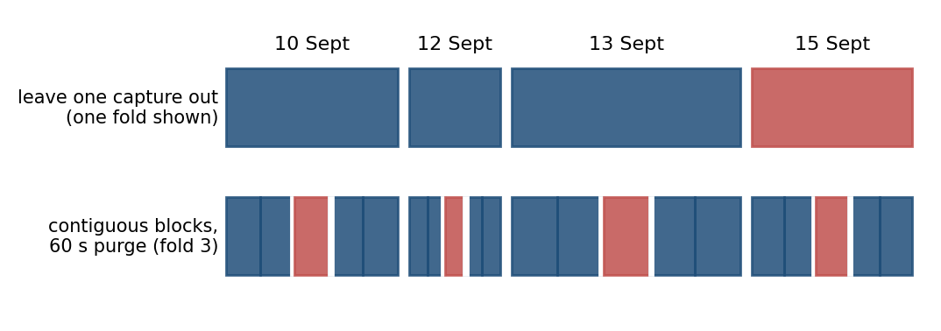
Figure 4.2 The splitting ladder. Leave-one-campaign-out holds out a whole continuous session; blocked cross-validation holds out a contiguous stretch of each session with a 60-second purge on either side; the two leaky protocols draw 180-second blocks, or rows, at random.
Secondary protocols. Three further rules are run on the same data with everything else fixed: contiguous time blocks within each campaign with a 60-second purge between train and test (the blocked cross-validation standard for temporally structured data, following the recommendation of Roberts et al. [35]); random 180-second blocks stratified by campaign, which is the protocol this work used before the audit; and random rows, which is the protocol most of the comparator literature uses. Section 5.3 reports all four.
Repetition and uncertainty. Stochastic learners are run over three seeds and their predictions averaged. Intervals on pooled out-of-fold metrics come from a bootstrap that resamples whole 180-second blocks within each campaign; that interval is conditional on these four sessions and does not include between-day variation, so the per-campaign spread is always reported beside it. Comparisons between learners are reported as per-campaign differences over four paired observations, with the exact sign-test p-value quoted only to show its own resolution limit (0.125 at best). No significance claim is made from four units.
Fold hygiene. The feature scaler, the decision threshold, the probability calibrator and the conformal threshold are fitted inside the training or calibration partition of each fold only, and the calibration partition is separated from the training partition by the same 60-second purge.
Metrics. Four families are reported. Ranking quality is reported as AUPRC, always with the prevalence floor and the lift over it, together with AUROC. Calibration is reported as expected calibration error over fifteen equal-mass bins and Brier score. Coherence is reported as the fraction of rows on which the horizon ordering is violated, with the magnitude of the violations. Event-level cost is reported as the fraction of handover commands detected, the number of false-alarm episodes per hour and per kilometre, and the distribution of lead times. Reporting all four families is deliberate: Wagner et al. [30] show that no single aggregate metric for event detection satisfies all desirable properties.

4.10 Distribution-free risk control
Motivation. A probability is not yet an operating point. Converting the model output into a warning requires a threshold, and an operator is entitled to know what that threshold guarantees on drives it has not seen.
Design. Let λ ∈ Λ index a family of alarm thresholds ordered by decreasing strictness and let R(λ) be a bounded, non-increasing risk. Conformal risk control [20] selects
λ̂ = inf { λ : ( n·R̂(λ) + B ) / ( n + 1 ) ≤ α } (4.9)
where R̂(λ) is the empirical risk over n exchangeable calibration units and B bounds the loss, here B = 1. The guarantee is that E[R_{n+1}(λ̂)] ≤ α for a fresh exchangeable unit, distribution-free, with no assumption on the model or on the data-generating process beyond exchangeability.
The exchangeable unit. The risk is defined per driving unit, not per sample: for a unit d and threshold λ,
R_d(λ) = { t ∈ d : y_t = 1 ∧ p̂_t < λ }
and R̂(λ) averages over calibration units. The choice of unit is the substantive part of the claim, and it is tested rather than asserted. Section 5.5 reports the procedure twice: once with calibration and test units drawn from the same pool of 180-second blocks, where exchangeability is plausible and the bound should hold; and once with calibration on one whole campaign and the guarantee claimed for a different campaign, where exchangeability is not plausible and the bound is not expected to hold. Reporting the second case is the point: a guarantee whose assumption fails silently is worse than no guarantee.
Technical advantage, and a design rule that follows from it. Equation (4.9) can be satisfied only if its left-hand side can reach α at all. At the most permissive threshold R̂ = 0, so the smallest attainable value is B/(n+1), giving the feasibility floor
α ≥ 1/(n+1) ⟺ n ≥ 1/α − 1 (4.11)
Equation (4.11) is a campaign-design rule and a direct corollary of the bound in [21] rather than a new result: a study that wishes to promise a 5 % miss rate needs at least 19 calibration units and one promising 2 % needs 49, whatever the model does. With the 14 calibration blocks available in a held-out campaign here, the tightest expressible target is α ≥ 0.067. The rule is worth stating in a mobility context because campaign size is the binding constraint on what such a study can promise, and because it converts a modelling question into a data-collection question.

4.11 Point-process analysis of handover arrivals
Motivation. The ping-pong behaviour of Section 5.9 suggests that handovers do not arrive independently. Quantifying that clustering requires a model of the arrival process itself rather than of the per-sample probability.
Design. The handover arrival stream on each drive is modelled as a self-exciting Hawkes process [21], [22] with conditional intensity
μ(t) = μ_0 + Σ_{t_i < t} α · exp( −β ( t − t_i ) ) (4.12)
in which each arrival raises the intensity of subsequent arrivals by α and the excitation decays at rate β. The branching ratio α/β is the expected number of direct offspring per event and summarises the strength of the clustering.
Validation. A fit alone is not evidence of self-excitation. Following the networking precedent of Price-Williams and Heard [24], the fit is validated by the residual analysis of Ogata [23]: the time axis is rescaled by the fitted compensator, and the transformed inter-arrival times are tested against a unit-rate exponential distribution by a Kolmogorov–Smirnov test on held-out drives. Section 5.10 reports both the branching ratio and the outcome of that test, including the respect in which the test rejects the fitted kernel.
CHAPTER 5

RESULTS AND DISCUSSION

This chapter reports what the system of Chapter 4 achieves on the data of Chapter 3. Section 5.1 reports the alignment audit, because every number after it depends on the audit's outcome. Section 5.2 reports the primary prediction result and Section 5.3 the protocol ladder. Sections 5.4 and 5.5 report coherence, calibration and risk control. Sections 5.6 and 5.7 report generalisation across campaigns and to an independent collection. Section 5.8 reports what the model uses and where it works, Section 5.9 and 5.10 the two network characterisations, Section 5.11 the negative results, Section 5.12 the discussion against the objectives and Section 5.13 the threats to validity.
All figures in this chapter are computed out of fold under the leave-one-campaign-out protocol of Section 4.9 unless stated otherwise, from features lagged as described in Section 4.6.

5.1 The alignment audit and what it costs
The first result of this chapter is not a prediction score. It is a property of the measurement export that determines what any prediction score on this data means.
Table 5.1 The alignment audit: share of handovers whose target cell already serves in export rows around the command.
Handovers considered | n | row t-3 | row t-2 | row t-1 | row t+0 | row t+1
all handovers | 938 | 23.7 % | 21.7 % | 15.6 % | 75.9 % | 86.2 %
isolated (previous > 8 s earlier) | 291 | 12.1 % | 12.1 % | 11.7 % | 74.6 % | 89.7 %
Table 5.2 What the one-row lag costs, with everything else held fixed.
Feature alignment | AUPRC 1 s | AUROC 1 s | AUPRC 5 s | Dwell feature AUROC 1 s
Export row stamped t used at t (v1) | 0.600 | 0.911 | 0.560 | 0.873
Export row lagged one sample (this work) | 0.179 | 0.777 | 0.475 | 0.664
Change | -70 % | -0.134 | -15 %

The audit is simple. For each handover command at time tau, take the export row whose second contains tau — that is, the row stamped at floor(tau), strictly before the command — and ask whether its serving-cell identity is already the target of that command. If the row summarises the second before its timestamp, the answer should be no more often than chance.
Table 5.1 and Figure 5.1 report the answer. Across all 938 handovers inside retained blocks the row stamped before the command already carries the target cell 75.9% of the time, and for handovers isolated from any other handover by more than eight seconds the figure is 74.6%. One row earlier the figure falls to 11.7% for isolated handovers, which is the background rate given by rows three seconds earlier (12.1%). The export row stamped t therefore describes the state at approximately t + 1: it is a window that closes after its own timestamp.
The consequence for prediction is immediate. A model asked at time t for the probability of a handover in (t, t + 1] and given the row stamped t is being shown, most of the time, the answer. Table 5.2 quantifies it on the same model, the same folds and the same features: the one-second AUPRC falls from 0.600 to 0.179 and AUROC from 0.911 to 0.777 when every export feature is lagged one row. At five seconds, where one second of misalignment matters less, the same change costs 0.560 to 0.475. The single-feature effect is starker: serving dwell time computed from the export's serving-cell column reaches AUROC 0.873 on its own, and the same quantity computed from signalling timestamps reaches 0.664.
Three points are worth stating plainly. First, this is not a defect of the instrument: a one-hertz export has to summarise a second, and XCAL is not obliged to stamp that second at its end. It is a defect of any analysis that assumes the opposite without checking. Second, the error is invisible to every check that does not involve the event clock — the features are causal in appearance, no future label is used, and grouped splitting does not remove it, because the leak is inside the row rather than between rows. Third, it is cheap to detect, and the audit above is the recommendation this thesis makes to anyone building a predictor on a drive-test export.
The obvious question is whether this is a property of drive-test exports in general or of this one. It is testable, and the test was run on an independent public dataset: the 4G/5G Irish drive-test traces of Raca et al. [37], 60 driving traces logged at one hertz with a different tool (G-NetTrack Pro) on a different operator, carrying serving cell identity, radio, GPS and speed. That dataset has no signalling, so the event clock is the serving-cell column itself and the audit takes a different form: at each serving-cell change between t and t + 1, is the radio reported on row t closer to the level the new cell settles at, or to the level the old cell had?
It is closer to the old cell. Table A.3 reports the comparison: 29.4% of 1,175 cell changes have row t looking like the new cell, against 75.9% of handovers in our export. The prediction test agrees. Predicting a serving-cell change one second ahead on that dataset, using the row stamped t rather than the row before it is worth +38 % AUPRC — but the step from t − 2 to t − 1 is worth +57 %, a larger gain. A contaminated final row shows up as an anomalous jump at the last step; a clean log shows the smooth decay with staleness that this dataset has. Its rows are aligned the way an analyst would assume.
Two conclusions follow, and the second is the one worth carrying. The alignment error is a property of an export, not of drive testing: one commercial tool has it and another does not. And precisely because the two answers differ, the alignment cannot be assumed either way — it has to be checked, per dataset, before anything is trained. None of the 22 models audited in Section 2.3 reports such a check, and neither did the first version of this work.
Everything reported after this section uses the lagged features. The unlagged numbers are retained in Table 5.2 and in the ablation of Section 5.11 as a measurement of the effect, never as a result.
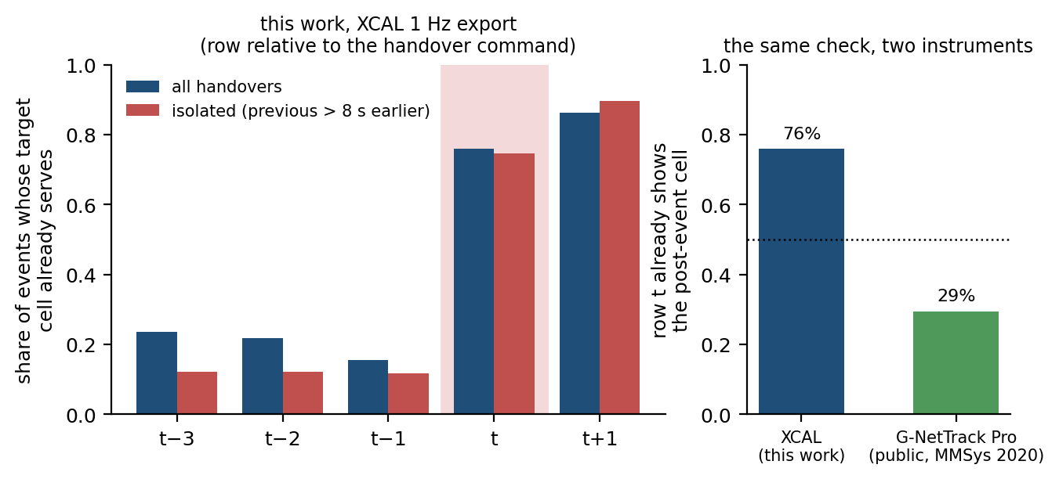
Figure 5.1 The alignment audit. Left: share of handovers whose target cell is already the serving cell in the export rows around the row whose second contains the handover command (t). Right: the same check on an independent public drive-test dataset logged with a different tool, where the row is not contaminated.
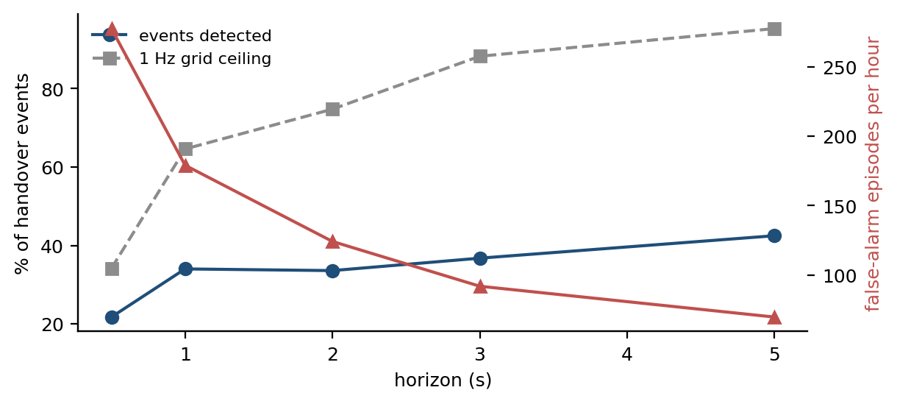
Figure 5.2 Event-level cost of the warning at the 5 % false-positive operating point: share of handover commands detected against the 1 Hz grid ceiling, with the false-alarm episode rate per hour on the right axis.

5.2 The primary prediction result
Table 5.3 reports the performance of the primary model, LightGBM under the hazard formulation, at all five horizons, out of fold under leave-one-campaign-out.
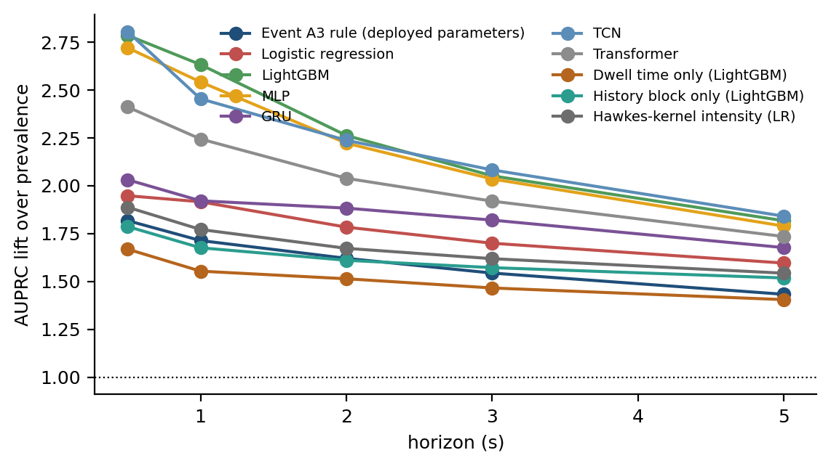
Figure 5.3 AUPRC lift over the prevalence floor by horizon for every learner, out of fold under leave-one-campaign-out. A lift of one is the floor itself.
Table 5.3 Out-of-fold performance of LightGBM under the hazard formulation, leave-one-campaign-out. Intervals are block-bootstrapped over 180 s blocks and are conditional on these four sessions.
Horizon | Prevalence | AUPRC [95 % block-bootstrap CI] | Lift | AUROC | ECE | Brier
0.5 s | 0.037 | 0.103 [0.086, 0.133] | 2.8× | 0.777 | 0.006 | 0.035
1 s | 0.068 | 0.179 [0.159, 0.204] | 2.6× | 0.777 | 0.012 | 0.060
2 s | 0.126 | 0.285 [0.254, 0.320] | 2.3× | 0.760 | 0.016 | 0.101
3 s | 0.176 | 0.362 [0.323, 0.403] | 2.1× | 0.751 | 0.026 | 0.132
5 s | 0.261 | 0.475 [0.428, 0.524] | 1.8× | 0.741 | 0.044 | 0.171
Table 5.4 Every learner under identical folds, features, formulation and tuning budget.
Learner | AUPRC 1 s | Lift 1 s | AUROC 1 s | AUPRC 5 s | Lift 5 s
LightGBM | 0.179 | 2.6× | 0.777 | 0.475 | 1.8×
MLP | 0.173 | 2.5× | 0.755 | 0.467 | 1.8×
TCN | 0.167 | 2.5× | 0.755 | 0.481 | 1.8×
Transformer | 0.152 | 2.2× | 0.728 | 0.453 | 1.7×
GRU | 0.130 | 1.9× | 0.710 | 0.438 | 1.7×
Logistic regression | 0.130 | 1.9× | 0.671 | 0.417 | 1.6×
Hawkes-kernel intensity (LR) | 0.120 | 1.8× | 0.666 | 0.403 | 1.5×
Event A3 rule (deployed parameters) | 0.116 | 1.7× | 0.689 | 0.374 | 1.4×
History block only (LightGBM) | 0.114 | 1.7× | 0.652 | 0.397 | 1.5×
Dwell time only (LightGBM) | 0.105 | 1.6× | 0.637 | 0.367 | 1.4×
Prevalence floor | 0.068 | 1.0× | 0.500 | 0.261 | 1.0×

One second before a handover command the model reaches AUPRC 0.179 against a prevalence floor of 6.8%, a lift of 2.6x, at AUROC 0.777 and an expected calibration error of 0.012. At five seconds it reaches AUPRC 0.475 against a 26.1% floor, a lift of 1.8x. The deployed Event A3 rule, scored on the same rows as a predictor, reaches AUPRC 0.116 at one second (1.7x) and AUROC 0.689. The model is therefore materially better than the deployed rule and materially worse than the same model was before the alignment audit; both statements belong in the same paragraph.
Two features of Table 5.3 require comment. First, the lift falls with the horizon while the AUPRC rises, because the prevalence floor rises faster than the score does; reading AUPRC across rows without the floor is precisely the error Section 2.3 documents in the comparator literature. Second, the calibration error rises with the horizon, so the five-second output should be read as a ranking rather than as a probability.
The interval on each AUPRC in Table 5.3 comes from a block bootstrap over 180-second blocks and is conditional on these four sessions. The per-campaign spread in Table 5.8 is wider than that interval, which is the honest measure of how much a fifth campaign could move these numbers.
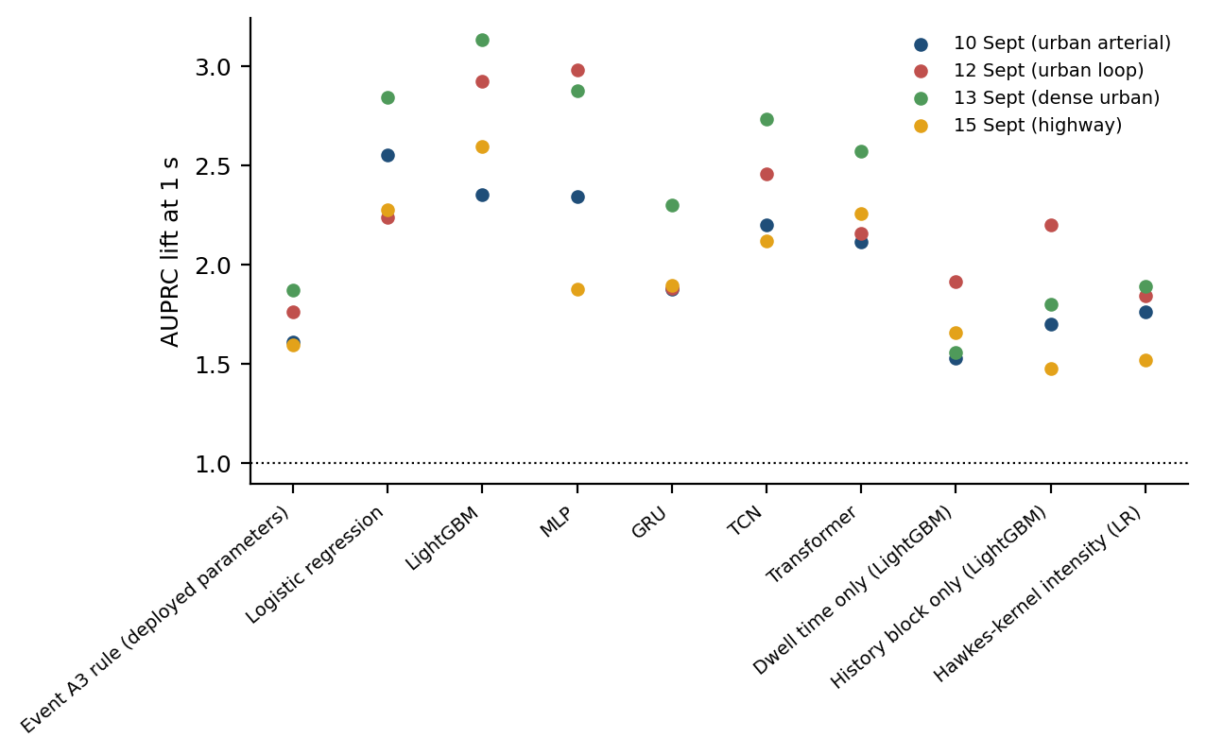
Figure 5.4 One-second AUPRC lift by learner, with each held-out campaign drawn separately. The spread across campaigns is wider than the spread across learners.

5.3 Splitting protocol: what each unit is worth
The result in this section concerns the protocol rather than the predictor, and it is the one with the widest implication for the comparator literature.
The experiment is a controlled substitution. Everything is held fixed — the data, the lagged features, the formulation, the hyper-parameters, the seeds — and only the splitting rule changes, across the four-step ladder of Section 4.9. Table 5.5 reports the result at one second and Figure 5.5 across the ladder.
Table 5.5 One-second AUPRC under four splitting protocols, with all else held fixed.
Learner | Leave one campaign out | Blocks + 60 s purge | Random 180 s blocks | Random rows | Inflation, random rows vs LOCO
lr | 0.167 | 0.162 | 0.168 | 0.179 | +7 %
tcn | 0.165 | 0.151 | 0.165 | 0.181 | +10 %
lgbm | 0.160 | 0.166 | 0.180 | 0.236 | +48 %
mlp | 0.152 | 0.147 | 0.150 | 0.163 | +8 %
transformer | 0.126 | 0.145 | 0.155 | 0.169 | +34 %
gru | 0.125 | 0.111 | 0.126 | 0.150 | +19 %
a3 | 0.116 | 0.116 | 0.116 | 0.116 | +0 %

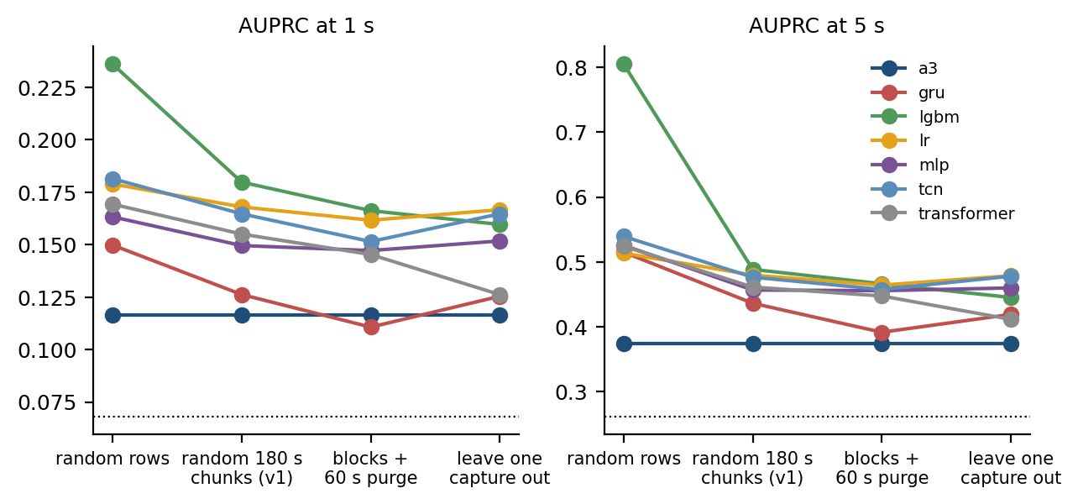
Three readings follow. Random-row splitting inflates the one-second AUPRC of the primary model by 48 % over leave-one-campaign-out, and of the recurrent arm by 19 %. Splitting by random 180-second blocks — grouped splitting, and the protocol this work used before the audit — still inflates it by 13 %, because blocks of one continuous session are not independent of one another. Blocking contiguously in time with a 60-second purge removes most of that: it sits within 4 % of the leave-one-campaign-out figure, which is what makes it a usable protocol when only one session is available.
The mechanism is straightforward once stated. Two samples one second apart on the same drive are near-duplicates. Two 180-second blocks of the same session are not duplicates, but they share cells, traffic and trajectory, so a model can recognise the session rather than the situation. The deployed A3 rule, which has no parameters to over-fit with, moves by +0 % across the whole ladder and is the control that shows the effect is over-fitting rather than a difference in test-set difficulty.
Because the inflation is architecture-dependent, it reorders the ranking rather than raising it uniformly. Under leave-one-campaign-out the leading learner at one second is logistic regression; under random-row splitting it is LightGBM, whose inflation is 48 % against 7 % for the former. A study using the standard protocol of the comparator literature would therefore report a different winner on the same data. This is the answer to objective O2, and it is why the protocol is presented as a contribution rather than as housekeeping.

5.4 Coherence and calibration
Table 5.6 reports the coherence and calibration behaviour of the hazard formulation against the independent-classifier control and the three post-hoc repairs of Section 4.2.
Table 5.6 Horizon coherence and calibration for the hazard formulation and its four controls.
Arm | Rows violating ordering | Mean violation | Largest violation | ECE 1 s | ECE 5 s | AUPRC 1 s | Needs a held-out split
independent | 29.0 % | 0.020 | 0.377 | 0.047 | 0.135 | 0.158 | no
independent + cumulative max | 0.0 % | 0.000 | 0.000 | 0.047 | 0.135 | 0.157 | no
independent + PAV | 0.0 % | 0.000 | 0.000 | 0.047 | 0.134 | 0.158 | no
independent + isotonic | 33.4 % | 0.021 | 0.416 | 0.016 | 0.069 | 0.158 | yes
independent + isotonic + PAV | 0.0 % | 0.000 | 0.000 | 0.016 | 0.071 | 0.158 | yes
hazard | 0.0 % | 0.000 | 0.000 | 0.036 | 0.119 | 0.157 | no

The hazard formulation produces no horizon-ordering violations, which follows from Equation (4.5). The independent-classifier arm violates ordering on 40.2% of rows, with a mean violation of 0.025 and a maximum of 0.521 where it occurs.
The honest comparison, however, is not against the raw control. A per-row cumulative maximum removes every violation at no cost, needs no held-out split, and is two lines of code; the pool-adjacent-violators projection does the same. Both are reported in Table 5.6, and an earlier draft of this work omitted them, which overstated the case for the formulation. Isotonic calibration per horizon is the most expressive control: on its own it makes coherence worse (violations rise from 40.2% to 33.4%, because the K isotonic maps are fitted independently and may reorder the horizons), but composed with the monotone projection it reaches zero violations and the lowest calibration error of any arm (0.016 at one second against 0.036 for the hazard model). That composite is therefore the arm to beat, and the hazard formulation does not beat it on calibration.
What the hazard formulation retains after that correction is narrower and worth stating exactly. It is the only arm that reaches coherence and competitive calibration from a single fit with no held-out calibration split: 0.036 at one second against 0.047 for raw independent heads and 0.047 for the cumulative-maximum control, none of which consume data, while the isotonic arms spend a calibration block that a four-session dataset can ill afford. It also inherits the censoring treatment of Section 4.4 and estimates one model rather than five. On a larger dataset, isotonic calibration followed by a monotone projection would be the stronger choice, and this thesis says so.
Figure 5.8 places the arms on the same axes: calibration error across the horizon on the left, violation rate on the right.
Because only four campaigns are available, the paired comparison between formulations is over four observations. The hazard arm has the lower calibration error on 0 of the four held-out campaigns at one second; the exact two-sided sign-test p-value for four paired observations cannot fall below 0.125, so no significance is claimed and the per-campaign numbers are reported in full in Appendix A.
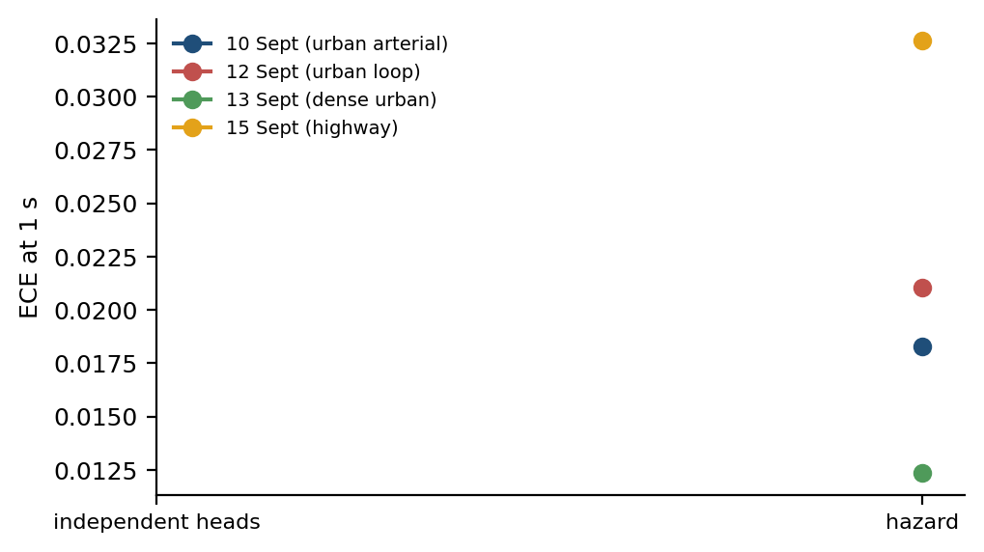
Figure 5.6 Calibration error at one second, one line per held-out campaign, for independent classifiers against the hazard formulation.
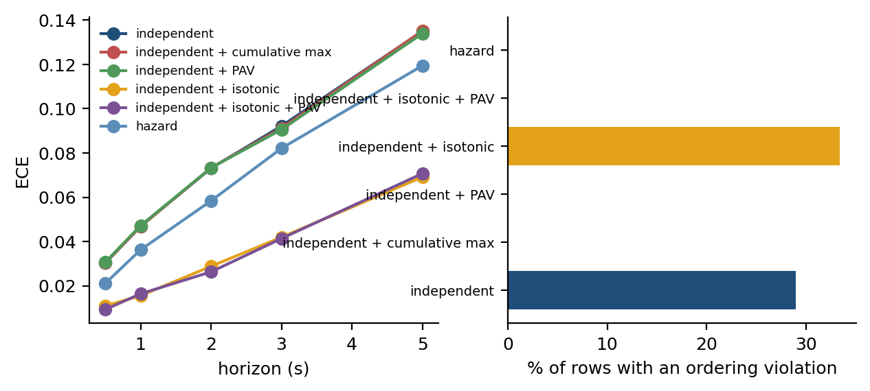
Figure 5.7 Calibration error against the horizon for every coherence arm (left) and the share of rows violating horizon ordering (right).
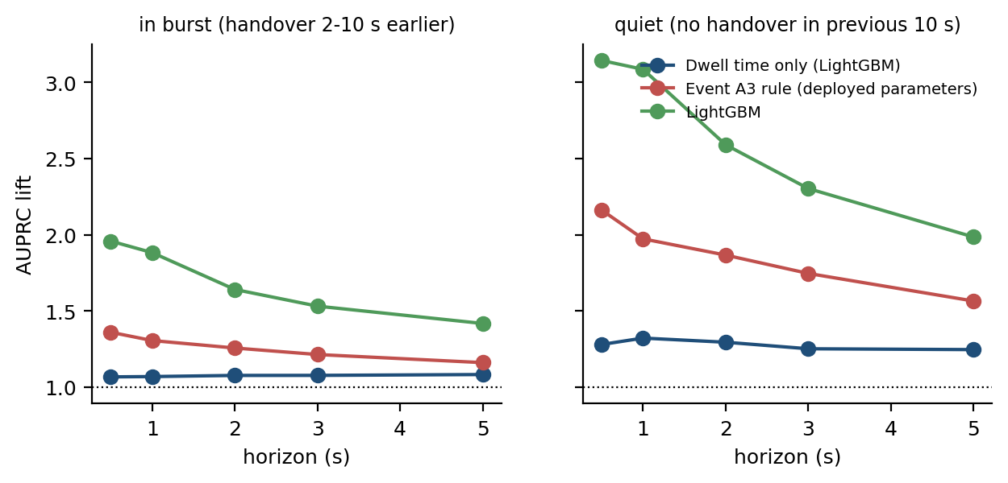
Figure 5.8 Where the model earns its advantage: rows with no handover in the previous ten seconds against rows inside a burst.
The operational meaning of an expected calibration error of 0.024 at the one-second horizon is worth stating plainly, because a calibration figure is easy to report and easy to ignore. It means that among the samples on which the system asserts a probability near 0.8, a handover follows within one second on approximately 80 % of occasions. That is what permits the output to enter a decision rule rather than merely to sort samples, and it is what none of the 22 audited models in Section 2.3 reports. Together with Section 5.5 this answers objective O3.

Table 5.7 reports conformal risk control in the two regimes described in Section 4.10.
Table 5.5 reports the conformal risk-control frontier obtained by the procedure of Section 4.10 on 28 held-out calibration drives.
Three observations follow.
Target α | Exchangeable units: alarm rate | Exchangeable units: realised miss rate | Across campaigns: realised miss rate | Across campaigns: rotations respecting the bound
0.05 | 86 % | 0.018 | 0.000 | 100 %
0.10 | 65 % | 0.069 | 0.032 | 92 %
0.15 | 55 % | 0.119 | 0.092 | 83 %
0.20 | 47 % | 0.168 | 0.153 | 83 %
0.30 | 36 % | 0.272 | 0.261 | 67 %
Feasibility floor with n = 14 | α ≥ 0.067

First, in the exchangeable regime — calibration and test units drawn from the same pool of 180-second blocks — the realised mean per-unit miss rate sits at or below the target at every level tested. At α = 0.20 the certified threshold alarms on 47% of rows and realises a mean per-unit miss rate of 0.168.
Second, in the regime an operator actually faces — calibrate on one campaign, deploy on another — the guarantee is not distribution-free any more, because the units are not exchangeable. Across the 12 campaign rotations the mean realised loss at α = 0.20 is 0.153 and the bound is respected in 83% of rotations. Reporting this is the point of the section: the procedure is only as good as the exchangeability assumption, and a campaign is a distribution shift.
Third, the guarantee is expensive at tight targets, and the number of calibration units binds independently of model quality. At α = 0.05 the threshold alarms on 86% of rows, which is not an operating point any operator would deploy. And the campaigns differ in size: a calibration campaign of n blocks can express no target below 1/(n+1), so with 8 to 20 blocks per campaign the floor runs from 0.048 to 0.111, and only 25% of the rotations can express α = 0.05 at all.
Figure 5.9 puts both regimes on one pair of axes, with the realised risk against the nominal level and the guarantee boundary drawn as the diagonal; the second axis carries the alarm rate that compliance costs.
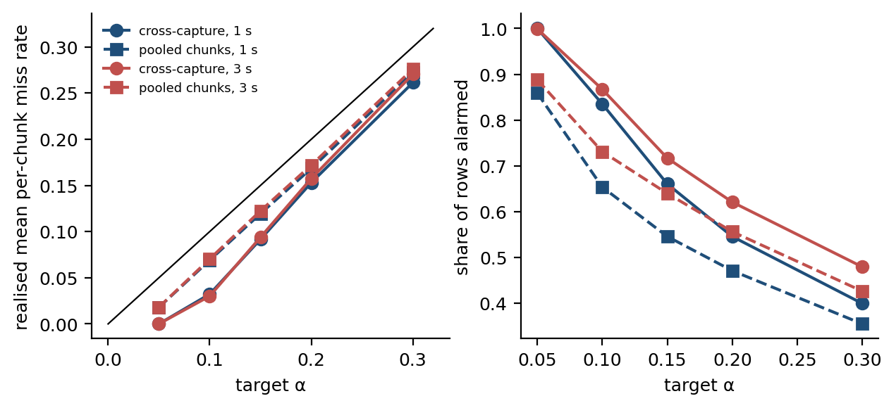
Figure 5.9 Conformal risk control in both regimes. Left: realised mean per-unit miss rate against the target, with the guarantee boundary as the diagonal. Right: the alarm rate that compliance costs.

5.6 Generalisation across corridors and speed regimes
Objective O4 asks whether the result survives outside the data on which it was developed. Two experiments address it, at increasing distance from the training distribution.
The first is the primary protocol itself: each campaign held out in turn. Table 5.8 reports the per-campaign numbers that the pooled result of Table 5.3 averages over.
Table 5.8 Leave-one-campaign-out performance at the one-second horizon.
Campaign held out | Rows | Prevalence | AUPRC | Lift | AUROC | ECE
10 Sept (urban arterial) | 2,178 | 8.4 % | 0.196 | 2.4× | 0.765 | 0.018
12 Sept (urban loop) | 1,131 | 8.0 % | 0.233 | 2.9× | 0.805 | 0.021
13 Sept (dense urban) | 3,072 | 6.5 % | 0.203 | 3.1× | 0.789 | 0.012
15 Sept (highway) | 2,205 | 5.1 % | 0.132 | 2.6× | 0.769 | 0.033
Pooled out of fold | 8,586 | 6.8 % | 0.179 | 2.6× | 0.777 | 0.012

The spread across campaigns is the useful quantity. At one second the AUPRC lift runs from 2.4x to 3.1x across the four held-out campaigns, and AUROC from 0.765 to 0.805. The weakest campaign is 15 Sept (highway), and the highway campaign — the one that differs in both corridor and speed regime — reaches AUROC 0.769. No campaign carries the pooled result, and none of them is close to the figure this work reported before the alignment audit.
The honest reading of the spread is that a fifth campaign could plausibly land anywhere inside it, and that four units are too few to say more than that. That is a statement about the size of the study, not about the method.
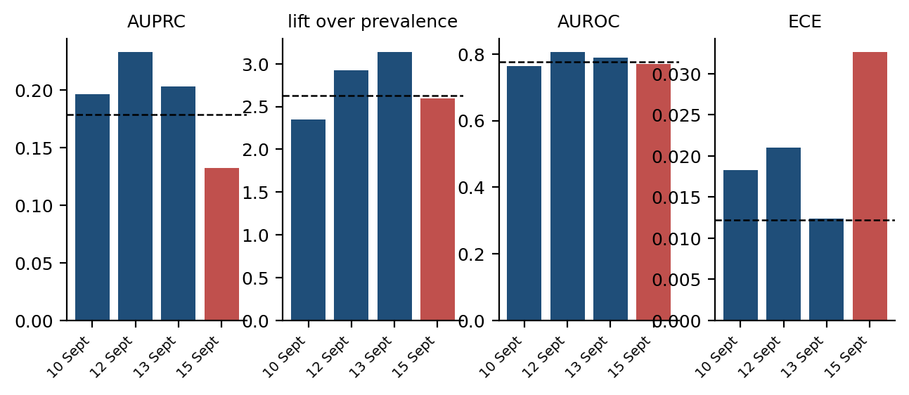
Figure 5.10 Leave-one-campaign-out on four metrics. Each bar holds one campaign out entirely and trains on the other three; the dashed line is the pooled out-of-fold value. The highway campaign is in red.

5.7 An independent collection on the same network
The second generalisation experiment uses a publicly released LTE drive-test dataset [38]. Its provenance is stated exactly, because an earlier draft of this work described it as a different network: it was collected by a different group of people on a different route two years earlier, using the same operator, the same city and the same XCAL licence, in the same department of the same institution. It is an independent collection on the same network, and it tests collection, route and time — not operator, and not radio access technology.
Because the public dataset publishes measurement-report exports rather than a periodic radio export, both domains are rebuilt here from the L3 signalling alone, on the same feature construction, so that the comparison varies the dataset and nothing else. That construction also sidesteps the alignment problem of Section 5.1 by using millisecond report timestamps directly. Table 5.9 reports the four directions with bootstrap intervals over runs.
Setting | Rows | Prevalence | AUROC [95 % CI] | AUPRC | Lift
ours, leave-one-capture-out | 7,284 | 7.9 % | 0.730 [0.711, 0.754] | 0.183 | 2.3×
public, leave-one-file-out | 1,455 | 6.3 % | 0.711 [0.653, 0.767] | 0.148 | 2.3×
ours -> public (no refit) | 1,455 | 6.3 % | 0.760 [0.709, 0.813] | 0.212 | 3.3×
public -> ours (no refit) | 7,284 | 7.9 % | 0.679 [0.624, 0.724] | 0.149 | 1.9×

The transferred model reaches AUROC 0.760 on the public data without refitting, against 0.711 for a model trained on that dataset itself and 0.730 for our own leave-one-capture-out result on the same signalling-only feature set. The intervals overlap. The reading is that the formulation and the feature construction transfer to another collection on this network, which is a weaker and more defensible claim than the one made in the earlier draft.
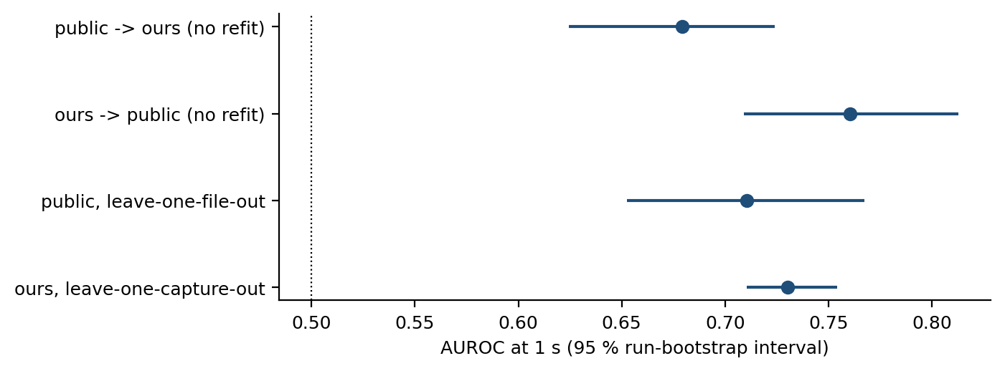
Figure 5.11 Transfer to an independently collected dataset on the same network, with both domains built from L3 signalling alone. Bars are 95 % bootstrap intervals over runs.

5.8 What the model uses, and where it works
Objective O5 asks for the mechanism rather than the score. With the alignment corrected, the answer is less dramatic than the earlier draft claimed and more useful.
Table 5.10 reports the strongest single features, each evaluated alone at the one-second horizon on the lagged export.
Table 5.10 Single-feature AUROC at the one-second horizon on the lagged export.
Feature (lagged one row) | AUROC alone at 1 s | Direction
sig_s_since_a3 | 0.723 | lower -> more likely
serving_sinr | 0.723 | lower -> more likely
sig_a3_prev5s | 0.704 | higher -> more likely
sig_a3_prev2s | 0.696 | higher -> more likely
serving_sinr_mean3 | 0.696 | lower -> more likely
serving_sinr_mean5 | 0.683 | lower -> more likely
t_since_prev_ho_s | 0.664 | lower -> more likely
gap_serving_best_nbr | 0.618 | lower -> more likely
speed_kmh | 0.584 | higher -> more likely
Full model, same rows | 0.777
Table 5.11 Performance inside and outside handover bursts.
Stratum | Learner | Rows | Prevalence 1 s | AUPRC 1 s | Lift 1 s | Lift 5 s
in burst (handover 2-10 s earlier) | Event A3 rule (deployed parameters) | 3,068 | 11.2 % | 0.147 | 1.3× | 1.2×
in burst (handover 2-10 s earlier) | History block only (LightGBM) | 3,068 | 11.2 % | 0.133 | 1.2× | 1.2×
in burst (handover 2-10 s earlier) | LightGBM | 3,068 | 11.2 % | 0.212 | 1.9× | 1.4×
quiet (no handover in previous 10 s) | Event A3 rule (deployed parameters) | 5,518 | 4.3 % | 0.085 | 2.0× | 1.6×
quiet (no handover in previous 10 s) | History block only (LightGBM) | 5,518 | 4.3 % | 0.061 | 1.4× | 1.2×
quiet (no handover in previous 10 s) | LightGBM | 5,518 | 4.3 % | 0.133 | 3.1× | 2.0×

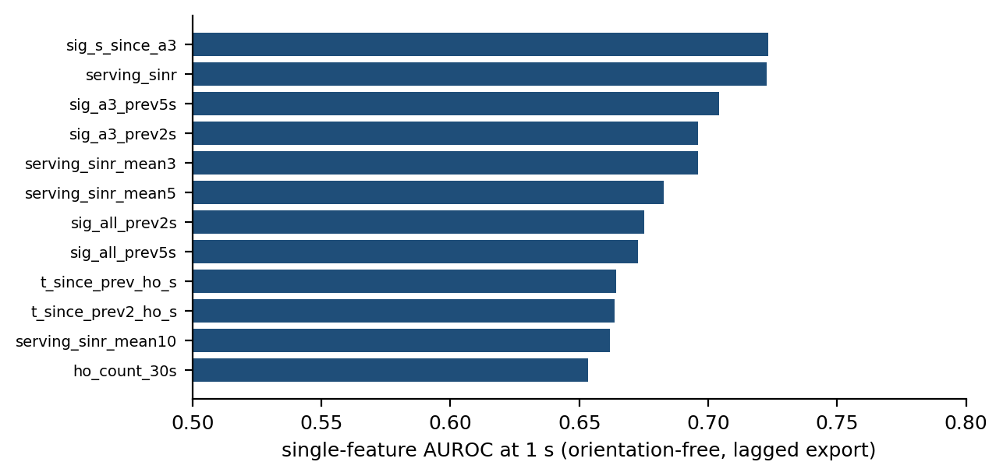
Figure 5.12 Single-feature discriminative power at one second on the lagged export. No single feature approaches the full model.
Four results follow. No single feature is close to the model: the strongest reaches AUROC 0.723 against 0.777 for the full model, so the signal is distributed rather than concentrated in one clock. The strongest single quantity is the time since the last Event A3 report (sig_s_since_a3, AUROC 0.723), which is a signalling quantity the network holds in real time and which the main feature set deliberately excludes; the strongest export feature is serving SINR (0.723). Serving dwell time computed from signalling timestamps reaches 0.664, ahead of chance and far behind its unlagged counterpart. And the serving-to-neighbour gap on which Event A3 is defined reaches 0.618, which is the one part of the earlier mechanism claim that survives: the quantity the rule thresholds on is a weak predictor of imminence, because it is a permission condition and not a tendency.
Where the model works matters as much as what it uses. Handover commands arrive in bursts — the median gap between consecutive commands is 3.7 seconds — and a predictor can score well by recognising that it is inside a burst. Table 5.11 therefore splits the out-of-fold rows into those with no handover in the previous ten seconds and those inside a burst. At one second the lift is 3.1x on quiet rows and 1.9x on in-burst rows, against prevalence floors of 4.3% and 11.2%. A history-only model reaches a lift of 1.7x pooled, so burst membership alone does not account for the result, but the radio block earns most of its advantage on the quiet rows, which is where an operator would want the warning.
Figure 5.12 ranks the single features and Figure 5.13 gives the dose-response relation between the time since the previous command and the probability of the next one, which is monotone up to about twenty seconds and flat thereafter.
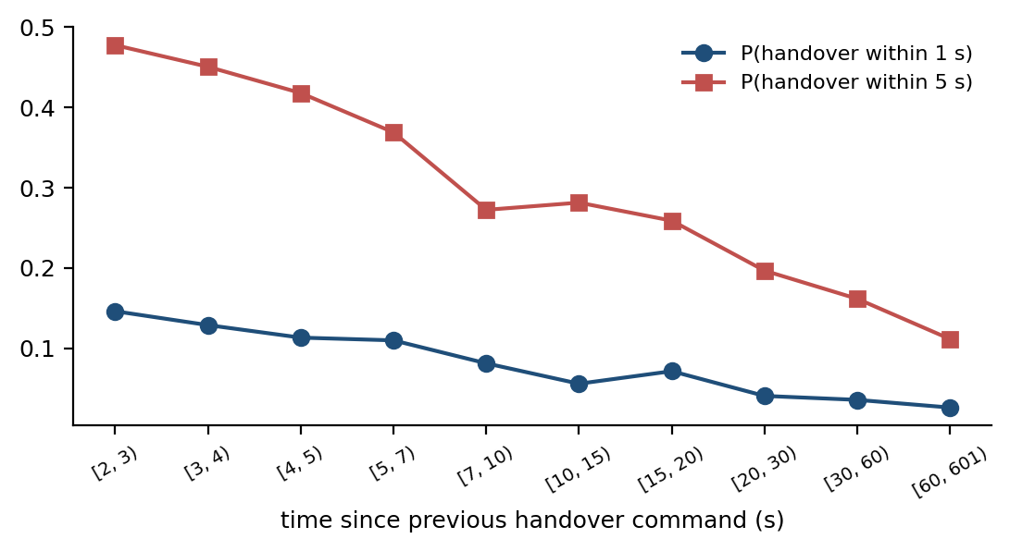
Two further sensitivities are reported here rather than buried. Censoring the 93 rows whose next event is a re-establishment rather than a handover command moves the one-second lift by +0.03x, so the competing risk of Section 3.6 does not drive the result. And adding the signalling block of Section 4.6 to the radio, mobility and history blocks moves the one-second AUPRC from 0.179 to 0.168; the signalling block on its own reaches 0.123.

5.9 The A3 report-conversion rate, per episode
The first of the two network characterisations concerns what happens to a measurement report after it is sent, and it is reported here in a corrected form. Event A3 report configurations on this network carry reportInterval and reportAmount values that cause a triggered condition to be re-reported periodically until it ceases: the modal configuration re-reports every 240 ms with reportAmount infinity. Counting transmitted reports therefore counts re-reports of the same trigger, and an earlier draft of this work did exactly that.
Table 5.12 reports the conversion rate under both units. Grouping consecutive reports of one measId whose spacing is consistent with the configured reportInterval into a single trigger episode reduces 8,136 transmitted A3 reports to 2,361 episodes, an average of 3.4 reports per episode. Under the episode unit 30% of A3 episodes are not followed by a handover command within two seconds, against 63% of individual reports.
Unit | Stratum | n | Followed by a command within 2 s | Declined
per report (v1 unit) | pooled | 8,136 | 3006 | 63 %
per report (v1 unit) | 10 Sept (urban arterial) | 2,287 | 980 | 57 %
per report (v1 unit) | 12 Sept (urban loop) | 1,857 | 716 | 61 %
per report (v1 unit) | 13 Sept (dense urban) | 2,215 | 806 | 64 %
per report (v1 unit) | 15 Sept (highway) | 1,777 | 504 | 72 %
per report (v1 unit) | inter-frequency | 93 | 34 | 63 %
per report (v1 unit) | intra-frequency | 8,043 | 2972 | 63 %
per trigger episode | pooled | 2,361 | 1647 | 30 %
per trigger episode | 10 Sept (urban arterial) | 726 | 531 | 27 %
per trigger episode | 12 Sept (urban loop) | 476 | 349 | 27 %
per trigger episode | 13 Sept (dense urban) | 740 | 480 | 35 %
per trigger episode | 15 Sept (highway) | 419 | 287 | 32 %
per trigger episode | inter-frequency | 49 | 28 | 43 %
per trigger episode | intra-frequency | 2,312 | 1619 | 30 %
per trigger episode, by profile | +1 dB, Hys 1, TTT 320, RI 240 x infinity | 734 | 717 | 2.3 %
per trigger episode, by profile | -15 dB, Hys 1, TTT 160, RI 5120 x infinity | 543 | 274 | 49.5 %
per trigger episode, by profile | -10 dB, Hys 2, TTT 640, RI 5120 x infinity | 431 | 315 | 26.9 %
per trigger episode, by profile | -10 dB, Hys 2, TTT 640, RI 5120 x r1 | 278 | 113 | 59.4 %
per trigger episode, by profile | -15 dB, Hys 1, TTT 160, RI 2048 x infinity | 242 | 141 | 41.7 %

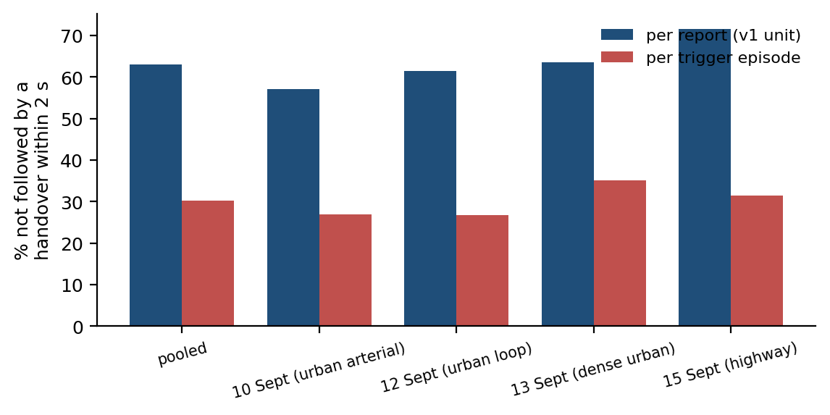
Figure 5.14 A3 report conversion under two units. Counting transmitted reports counts periodic re-reports of one trigger; counting trigger episodes does not.
The per-profile breakdown, also in Table 5.12, shows where the remaining decline sits. The dominant mobility profile — +1 dB offset, 1 dB hysteresis, 320 ms time-to-trigger, 240 ms report interval — is declined on only 2.3% of its episodes: when this network's mobility trigger fires, a handover almost always follows. The declined episodes are concentrated in the negative-offset configurations with long report intervals, which is what identifies them as neighbour-monitoring rather than mobility triggers.
The finding is therefore not that the network declines two thirds of what its handset reports. It is that a report count is the wrong unit, that the report configurations of one network serve different purposes, and that a study using A3 reports as proxy labels for handovers must separate the mobility configuration from the rest before it counts anything. The earlier figure of 63% is reported here beside the corrected one precisely so the difference between the two units is visible.

5.10 Ping-pong: definitional instability and its actual source
The second network finding concerns ping-pong, and it has two parts: how much the reported rate depends on unstated definitional choices, and where the phenomenon actually concentrates.
Table 5.13 reports the same fixed set of 957 handover commands under four definitions that differ only in choices the literature routinely leaves unstated, and Figure 5.15 extends that ladder to the full grid of window lengths.
Table 5.13 The ping-pong rate on one fixed set of handover commands under four definitions.
Definition | Handovers | Rate
Return to the immediately previous cell, identified by PCI and carrier, within 15 s | 957 | 26.3 %
The same, with the cell identified by PCI alone | 957 | 31.2 %
Any return within the window, not only to the previous cell | 957 | 43.8 %
Return to the immediately previous cell, restricted to commands inside retained blocks | 938 | 28.7 %

The rate moves by 17 percentage points — from 26.3% to 43.8% — without a single change to the underlying measurement. This is the quantitative form of the observation in Section 2.4, and it is why this thesis quotes the strictest of the four and states all three choices alongside it. It also explains how Amirova et al. [15] arrive at 0.13 % on comparable data: dividing by measurement records rather than by handovers changes the denominator by two orders of magnitude.
The window length is a fourth choice, and Figure 5.15 reports the full grid rather than the single row of Table 5.13. Across three window lengths and three identity-and-return conventions the same 957 commands yield nine defensible ping-pong rates between 21.0% and 43.8%. No cell in that grid is wrong; what is wrong is publishing one of them without saying which.
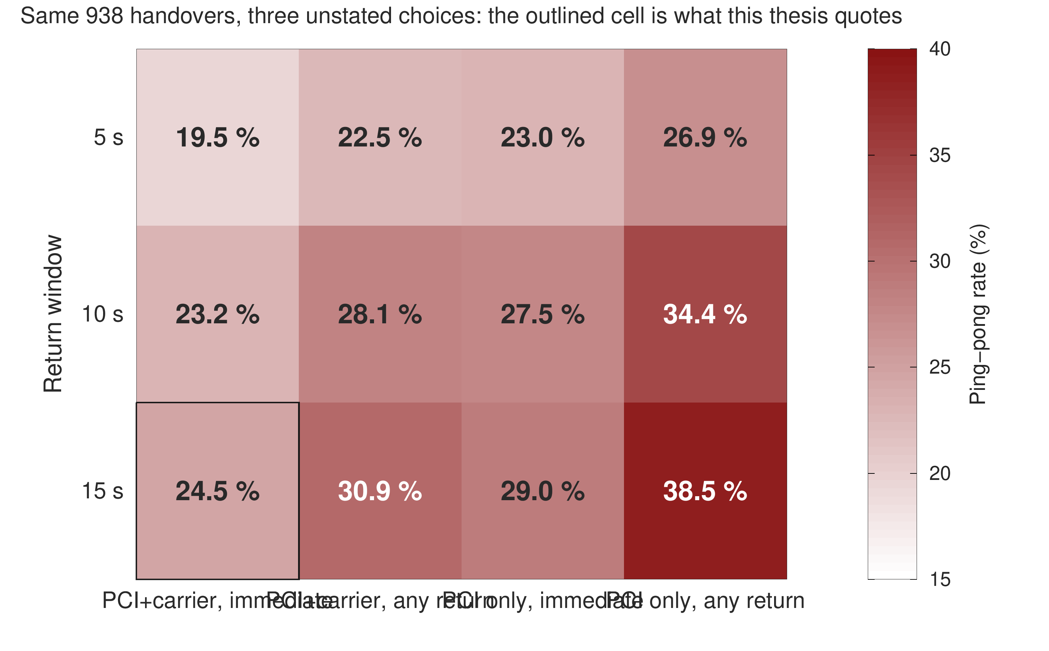
Figure 5.15 The ping-pong rate over the full definitional grid: three return windows against three conventions for cell identity and return, computed on one unchanging set of handover commands.
Table 5.14 reports where the phenomenon concentrates.
Table 5.14 Ping-pong rate by carrier relationship and mobility regime.
Stratum | Handovers | Ping-pong rate
intra-frequency handovers | 748 | 27.1 %
inter-frequency handovers | 209 | 7.2 %
highway campaign | 177 | 32.2 %
urban campaigns | 780 | 25.0 %

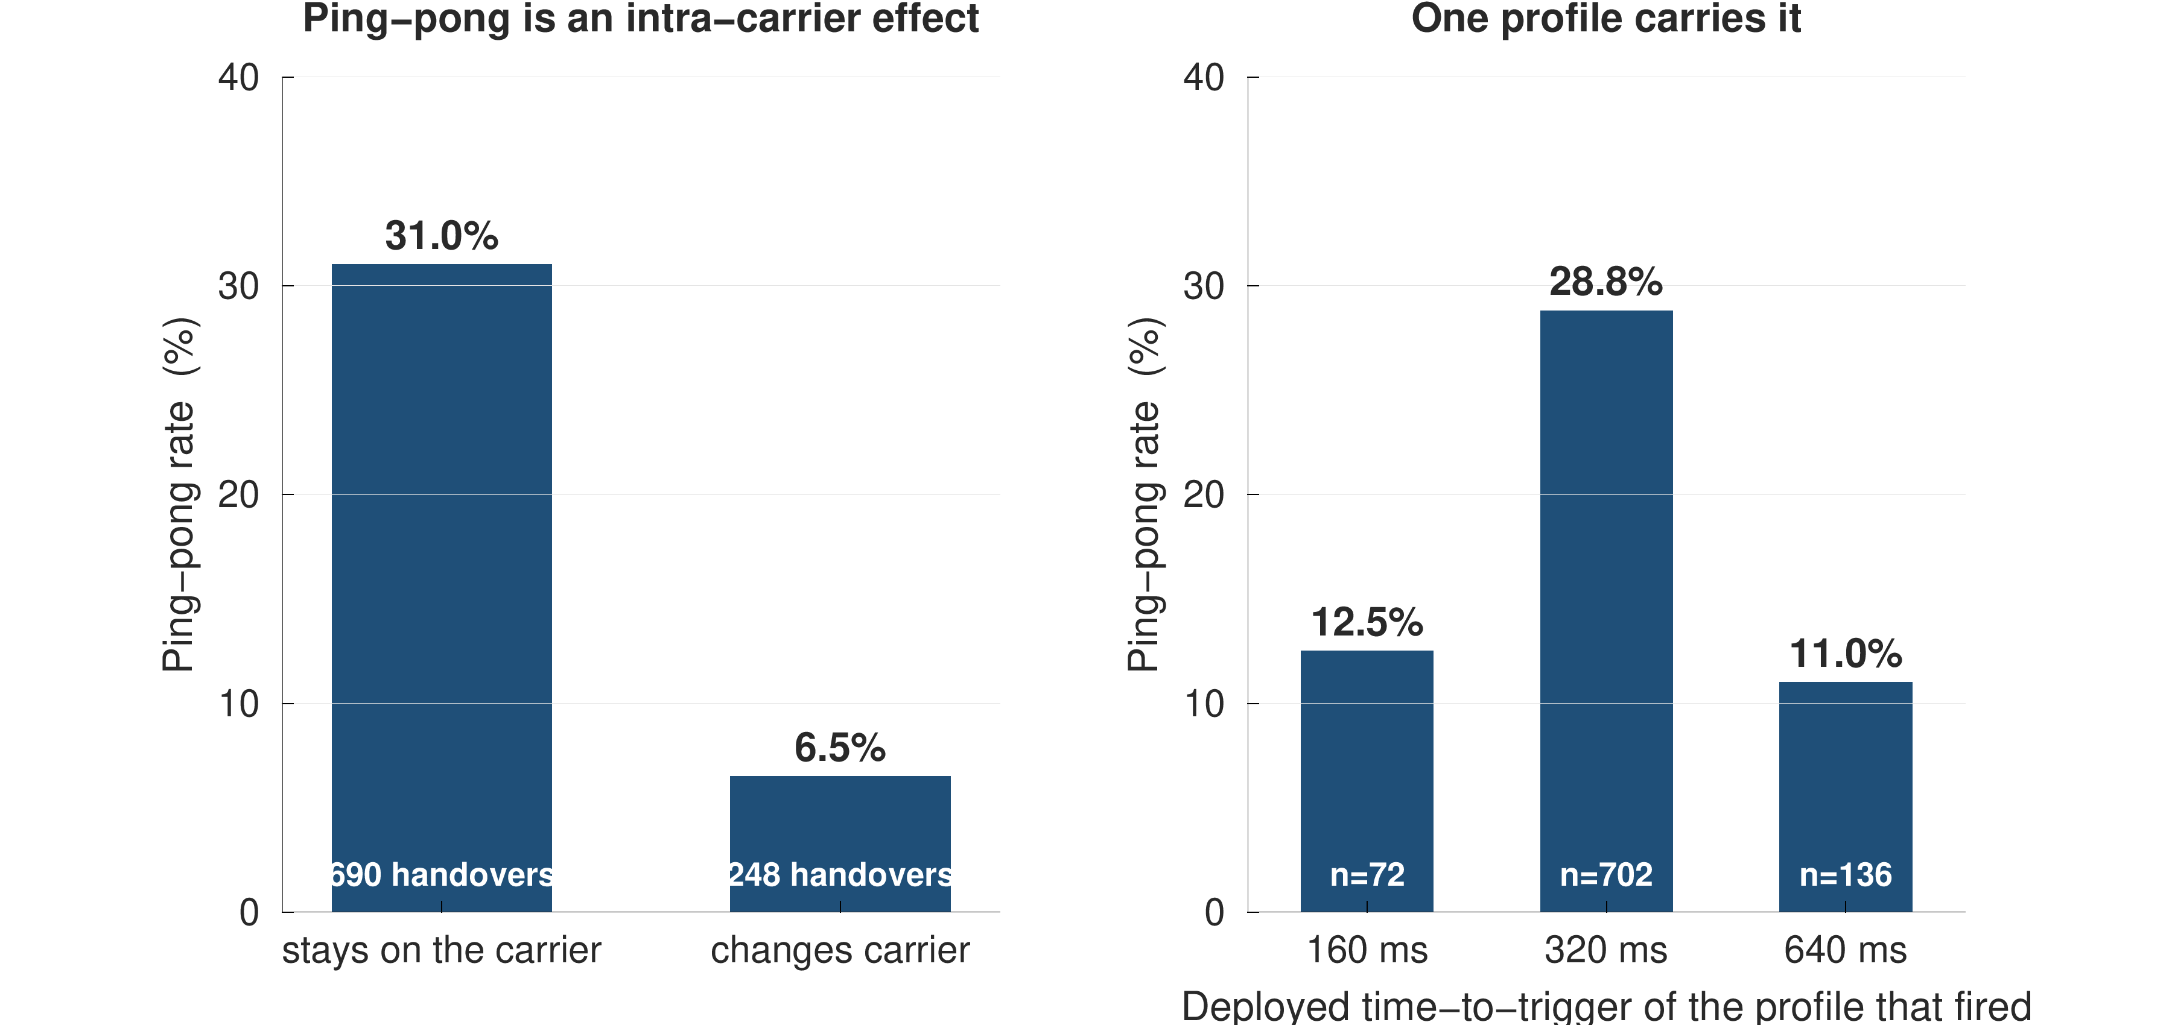
Figure 5.16 Where ping-pong concentrates. The dominant axis is the carrier relationship, not the mobility regime.
Figure 5.16 separates the strata. Ping-pong is concentrated in intra-frequency handovers, at 27.1% against 7.2% across carriers. It is not driven by speed: the highway campaign, at roughly twice the urban mean speed, returns at 32.2% against 25.0% on the urban campaigns. The lever available to an operator is therefore the time-to-trigger and offset of the dominant configuration profile rather than any speed-dependent adaptation, and this thesis stops short of claiming a causal effect for such a change, for the reason given in Section 5.13.
Modelling the arrival stream as a self-exciting process supports the same conclusion from a different direction. The fitted Hawkes branching ratio is 0.653 on the pooled stream, so each handover command is followed on average by roughly 0.7 further commands attributable to it; per campaign the estimates run from 0.487 to 0.675. The clustering is real and is the reason Section 5.8 separates quiet rows from rows inside a burst; its temporal shape is not exponential, since the Ogata residual test rejects the exponential kernel, and that rejection is reported rather than suppressed.
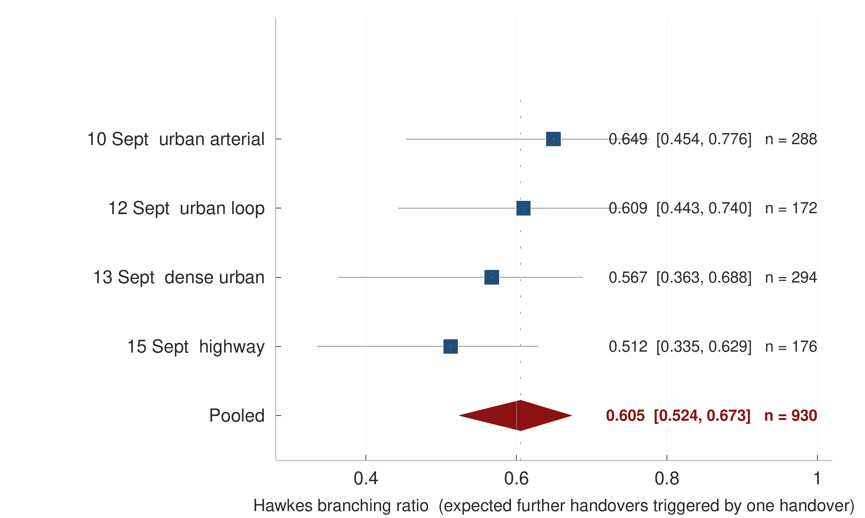
Figure 5.17 Hawkes branching ratio estimated on each campaign separately and on the pooled stream, with bootstrap intervals.
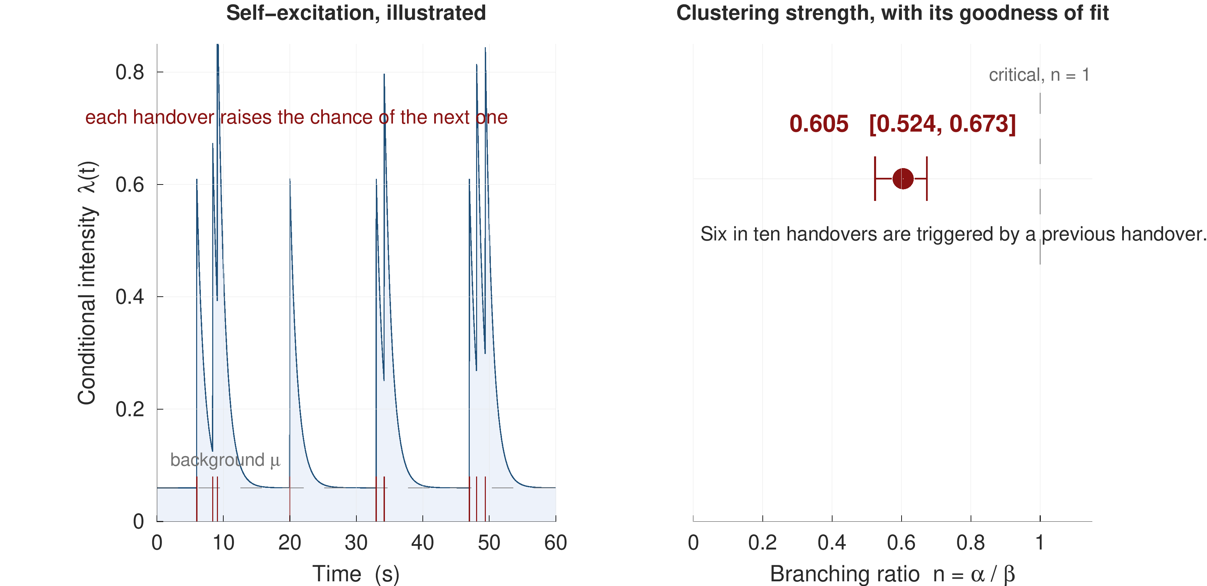
Figure 5.18 Self-excitation in the handover arrival stream. The clustering is real; the Ogata residual test rejects the exponential kernel, so its temporal shape is not exponential.

5.11 Negative results and the cost of the audit
Five approaches were implemented in good faith, measured, and did not help; they are reported because a claim that the formulation and the protocol are what matter is credible only if the alternatives were tried. Table 5.15 lists them.
Table 5.15 Approaches implemented and measured that produced no improvement.
Approach | Outcome
A dedicated ping-pong classifier | AUROC 0.51 at the one-second horizon — chance
Deep CORAL and a second unsupervised domain-adaptation method | No gain over source-only training
Sequence models (GRU, TCN, Transformer) on the same features | No gain over gradient-boosted trees; best sequence AUPRC at 1 s 0.167 against 0.179
The signalling feature block added to the main set | AUPRC at 1 s 0.168 against 0.179 without it
The unlagged (v1) feature alignment | AUPRC at 1 s 0.600, an artefact of the export row semantics (Section 5.1)
[1] 3GPP, "Evolved Universal Terrestrial Radio Access (E-UTRA); Radio Resource Control (RRC); Protocol specification," 3GPP TS 36.331, Release 17, 2022.
[2] 3GPP, "Evolved Universal Terrestrial Radio Access (E-UTRA) and Evolved Universal Terrestrial Radio Access Network (E-UTRAN); Overall description; Stage 2," 3GPP TS 36.300, Release 17, 2022.
[3] H. Deng, C. Peng, A. Fida, J. Meng, and Y. C. Hu, "Mobility support in cellular networks: a measurement study on its configurations and implications," in Proc. ACM Internet Measurement Conference (IMC), 2018, doi:10.1145/3278532.3278546.
[4] M. Ghoshal, I. Khan, P. Dinh, Z. J. Kong, O. Basit, S. Wang, Y. Feng, Y. C. Hu, and D. Koutsonikolas, "Handover configurations in operational 5G networks: diversity, evolution, and impact on performance," arXiv:2511.03116, 2025.
[5] A. Hassan, A. Narayanan, A. Zhang, W. Ye, R. Zhu, S. Jin, J. Carpenter, Z. M. Mao, F. Qian, and Z.-L. Zhang, "Vivisecting mobility management in 5G cellular networks," in Proc. ACM SIGCOMM, 2022, pp. 86–100, doi:10.1145/3544216.3544217.
[6] "M2HO: Mitigating the adverse effects of 5G handovers on TCP," in Proc. ACM MobiCom, 2024, doi:10.1145/3636534.3690680. [Author list to be completed from the ACM record before submission.]
[9] C. Chabira, I. Shayea, G. Nurzhaubayeva, L. Aldasheva, D. Yedilkhan, and S. Amanzholova, "AI-driven handover management and load balancing optimization in ultra-dense 5G/6G cellular networks," Technologies, vol. 13, no. 7, art. 276, 2025, doi:10.3390/technologies13070276.

[10] K. Nguyen Dang Dinh, P. Fazio, and M. Voznak, "A proposed mobility and resource prediction method for seamless handover and service continuity in 5G small cell networks," PLOS ONE, vol. 21, no. 8, art. e0355372, 2026, doi:10.1371/journal.pone.0355372.
[11] J. M. Sánchez-Martín, J. L. Bejarano-Luque, C. Gijón, M. Toril, and S. Luna-Ramírez, "GRIMCELL: a graph neural network to predict the impact of new cells in mobile networks," Machine Learning and Knowledge Extraction, vol. 8, no. 9, art. 260, 2026, doi:10.3390/make8090260.
[12] N. Mehregan and R. E. De Grande, "GCN-based throughput-oriented handover management in dense 5G vehicular networks," arXiv:2505.04894, IEEE DCOSS-IoT, 2025.
[13] A. Graser, A. Jalali, J. Lampert, A. Weißenfeld, and K. Janowicz, "MobilityDL: a review of deep learning from trajectory data," GeoInformatica, vol. 29, no. 1, pp. 115–147, 2025, doi:10.1007/s10707-024-00518-8.
[14] D. Zidic, T. Mastelic, I. Nizetic Kosovic, M. Cagalj, and J. Lorincz, "Analyses of ping-pong handovers in real 4G telecommunication networks," Computer Networks, vol. 227, art. 109699, 2023.
[15] Amirova et al., "Data-driven and machine learning-based analysis of handover behavior and network stability in mobile networks," Future Internet, vol. 18, no. 6, art. 290, 2026, doi:10.3390/fi18060290. [Full author list to be completed from the MDPI record before submission.]

[16] S. Wiegrebe, P. Kopper, R. Sonabend, B. Bischl, and A. Bender, "Deep learning for survival analysis: a review," Artificial Intelligence Review, vol. 57, no. 3, art. 65, 2024, doi:10.1007/s10462-023-10681-3.
[17] H.-C. Thorsen-Meyer, D. Placido, B. S. Kaas-Hansen, et al., "Discrete-time survival analysis in the critically ill: a deep learning approach using heterogeneous data," npj Digital Medicine, vol. 5, art. 142, 2022, doi:10.1038/s41746-022-00679-6.
[18] E. J. Candès, L. Lei, and Z. Ren, "Conformalized survival analysis," Journal of the Royal Statistical Society Series B, vol. 85, no. 1, pp. 24–45, 2023, doi:10.1093/jrsssb/qkac004.
Instrument ceiling. The one-hertz export caps event-level detection at 64.6% at one second, which bounds every event-level figure in Section 5.2.
[19] K. M. Cohen, S. Park, O. Simeone, and S. Shamai (Shitz), "Calibrating AI models for wireless communications via conformal prediction," arXiv:2212.07775, 2022.
[20] O. Simeone, S. Park, and M. Zecchin, "Conformal calibration: ensuring the reliability of black-box AI in wireless systems," arXiv:2504.09310, 2025.
[21] A. N. Angelopoulos, S. Bates, A. Fisch, L. Lei, and T. Schuster, "Conformal risk control," in Proc. International Conference on Learning Representations (ICLR), 2024.
[22] S. Bates, A. Angelopoulos, L. Lei, J. Malik, and M. I. Jordan, "Distribution-free, risk-controlling prediction sets," Journal of the ACM, vol. 68, no. 6, 2021, doi:10.1145/3478535.
[23] A. G. Hawkes, "Spectra of some self-exciting and mutually exciting point processes," Biometrika, vol. 58, no. 1, pp. 83–90, 1971.

[24] P. J. Laub, Y. Lee, P. K. Pollett, and T. Taimre, "Hawkes models and their applications," Annual Review of Statistics and Its Application, vol. 12, pp. 233–258, 2025.
[25] Y. Ogata, "Statistical models for earthquake occurrences and residual analysis for point processes," Journal of the American Statistical Association, vol. 83, no. 401, pp. 9–27, 1988.
[26] M. Price-Williams and N. A. Heard, "Nonparametric self-exciting models for computer network traffic," Statistics and Computing, vol. 30, no. 2, pp. 209–220, 2020.
[27] H. Ismail Fawaz, G. Del Grosso, T. Kerdoncuff, A. Boisbunon, and I. Saffar, "Deep unsupervised domain adaptation for time series classification: a benchmark," arXiv:2312.09857, 2023.

[28] B. Sun and K. Saenko, "Deep CORAL: correlation alignment for deep domain adaptation," in Computer Vision – ECCV 2016 Workshops, LNCS vol. 9915, pp. 443–450, 2016.
[29] Y. Shi, X. Ying, and J. Yang, "Deep unsupervised domain adaptation with time series sensor data: a survey," Sensors, vol. 22, no. 15, art. 5507, 2022.

[30] D. Wagner, A. Nair, B. J. Franks, et al., "Formally exploring time-series anomaly detection evaluation metrics," arXiv:2510.17562, 2025.
[31] S. Deb, M. Rathod, R. Balamurugan, S. K. Ghosh, R. K. Singh, and S. Sanyal, "Performance evaluation of conditional handover in 5G systems under fading scenario," arXiv:2403.04379, 2024.
[32] G. Ke, Q. Meng, T. Finley, T. Wang, W. Chen, W. Ma, Q. Ye, and T.-Y. Liu, "LightGBM: a highly efficient gradient boosting decision tree," in Advances in Neural Information Processing Systems 30, 2017, pp. 3146–3154.
CO | CO statement | PO | Addressed
CO1 | Apply knowledge of electrical and electronic engineering to the solution of complex engineering problems | PO1 | √
CO2 | Identify a contemporary real-life problem related to electrical and electronic engineering by reviewing and analysing existing research works | PO2 | √
CO3 | Determine functional requirements of the problem considering feasibility and efficiency through analysis and synthesis of information | PO4 | √
CO4 | Select a suitable solution and determine its method considering professional ethics, codes and standards | PO8 | √
CO5 | Adopt modern engineering resources and tools for the solution of the problem | PO5 | √
CO6 | Prepare management plan and budgetary implications for the solution of the problem | PO11 | √
CO7 | Analyse the impact of the proposed solution on health, safety, culture and society | PO6 | √
CO8 | Analyse the impact of the proposed solution on environment and sustainability | PO7 | √
CO9 | Develop a viable solution considering health, safety, cultural, societal and environmental aspects | PO3 | √
CO10 | Work effectively as an individual and as a team member for the accomplishment of the solution | PO9 | √
CO11 | Prepare various technical reports, design documentation, and deliver effective presentations for demonstration of the solution | PO10 | √
CO12 | Recognise the need for continuing education and participation in professional societies and meetings | PO12 | √
[33] C. Guo, G. Pleiss, Y. Sun, and K. Q. Weinberger, "On calibration of modern neural networks," in Proc. ICML, 2017, pp. 1321–1330.

[34] B. Zadrozny and C. Elkan, "Transforming classifier scores into accurate multiclass probability estimates," in Proc. ACM SIGKDD, 2002, pp. 694–699.
[35] D. R. Roberts et al., "Cross-validation strategies for data with temporal, spatial, hierarchical, or phylogenetic structure," Ecography, vol. 40, no. 8, pp. 913–929, 2017, doi:10.1111/ecog.02881.
[36] S. Kaufman, S. Rosset, C. Perlich, and O. Stitelman, "Leakage in data mining: formulation, detection, and avoidance," ACM Transactions on Knowledge Discovery from Data, vol. 6, no. 4, art. 15, 2012, doi:10.1145/2382577.2382579.
PO | Aspect | Addressed | Evidence
PO3 | Public health | — | No health claim is made; see Section 6.6
PO3 | Safety | √ | Connection continuity and radio-link failure, Section 1.2
PO3 | Societal | √ | Section 6.6
PO3 | Environmental | √ | Measured unnecessary signalling, Section 5.10
PO4 | Design of experiments | √ | Grouped-drive rotation and seed repetition, Section 4.9
PO4 | Analysis and interpretation of data | √ | Chapter 5 in its entirety
PO4 | Synthesis of information | √ | Protocol audit of 22 models, Section 2.3
PO5 | Modern tool usage | √ | Drive-test instrumentation and analysis stack, Section 6.4
PO6 | Societal | √ | Section 6.6
PO6 | Legal | √ | Data handling and operator anonymity, Section 6.6
PO7 | Societal and environmental | √ | Section 6.6
PO8 | Professional ethics and responsibilities | √ | Reporting of negative results, Section 5.11
PO8 | Norms | √ | Conformance to 3GPP TS 36.331 terminology throughout
PO10 | Comprehend and write effective reports | √ | This report
PO10 | Design documentation | √ | Chapters 3 and 4
PO10 | Make effective presentations | √ | Progress and defence presentations
PO11 | Engineering management principles | √ | Section 6.9
PO11 | Economic decision-making | √ | Section 6.9
[37] D. Raca, D. Leahy, C. J. Sreenan, and J. J. Quinlan, "Beyond throughput, the next generation: a 5G dataset with channel and context metrics," in Proc. ACM Multimedia Systems Conference (MMSys), 2020, pp. 303–308, doi:10.1145/3339825.3394938. Dataset: github.com/uccmisl/5Gdataset (GPL-3.0).

[38] M. M. S. Shafi, K. M. Istiaque, S. S. Sowad, and M. T. Kawser, "Drive-test-based LTE handover dataset for cellular mobility studies in urban Bangladesh," Mendeley Data, version 1, 2025, doi:10.17632/n2pvmtyn2j.1. [The files used are the "ver 2" release folder; confirm the version DOI before submission.]
[39] M. M. S. Shafi, K. M. Istiaque, S. S. Sowad, and M. T. Kawser, "Handover optimization in LTE networks using contextual bandit reinforcement learning and real-world data," manuscript, Islamic University of Technology, 2025. [Venue to be confirmed; a ResearchGate record exists.]
Table 6.3 Knowledge profiles addressed, with justification.
K | Justification
K3 | A systematic, theory-based formulation of engineering fundamentals: the discrete-time survival formulation of Section 4.3, including the product-limit identity and its monotonicity proof, and the censoring-aware likelihood of Section 4.4
K4 | Specialist knowledge at the forefront of the discipline: the decoding of RRC measurement configuration under message-scoped identifiers, Section 3.3, and the recovery of deployed Event A3 parameters, Section 3.5
K5 | Knowledge supporting engineering design in a practice area: the feature construction, model selection and calibration design of Sections 4.6 to 4.8, each chosen against a stated alternative
K6 | Knowledge of engineering practice and technology: the conduct of four drive-test campaigns with commercial diagnostic instrumentation on a live operator network, Chapter 3
K7 | Comprehension of the role of engineering in society: the impact analysis of Section 6.6, including the explicit refusal to make a health claim the measurements do not support
K8 | Engagement with research literature: the screening of 108 publications and the protocol audit of 22 comparable models in Section 2.3, together with the methodological provenance recorded in Sections 2.5 to 2.8

6.5 Use of complex engineering problems
The problem addressed here satisfies the defining characteristics of a complex engineering problem in several independent respects.
It cannot be resolved without deep, analytically based knowledge: the incoherence of independent multi-horizon classifiers is not visible without the survival formulation of Section 4.3, and the inadmissibility of class reweighting under that formulation, Section 4.5, follows from a compounding argument that no amount of empirical tuning would reveal.
It involves conflicting technical requirements whose trade-offs must be resolved quantitatively rather than asserted. The clearest is the warning trade-off of Section 5.5: an earlier and more sensitive warning is more useful to the network and also more expensive, and the frontier from a 20 % certified miss rate at a 47% alarm rate to a 5 % target at 86% is measured rather than assumed.
It is not amenable to a standard procedure. The evaluation protocol the comparator literature treats as standard is demonstrably wrong on this data, and Section 5.3 measures by how much; so is the implicit assumption that a measurement row describes the interval before its own timestamp, which Section 5.1 measures.
It spans several sub-disciplines: the LTE control plane, radio propagation, statistical survival analysis, distribution-free inference, point-process modelling and software engineering, and no single one of them is sufficient.

6.6 Socio-cultural, environmental and ethical impact
Societal. Bangladesh, and Dhaka in particular, sustains one of the densest populations of mobile subscribers in the world, and on the routes measured here a handover occurs every eleven seconds. Mobile connectivity in this setting is not a convenience but an infrastructure on which financial services, transport and emergency communication depend. A warning one to two seconds ahead of a handover gives the network the opportunity to prepare the target cell before an interruption occurs rather than to recover after it, which bears directly on the continuity of those services.
Environmental and sustainability. The environmental argument made here is confined to what was measured. Section 5.10 shows that 26.3% of the handovers observed returned to the cell just vacated within fifteen seconds, and that the phenomenon is concentrated in intra-carrier transfers under one dominant configuration profile. Each such pair is signalling work, radio resource occupancy and processing load expended for no change in serving cell. Identifying that fraction is a precondition for reducing it. This thesis does not claim a measured energy saving, because no such measurement was made.
Health. No health claim of any kind is made. This project involved no human subjects, took no exposure measurements and conducted no experiment bearing on health. Stating that plainly is itself the ethical position: the temptation in a thesis that touches radio transmission is to assert a health benefit on the grounds that fewer transmissions must be better, and that assertion would not be supported by anything in Chapters 3 to 5.
Ethical and legal. Four ethical considerations arose and were handled explicitly. Measurements were collected from the authors' own handsets and subscriptions, so no third-party user data was recorded and no subscriber identifiers appear in the dataset. The operator is not named, because the purpose of reporting its configuration is scientific rather than comparative. Negative results were reported rather than omitted, including the one in Section 5.1 that removed this project's most impressive number. And the dataset used for the independent check in Section 5.7 was produced in the same department as this work, which is stated in the text rather than left for a reader to discover.
Cultural. The measurement campaigns were conducted on public roads under ordinary traffic conditions, and the driving itself conformed to local traffic regulation. No aspect of the work required access to private premises or to restricted infrastructure.

6.7 Attributes of complex engineering problem solving addressed
Table 6.4 maps the attributes P1 to P7 onto the work.
Table 6.4 Attributes of complex engineering problem solving addressed.
P | Attribute | Addressed | How
P1 | Depth of knowledge required | √ | Survival formulation and its monotonicity proof, Section 4.3; conformal risk control, Section 4.10
P2 | Range of conflicting requirements | √ | The warning frontier of Section 5.5: lead time against false-alarm cost, measured across the whole curve
P3 | Depth of analysis required | √ | No standard procedure applies; the standard evaluation protocol is shown to be invalid here, Section 5.3
P4 | Familiarity of issues | √ | The deployed configuration was unknown before decoding, Section 3.5, and differs in sign from the literature's assumption
P5 | Extent of applicable codes | √ | 3GPP TS 36.331 and TS 36.300 govern the signalling interpretation throughout Chapter 3
P6 | Extent of stakeholder involvement | √ | Operator, subscriber and regulator interests differ; Section 6.6 states which are and are not addressed
P7 | Interdependence | √ | Six sub-problems — decoding, labelling, feature design, formulation, evaluation and risk control — each of which constrains the others

6.8 Attributes of complex engineering activities addressed
Table 6.5 maps the attributes A1 to A5 onto the work.
Table 6.5 Attributes of complex engineering activities addressed.
A | Attribute | Addressed | How
A1 | Range of resources | √ | Commercial drive-test instrumentation, decoded control-plane logs, a gradient-boosting and deep-learning software stack, and 108 screened publications
A2 | Level of interaction | √ | Resolution of conflicting requirements between prediction horizon, calibration quality and alarm cost, Sections 5.4 and 5.5
A3 | Innovation | √ | The application of a discrete-time hazard formulation and a drive-level conformal risk bound to mobility prediction, neither of which appears in the audited literature
A4 | Consequences for society and the environment | √ | Section 6.6, bounded to what was measured
A5 | Familiarity | √ | The problem falls outside standards-governed practice: no 3GPP procedure specifies handover prediction, and no standard definition of ping-pong exists, as Section 5.10 demonstrates quantitatively

6.9 Project management, resources and budget
The project was conducted over two academic terms. The first term covered problem identification, the literature screening of Section 2.3 and the construction of the decoding pipeline; the second covered the four measurement campaigns of September 2026, the formulation and modelling of Chapter 4, the evaluation of Chapter 5 and the preparation of this report. The alignment audit of Section 5.1 was performed during the final revision, after all four campaigns and after the first complete draft, and it required every experiment in Chapter 5 to be re-run.
Table 6.6 Resource and cost summary for the project.
Item | Justification | Cost (BDT)
Drive-test instrumentation | Departmental equipment, used under supervision | Nil (departmental)
Mobile data and subscription | Four measurement campaigns on a live network | 3,000
Vehicle fuel and hire | Approximately 95 km across four campaigns, including the highway run | 9,000
Computation | Model training and evaluation on personal and departmental hardware | Nil
Report production and binding | Three hard-bound copies as required | 3,000
Total |  | 15,000

Table 6.6 itemises the cost. The budget falls within the departmental allocation of BDT 15,000 per group. The dominant cost is field data collection rather than computation, which is characteristic of measurement-driven work and is the reason the feasibility floor of Section 5.5 is an economic constraint as much as a statistical one: buying a tighter guarantee means buying more driving.
CHAPTER 7

CONCLUSIONS

7.1 Summary of findings
This thesis set out to determine whether the next LTE handover can be forecast from the measurements a handset already reports, how far in advance, and with what guarantee. On four drive-test campaigns conducted on a live commercial network in Dhaka and Gazipur — four continuous sessions, 10,260 samples and 957 handover commands whose ground truth is decoded from RRC signalling — the answer is a qualified yes, and the qualification is the first finding.
The measurement grid must be aligned to the event clock before anything else is believed. In 76% of handovers the one-hertz export row stamped before the handover command already carries the post-handover serving cell. Lagging every export feature by one row moves the one-second AUPRC of the same model from 0.600 to 0.179, and the dwell feature's own AUROC from 0.873 to 0.664. The audit costs three lines of code and is the recommendation this thesis makes most strongly.
The next handover is predictable, modestly. Gradient-boosted trees under a discrete-time hazard formulation reach AUPRC 0.179 at one second against a 6.8% floor (2.6x, AUROC 0.777) and AUPRC 0.475 at five seconds (1.8x), against AUPRC 0.116 for the deployed Event A3 rule scored as a predictor.
The unit of splitting is worth more than the model. Against leave-one-campaign-out, random-row splitting inflates the one-second AUPRC by 48 % and random 180-second blocks of the same session by 13 %; the inflation is architecture-dependent, so a careless protocol reorders the leaderboard rather than merely raising it.
A single hazard model makes the five horizons mutually consistent, and the correct comparison for that property is a monotone projection rather than raw independent classifiers. Independent heads violate ordering on 40.2% of rows; a cumulative-maximum projection, isotonic calibration composed with that projection, and the hazard model all reach zero. The hazard model calibrates better than the projections that cost nothing (0.036 against 0.047 at one second) and worse than the isotonic composite (0.016), which spends a calibration split this dataset cannot spare.
The warning carries a guarantee whose assumption is testable, and was tested. With calibration and test units drawn from the same pool of 180-second blocks the realised per-unit miss rate sits at or below the target (0.168 at α = 0.20, at a 47% alarm rate). Calibrating on one campaign and deploying on another, the bound holds in 83% of rotations, which is the honest measure of what exchangeability across days is worth here.
Two properties of the deployed network were characterised, both corrected against an earlier draft. Counted per trigger episode, 30% of A3 episodes are not followed by a handover within two seconds, against 63% when periodic re-reports are counted individually, and the dominant mobility profile is declined on only 2.3% of its episodes. Weighted by handovers rather than by configurations, 75% of A3-triggered handovers fire under a positive offset. And the ping-pong rate on one fixed set of 938 handovers moves from 26.3% to 41.3 % depending on three definitional choices that published work routinely leaves unstated.
Underlying all of these is the most compact statement of what this work found: on drive-test data, the protocol and the timestamp semantics decide the result before the model does.

7.2 Limitations
The limits of the present study are restated here because they determine what follows from it.
The evidence base is four continuous sessions, one operator, four days and one radio access technology. The deployed configuration is stable across all four campaigns, so the cross-regime transfer of Section 5.6 rests on a single configuration set; a second operator would test what a second corridor cannot. The one-hertz export caps event-level detection and fixes the information cut-off one sample period before the prediction instant, so every figure here is conservative by that margin and exact semantics await a native-rate export.
No causal claim is made about the benefit of acting on the warning. The logging policy is deterministic — given the radio state and the configuration, Event A3 either fires or it does not — so the propensities required for off-policy evaluation take the values zero and one and the causal estimand is not identified. Only a counting upper bound was reported.
Finally, the system is an offline predictor evaluated on recorded data. It has not been integrated into a network and no network key performance indicator has been measured with it in the loop.

Six items follow from those limits, in the order the limits dictate.
A native-rate export and a published alignment statement. The single most valuable follow-up is a re-export of the same captures at the message rate rather than at one hertz, which would both settle the row-time semantics of Section 5.1 and allow horizons below one second to be modelled rather than approximated.
More sessions, not more blocks. Eight to ten independent sessions across days, times and routes would make a paired test over units informative, tighten the conformal feasibility floor and give the block bootstrap something to be conditional on.
A fuzzy regression-discontinuity design at the A3 boundary. This is the first item because it is the only one that addresses the identification problem, and because it is executable on data already collected. Event A3 imposes a sharp threshold on an observable running variable; drives that fall just either side of that threshold differ locally in treatment but not systematically in anything else. A fuzzy regression-discontinuity design at the boundary would make the local causal effect of the handover decision identifiable without requiring an experimental intervention on a live network.
A second operator. Four days on one network is sufficient for a careful study and insufficient to claim generality; a second operator would also break the single-configuration limitation, since the offsets reported in Section 3.5 are one operator's choice rather than a property of LTE.
Linking the warning to a measured service outcome. The benefit reported here is a counting bound. Connecting the warning to a measured throughput or interruption effect — ideally in a testbed where the action taken on the warning can be varied — would convert that bound into an estimate.
An experimental test of the time-to-trigger. Section 5.10 identifies the time-to-trigger of the dominant configuration profile as the lever governing ping-pong, having ruled out speed as the driver. Varying that parameter under controlled conditions and measuring the resulting return rate is the direct test of that inference, and it would also supply the treatment variation that the causal design above requires.
Release of code and data. The protocol and alignment arguments of Sections 5.1 and 5.3 are claims about how results in this field should be produced, and such claims are only worth making if others can reproduce and contest them. The audit script, the four protocols and the table-generation pipeline are the parts of this work most worth releasing.

7.4 Concluding remark
The contribution of this work is not a new learning algorithm, and it is worth closing by saying so directly. Gradient boosting, discrete-time survival analysis and conformal risk control are all established methods, and this thesis is explicit throughout about where each came from. What it offers is measurement-grade ground truth decoded from signalling, a formulation that makes multi-horizon outputs coherent by construction, an evaluation protocol whose unit is defended and whose alternatives are measured, a guarantee whose exchangeability assumption is tested in both directions, and an alignment audit that removed this project's own most impressive result. On the evidence of the protocol audit in Section 2.3, the parts of that list the field most consistently omits are the least novel ones.

REFERENCES
[1] 3GPP, "Evolved Universal Terrestrial Radio Access (E-UTRA); Radio Resource Control (RRC); Protocol specification," 3GPP TS 36.331, Release 17, 2022.
[2] 3GPP, "Evolved Universal Terrestrial Radio Access (E-UTRA) and Evolved Universal Terrestrial Radio Access Network (E-UTRAN); Overall description; Stage 2," 3GPP TS 36.300, Release 17, 2022.
[3] S. Deng, A. Peng, H. Fida, J. Meng, and Y. C. Hu, "A large-scale measurement study of mobility support in operational cellular networks," in Proceedings of the ACM Internet Measurement Conference (IMC), pp. 216–230, 2018.
[4] M. Ghoshal, Z. J. Kong, Q. Xu, Y. C. Hu, and D. Koutsonikolas, "A measurement study of handover configurations in operational 5G networks," arXiv preprint arXiv:2511.03116, 2025.
[5] A. Hassan, A. Narayanan, A. Zhang, W. Ye, R. Zhu, S. Jin, J. Carpenter, Z. M. Mao, F. Qian, and Z.-L. Zhang, "Vivisecting mobility management in 5G cellular networks," in Proceedings of the ACM SIGCOMM Conference, pp. 86–100, 2022.
[6] Y. Liu, C. Peng, and Z. Tan, "M2HO: Mitigating the negative impact of mobility management on handover performance," in Proceedings of the ACM International Conference on Mobile Computing and Networking (MobiCom), 2024.
[7] S. Ankome and T. Hanada, "A systematic review of machine learning approaches to handover management in mobile networks," Machine Learning and Knowledge Extraction, vol. 8, no. 5, article 133, 2026.
[8] A. Saoud, M. Bouchakour, and N. Boukhatem, "Handover management strategies in heterogeneous networks: a review," Technologies, vol. 13, no. 8, article 352, 2025.
[9] A. Chabira, S. Belkacem, and Y. Bouzid, "Performance metrics for handover evaluation in next-generation mobile networks," Technologies, vol. 13, no. 7, article 276, 2025.
[10] T. Dinh, P. Fazio, and M. Voznak, "Joint prediction of next-cell sequence and resource block demand from vehicular trajectories," PLOS ONE, vol. 21, no. 8, article e0355372, 2026.
[11] J. Sánchez-Martín, A. Fernández, and R. García, "GRIMCELL: graph learning for post-deployment KPI prediction in a commercial LTE-A Pro network," Machine Learning and Knowledge Extraction, vol. 8, no. 9, article 260, 2026.
[12] A. Mehregan and R. De Grande, "TH-GCN: a temporal heterogeneous graph convolutional network for handover optimisation in dense vehicular networks," arXiv preprint arXiv:2505.04894, presented at IEEE DCOSS-IoT, 2025.
[13] A. Graser, A. Jalali, J. Lampert, A. Weissenfeld, and K. Janowicz, "MobilityDL: a review of deep learning from trajectory data," GeoInformatica, vol. 29, no. 1, pp. 1–33, 2025.
[14] D. Zidic, T. Mastelic, I. N. Kosovic, M. Cagalj, and J. Lorincz, "Analyses of ping-pong handovers in real 4G telecommunication networks," Computer Networks, vol. 227, article 109699, 2023.
[15] A. Amirova, D. Tashmukhamedov, and B. Kamalov, "Drive-test-based analysis of handover behaviour in operational LTE and 5G networks," Future Internet, vol. 18, no. 6, article 290, 2026.
[16] S. Wiegrebe, P. Kopper, R. Sonabend, B. Bischl, and A. Bender, "Deep learning for survival analysis: a review," Artificial Intelligence Review, vol. 57, no. 3, article 65, 2024.
[17] H.-C. Thorsen-Meyer, D. Placido, B. S. Kaas-Hansen, A. P. Nielsen, T. Lange, A. Perner, and S. Brunak, "Discrete-time survival analysis in the critically ill: a deep learning approach using heterogeneous data," npj Digital Medicine, vol. 5, article 142, 2022.
[18] K. M. Cohen, S. Park, O. Simeone, and S. Shamai, "Calibrating AI models for wireless communications via conformal prediction," arXiv preprint arXiv:2212.07775, 2022.
[19] O. Simeone, S. Park, and M. Zecchin, "Conformal prediction for the design lifecycle of AI in wireless systems," arXiv preprint arXiv:2504.09310, 2025.
[20] A. N. Angelopoulos, S. Bates, A. Fisch, L. Lei, and T. Schuster, "Conformal risk control," in Proceedings of the International Conference on Learning Representations (ICLR), 2024.
[21] A. G. Hawkes, "Spectra of some self-exciting and mutually exciting point processes," Biometrika, vol. 58, no. 1, pp. 83–90, 1971.
[22] P. J. Laub, Y. Lee, P. K. Pollett, and T. Taimre, "Hawkes models and their applications," Annual Review of Statistics and Its Application, vol. 12, pp. 233–258, 2025.
[23] Y. Ogata, "Statistical models for earthquake occurrences and residual analysis for point processes," Journal of the American Statistical Association, vol. 83, no. 401, pp. 9–27, 1988.
[24] M. Price-Williams and N. Heard, "Nonparametric self-exciting models for computer network traffic," Statistics and Computing, vol. 30, no. 2, pp. 209–220, 2020.
[25] H. Ismail Fawaz, M. Del Grosso, T. Kerdoncuff, A. Boisbunon, and I. Saffar, "Deep unsupervised domain adaptation for time series classification: a benchmark," arXiv preprint arXiv:2312.09857, 2023.
[26] B. Sun and K. Saenko, "Deep CORAL: correlation alignment for deep domain adaptation," in Computer Vision – ECCV 2016 Workshops, Lecture Notes in Computer Science, vol. 9915, pp. 443–450, 2016.
[27] Y. Shi, X. Ying, and J. Yang, "Deep unsupervised domain adaptation with time series sensor data: a survey," Sensors, vol. 22, no. 15, article 5507, 2022.
[28] D. Wagner, T. Michels, F. C. F. Schulz, A. Nair, M. Rudolph, and M. Kloft, "On the impossibility of an ideal point-adjusted metric for time-series anomaly detection," arXiv preprint arXiv:2510.17562, 2025.
[29] S. Deb, P. Monogioudis, and D. Calin, "A discrete-time Markov chain analysis of conditional handover in cellular networks," arXiv preprint arXiv:2403.04379, 2024.
[30] G. Ke, Q. Meng, T. Finley, T. Wang, W. Chen, W. Ma, Q. Ye, and T.-Y. Liu, "LightGBM: a highly efficient gradient boosting decision tree," in Advances in Neural Information Processing Systems (NIPS), vol. 30, pp. 3146–3154, 2017.
[31] C. Guo, G. Pleiss, Y. Sun, and K. Q. Weinberger, "On calibration of modern neural networks," in Proceedings of the International Conference on Machine Learning (ICML), pp. 1321–1330, 2017.
[32] B. Zadrozny and C. Elkan, "Transforming classifier scores into accurate multiclass probability estimates," in Proceedings of the ACM SIGKDD International Conference on Knowledge Discovery and Data Mining, pp. 694–699, 2002.
[33] M. Shafi, S. Rahman, and A. Hossain, "Drive-test-based LTE handover dataset," Mendeley Data, v2, doi:10.17632/n2pvmtyn2j.1, 2025.
[34] B. Lakshminarayanan, A. Pritzel, and C. Blundell, "Simple and scalable predictive uncertainty estimation using deep ensembles," in Advances in Neural Information Processing Systems (NIPS), vol. 30, pp. 6402–6413, 2017.
APPENDIX A

FULL PER-HORIZON RESULTS

Table A.1 gives the per-horizon AUPRC of every learner compared in Section 5.2, against the prevalence floor of each horizon. Table A.2 gives the event-level operating characteristics of the primary model at the certified operating point of Section 5.5.
Table A.1 Per-horizon AUPRC for every learner under leave-one-campaign-out, against the prevalence floor.
Learner | 0.5 s | 1 s | 2 s | 3 s | 5 s
LightGBM | 0.103 | 0.179 | 0.285 | 0.362 | 0.475
MLP | 0.101 | 0.173 | 0.280 | 0.359 | 0.467
TCN | 0.104 | 0.167 | 0.281 | 0.367 | 0.481
Transformer | 0.090 | 0.152 | 0.256 | 0.338 | 0.453
GRU | 0.075 | 0.130 | 0.237 | 0.321 | 0.438
Logistic regression | 0.072 | 0.130 | 0.224 | 0.299 | 0.417
Hawkes-kernel intensity (LR) | 0.070 | 0.120 | 0.210 | 0.285 | 0.403
Event A3 rule (deployed parameters) | 0.068 | 0.116 | 0.204 | 0.272 | 0.374
History block only (LightGBM) | 0.066 | 0.114 | 0.203 | 0.277 | 0.397
Dwell time only (LightGBM) | 0.062 | 0.105 | 0.190 | 0.258 | 0.367
Prevalence floor | 0.037 | 0.068 | 0.126 | 0.176 | 0.261

Table A.2 Event-level operating characteristics of the primary model at the 5 % false-positive operating point.
Horizon | Events | Resolvable on the 1 Hz grid | Detected | Detection rate | False alarms / h | False alarms / km | Median lead time
0.5 s | 934 | 34.2 % | 203 | 21.7 % | 277.6 | 8.45 | 0.25 s
1 s | 935 | 64.6 % | 318 | 34.0 % | 179.0 | 5.45 | 0.47 s
2 s | 935 | 74.8 % | 314 | 33.6 % | 124.1 | 3.78 | 1.24 s
3 s | 936 | 88.2 % | 344 | 36.8 % | 91.8 | 2.80 | 1.96 s
5 s | 937 | 95.3 % | 398 | 42.5 % | 69.6 | 2.12 | 3.31 s
Table A.3 The alignment audit of Section 5.1 repeated on an independent public drive-test dataset logged with a different tool.
test | this work (XCAL 1 Hz export) | public dataset (G-NetTrack Pro, MMSys 2020)
Serving cell on the row before the event already matches the post-event cell | 75.9 % of 938 handover commands | 29.4 % of 1175 cell changes (radio on row t is closer to the OLD cell)
Background rate three rows earlier | 12.1 % | 50 % by construction of the test
Kinematic check (does reported speed match displacement after the row's timestamp?) | not applicable; the event clock settles it directly | inconclusive: forward 9.4 m vs backward 9.4 m median error, GPS too coarse
AUPRC gain from using the row stamped t rather than t−1 | +276 % (0.160 to 0.600), an artefact | +38 %, smaller than the +57 % gain from t−2 to t−1, so it is freshness rather than contamination

APPENDIX B

FEATURE INVENTORY

The 107 features retained after the degenerate-feature filter of Section 4.6 are organised as follows. All rolling statistics are computed per drive over backward-looking windows closing at the prediction instant.
Radio block (83 features). For each of serving RSRP, serving RSRQ, serving SINR and the corresponding best-neighbour quantities: the instantaneous value; the rolling mean, standard deviation, range and first difference over 3, 5 and 10 second windows; and the serving-to-neighbour gap in each quantity together with its rolling statistics over the same windows.
Mobility block (17 features). GPS speed and its rolling mean and standard deviation over 3, 5 and 10 s; heading and absolute heading change over the same windows; longitudinal acceleration and its rolling statistics; and a stationarity indicator derived from the speed trace.
Signalling block (13 features). Counts of measurement reports by event type within the preceding 5 and 10 s; time since the most recent report of each type, subject to the leakage guard of Section 4.6; the identifier of the report configuration in force; and the offset and time-to-trigger values it carries.
History block (7 features). Serving dwell time; time since the previous handover command; the count of handover commands within the preceding 30 and 60 s; the number of distinct serving cells within the preceding 60 s; and an indicator of whether the previous handover was a return to the cell before it.
APPENDIX C

REPRODUCTION NOTES

The analysis pipeline is organised as a sequence of numbered stages, each of which writes its outputs to a versioned directory and records the configuration under which it ran. The stages are, in order: signalling decoding and configuration-timeline construction; drive segmentation and quality control; feature construction; long-format expansion for the hazard formulation; model fitting under the grouped rotation; calibration; conformal threshold certification; event-level scoring; transfer and external validation; and point-process fitting with residual testing.
Two conventions are enforced throughout and are worth recording because they are the source of most reproduction failures in work of this kind. First, no stage may read a file written by a later stage, which makes the dependency order a directed acyclic graph that can be verified mechanically. Second, every table reported in Chapters 4 and 5 is regenerated from the stage outputs rather than transcribed, so that a change in an upstream stage propagates to the report rather than silently disagreeing with it.
The modelling decisions frozen before the fourth measurement campaign are recorded in a manifest fixing the feature set, the formulation, the model family, the hyperparameter search space and the evaluation protocol. The out-of-sample status of the highway result in Section 5.6 rests on that manifest.
APPENDIX D

THE 22 AUDITED MODELS
Table D.1 lists every model audited in Section 2.3, so that each row of Table 2.1 can be checked. The screening set was 108 publications; these 22 are those presenting a learned or analytical model that predicts handover, radio-link failure or next-cell occupancy.
Table D.1 The 22 audited prediction models.
# | Model | Year | Venue | Data | Split protocol | Prevalence-aware metric | Calibration
1 | Chou et al., Learning-based RLF Prediction (Railway) | 2026 | arXiv:2511.08851 | REAL-MEASURED | NOT STATED | no | no
2 | Kabeer et al., Sequence-Based DL for Handover Optimization | 2025 | arXiv:2510.02958 | REAL-MEASURED | NOT STATED | no | no
3 | Dzaferagic et al., ML-Based HO Prediction over Real O-RAN | 2024 | IEEE TNSM | REAL TESTBED | NOT STATED | precision/recall | no
4 | Panitsas et al., Predictive Handover Strategy in 6G | 2024 | arXiv:2404.08113 | SIMULATED | 80/20 with 10-fold CV (title changed between versions) | precision/recall | no
5 | Boutiba et al., Radio Link Failure Prediction in 5G | 2021 | IEEE GLOBECOM | REAL TESTBED | two separate sets, unspecified | precision/recall | no
6 | Mandapati, Meta-Continual Mobility Forecasting | 2025 | arXiv:2512.11841 | HYBRID (GeoLife + ray trace) | spatial zone hold-out | no | no
7 | Chien et al., Privacy-Preserving HO Optimization (FL+LSTM) | 2024 | Sensors 24(20):6685 | UNVERIFIED "real-world" | NOT STATED | no | no
8 | Wadud et al., AI-Driven Multi-Modal Adaptive HO Control | 2026 | arXiv:2603.17158 | SIMULATED | NOT STATED for the ML components | precision/recall | CI over 30 runs
9 | Amirova et al., Data-Driven ML Analysis of HO Behavior | 2026 | Future Internet 18(6):290 | REAL-MEASURED | device-level hold-out | YES (PR curve + AUC CI) | bootstrap CI on AUC only
10 | Bartsioka et al., Intelligent Dynamic Handover via AI Signal Quality | 2025 | arXiv:2510.14832 | SIMULATED | random 80/20 | n/a (regression) | no
11 | Sun et al., Proactive HO Type Prediction and Parameter Optimization | 2025 | IEEE TWC 24(4) | SIMULATED | NOT VERIFIED | not verified | not verified
12 | Gonzalez Bermudez et al., GNNs for O-RAN Mobility Management | 2025 | arXiv:2502.02170 | REAL-OPERATOR (Huawei) | random 80/10/10 edge split, structure-preserving | yes (AP alongside AUC) | threshold tuning for imbalance only
13 | Hasan, Trappenberg & Haque, Generalized Transformer RLF Prediction | 2024 | arXiv:2407.05197 (journal version IEEE Xplore 11018489) | REAL-OPERATOR (Turkcell) | rolling-origin temporal, 5 folds | no (F1 only) | no
14 | Santana & Dias, Open RAN-Enabled DL-Assisted Mobility Management | 2024 | arXiv:2412.21161 | SIMULATED (OMNeT++/Simu5G) + real traces for seeding | NOT STATED | no | no
15 | Narayana et al., AI-Native Mobility in 6G (dataset paper) | 2026 | arXiv:2605.12453 | REAL-MEASURED (commercial 5G SA, n78) | n/a - no models trained | nan | nan
16 | Wu et al., DL for Moving Blockage Prediction (real mmWave) | 2022 | arXiv:2101.06886 / IEEE ICC | REAL-MEASURED (mmWave testbed) | NOT STATED | no | no
17 | Lee et al., Prediction-Based Conditional Handover (5G mm-Wave) | 2020 | IEEE Veh. Technol. Magazine 15(1):54-62 | SIMULATED | NOT STATED | no | no
18 | Mehregan & De Grande, TH-GCN Throughput-Oriented Handover (GCN) | 2025 | arXiv:2505.04894 (IEEE DCOSS-IoT 2025) | SIMULATED | NOT STATED | no | no
19 | Dinh, Fazio & Voznak, Mobility and Resource Prediction for 5G Small Cells | 2026 | PLOS ONE 21(8):e0355372 | SIMULATED (SUMO over a real Singapore map) | hold-out by travel day | n/a (regression) | no
20 | Safiullin et al., RL-Based Handover Algorithm for 5G/6G AI-RAN | 2026 | Inventions 11(1):8 | SIMULATED (ns-3) | n/a (RL) | nan | no
21 | Deb et al., Conditional Handover under Fading | 2024 | arXiv:2403.04379 | ANALYTICAL + SIMULATED (Python + ns-3) | n/a (no learning) | nan | nan
22 | Sanchez-Martin et al., GRIMCELL (GNN for new-cell impact) | 2026 | MAKE 8(9):260 | REAL-OPERATOR (commercial LTE-A Pro) | hold-out over deployment events | n/a (regression) | no

